Annual Report 2018-2019

College of Physiotherapists of Ontario

About the College

President's Letter

Registrar's Letter

Strategic Plan

College Council and Committees

The Year in Review

Summary Financial Statements

Program Review

Discipline Summaries 2018-2019

Contact the College

Page 1 of 10

About the College

Regulating Physiotherapists in Ontario

The College of Physiotherapists of Ontario is the regulator for physiotherapists in Ontario. We believe patients have the right to safe, competent and ethical physiotherapy care.

We work to protect and serve the public interest, and to continually improve the practice of more than 9,500 physiotherapists, also known as physical therapists.

By law, we are required to:

make sure that only qualified people can practice as physiotherapists

ensure that physiotherapists continue learning throughout their career

make sure that all physiotherapists meet our standards for entry into the profession and for ongoing conduct and practice

consider all complaints and concerns brought to the College’s attention by the public

Our work is guided by the College Council, which is made up of:

members of the public—appointed by the Lieutenant Governor of Ontario

physiotherapists—elected by their peers

academic representatives who are physiotherapists—appointed by their educational institutions

Vision
Innovative Regulatory Leadership Promoting a Healthier Ontario

Mission Statement

To protect and serve the public interest by promoting collaboration and accountability for self-regulation and enabling a culture of continuous improvement to ensure that physiotherapists provide competent and ethical services.

 Watch our Video: What is the College of Physiotherapists of Ontario?

CONTI NUE

Page 2 of 10

President's Letter

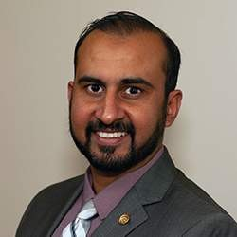

President's Letter
Gary Rehan, PT Council President
College of Physiotherapists of Ontario

As I craft my final annual report letter as the President of the College of Physiotherapists of Ontario, I cannot help but fondly reflect on my term, and my overall involvement with Council. In the past five years I have been fortunate enough to lead and contribute to many initiatives that have helped further the College’s mandate of ensuring patients have access to safe and high-quality physiotherapy care.

I was elected to Council as an experienced physiotherapist looking to expand my skill set, learn more about self-regulation and help protect the public interest. I was Vice-President of the College for a year before being elected as President, and have served as Chair of the Finance, Registration, Executive, and Inquiries, Complaints and Reports Committees, respectively. Through these various appointments I have gained valuable insight into the importance of self-regulation and how the College works to ensure that the public of Ontario has access to safe physiotherapy care.

I firmly believe in the power of engagement and the importance of connecting with physiotherapists across the province to draw on their knowledge and experiences. I have attended many outreach events with the College and heard firsthand the invaluable conversations that have helped shaped so many key outcomes.

I have also been a member of the Quality Assurance Working Group and have worked alongside my esteemed colleagues to examine best practices in quality assurance and develop the framework for a new practice assessment process. More than ever before, the streamlined process will help ensure physiotherapists are meeting their professional obligations and delivering the best possible care. I am excited that this program is now in a comprehensive pilot stage and look forward to its official launch later this year.

As Chair of Finance committee, I have led the College to find financial efficiencies, which resulted in the recent approval of a College registration fee reduction.

My tenure was not without challenges. I led the College through a challenging leadership transition and subsequently led Council through the recruitment process of our new Registrar, Rod Hamilton. This would not have been possible without the ongoing support of the physiotherapists who elected me, and the fellow Council members who I have been privileged to have the opportunity of working with.

I would like to take this opportunity to thank my fellow members of Council, our Registrar, Rod Hamilton, and College staff for their immeasurable contributions.

As I complete my term as President, I will continue serving in my role as Councillor for another year, following which I intend to run for my final term as Councillor from my home district of Eastern Ontario.

I look forward to continuing to serve the College as a Council member in the years to come.

Till again,

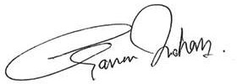

Gary Rehan, PT President
College of Physiotherapists of Ontario

CONTI NUE

Page 3 of 10

Registrar's Letter

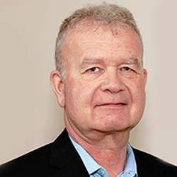

Registrar's Letter
Rod Hamilton Registrar
College of Physiotherapists of Ontario

I am very pleased to be writing my first annual report letter as Registrar at the College of Physiotherapists

of Ontario. Summarizing an entire year in a few short paragraphs is no easy task, but I am proud to reflect on another successful year for the College, and to highlight some of our accomplishments.

Throughout the annual report you will find details about the College, Council and Committees, our efforts to increase awareness with patients and caregivers, updates to the rules and standards that physiotherapists must follow, and changes to programs that promote quality physiotherapy services—such as the Quality Assurance program.

Everything that the College does is in pursuit of our mandate to ensure that every patient in Ontario receives safe, competent and ethical physiotherapy care. To accomplish this, it is imperative that we continue to engage with patients and physiotherapists and collaborate with like-minded organizations that influence patient care. We are here to listen to ideas that can inspire positive change.

This year we saw significant changes to one of our standards—the Advertising Standard. Feedback indicated that adjustments could be made to better embrace technological advancements and the way that people search for a health care provider, and we listened. As you know, physiotherapists can now use testimonials on their websites and social media pages so long as they are truthful, verifiable and free of claims of superiority.

We also visited communities across the province for a series of outreach events with the College Practice Advisor. This provided physiotherapists with the opportunity to ask questions about their practice and engage in conversation with their peers. In addition to the in-person events, we hosted a series of webinars to expand access to the Practice Advice team as well as experts in related fields such as infection control and mental health. We look forward to hosting more webinars and in-person outreach events in the coming year and we welcome topic suggestions.

I have very much enjoyed the responsibilities, challenges and achievements that have filled my first year as Registrar and look forward to many more in the year ahead.

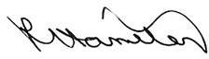

Rod Hamilton

Registrar
College of Physiotherapists of Ontario

CONTI NUE

Page 4 of 10

Strategic Plan

Having a strategic plan allows the College to set priorities and direction, to be most efficient and effective with its resources, and to communicate more successfully with its stakeholders.

Ensure physiotherapists’ business practices meet professional standards and do not damage the reputation of the profession.

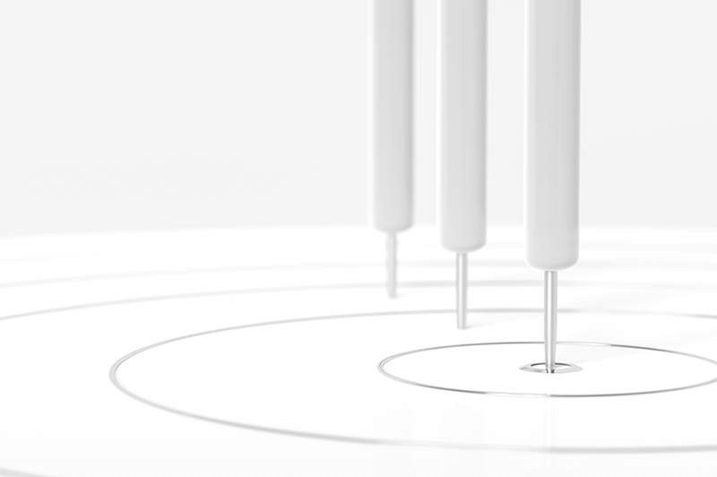

Promote quality physiotherapy services by ensuring registered physiotherapists are aware of and adhere to professional standards and expectations.

Increase the value and awareness of the services the College provides for Ontarians.

CONTI NUE

Page 5 of 10

College Council and Committees

The Council is the governing body for more than 9,500 PTs practicing in Ontario. Council is made up of eight elected physiotherapists, two academic representatives and seven government-appointed public members. Councillors are responsible for ensuring the protection of the public interest.

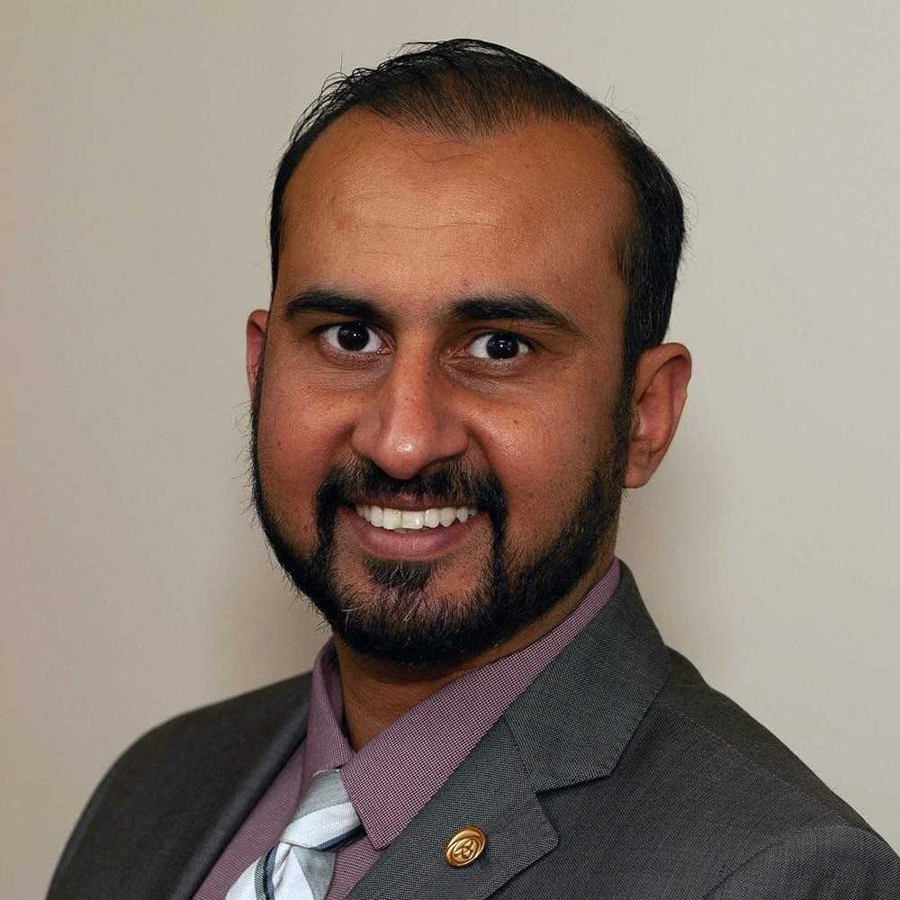

Gary Rehan, Council President (Elected Representative)

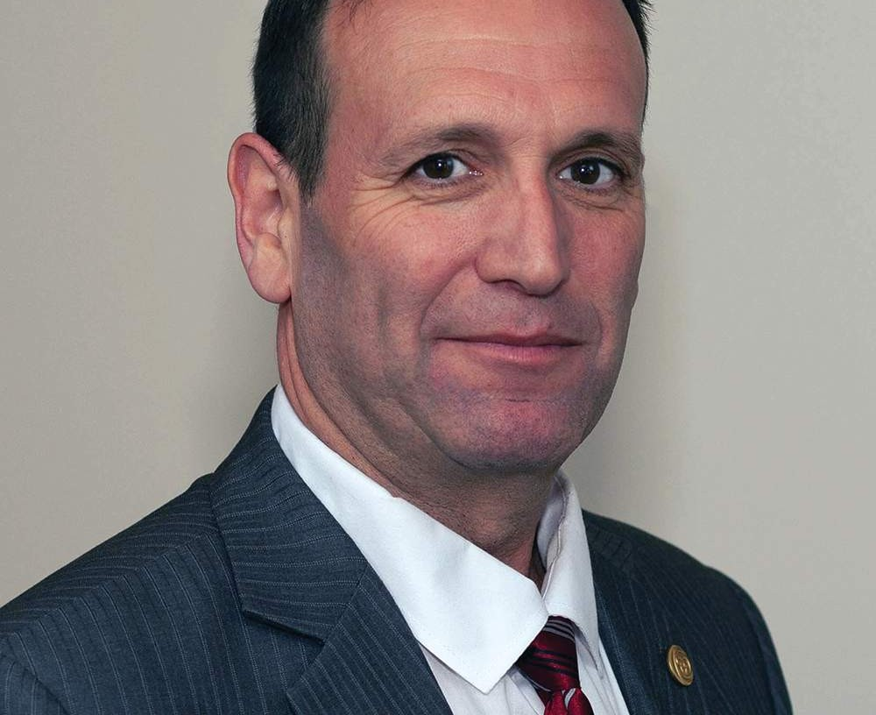

Darryn
Mandel, Council Vice-President (Elected Representative)

Elected Representatives

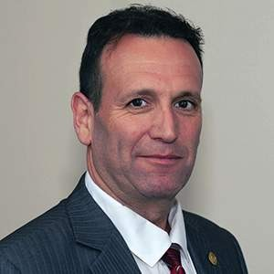

Nicole Graham Janet Law Darryn Mandel Sharee Mandel

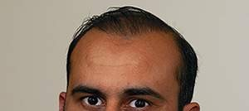
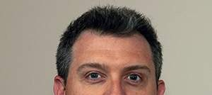

Gary Rehan Mark Ruggiero (from June 2018)
Theresa Stevens Lisa Tichband

Academic Representatives

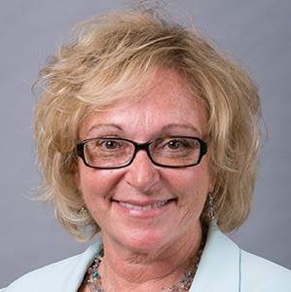

Kathleen Norman
—Queen's University
Martin Bilodeau— University of Ottawa (from June 2018)
Nadine Graham— McMaster University (until June 2018)

Public Appointees

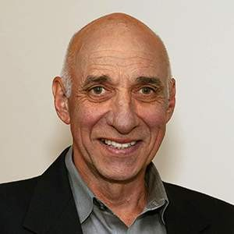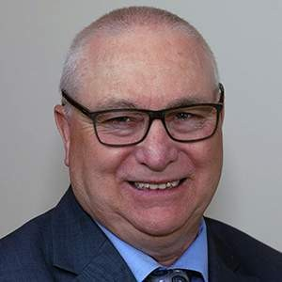

Ronald Bourret Jane Darville Jennifer Dolling Tyrone Skanes

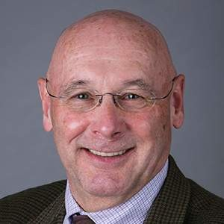

Kenneth Moreau Zita Devan
(until October 2018)
James Lee
(until December 2018)

Professional Committee Members
Jatinder Bains Sheila Cameron Vinh Lu
Lori Neill Marcia Dunn Jim Wernham Daniel Negro
Heather Anders (from October 2018) Sue Grebe (from October 2018) Monica Clarke (from October 2018) Deborah Lucy (until April 2018) Michelle Addison (until June 2018)

College of Physiotherapists of Ontario Committees
In addition to Council, the College has statutory and non-statutory Committees described in the legislation. These Committees are made of a combination of Council and Non-Council members.

Executive Committee –
Gary Rehan—Chair Darryn Mandel
Sharee Mandel (from June 2018) Tyrone Skanes
Theresa Stevens

Patient Relations Committee –
Jennifer Dolling—Chair (from June 2018) Kathleen Norman (from June 2018) Mark Ruggiero (from June 2018) Jatinder Bains
Sharee Mandel (until June 2018) Nicole Graham (until June 2018) Zita Devan (until June 2018)

Discipline and Fitness to Practise Committee  Ronald Bourret—Chair (from June 2018)  Darryn Mandel—Chair (from March 2018 to June 2018) Sheila Cameron  Daniel Negro James Wernham Lori Neill  Lisa Tichband Janet Law  Kenneth Moreau (from January 2019) Jennifer Dolling (from January 2019) Sue Grebe (from October 2018) Heather Tennant (from October 2018) Nadine Graham (until June 2018)  Zita Devan (until October 2018) James Lee (until December 2018) | –
Inquiries, Complaints and Reports Committee  Tyrone Skanes—Chair Gary Rehan  Jane Darville  Theresa Stevens (from June 2018) Monica Clarke (from October 2018) Michelle Addison (until June 2018) Sharee Mandel (until June 2018) Vinh Lu (until June 2018)  Kenneth Moreau (until January 2019) | –
Registration Committee  Jennifer Dolling—Chair | –

Marcia Dunn
Sharee Mandel (from June 2018) Martin Bilodeau (from June 2018) Kenneth Moreau (from June 2018) Janet Law (until June 2018)
Jane Darville (until June 2018) Kathleen Norman (until June 2018)
Quality Assurance Committee  Theresa Stevens—Chair Ronald Bourret  Jatinder Bains  Nicole Graham (from June 2018) Janet Law (from June 2018) Vinh Lu (from June 2018)  Kenneth Moreau (from January 2019) James Lee (until December 2018) Deborah Lucy (until April 2018) | –
Finance Committee  Gary Rehan—Chair Nicole Graham Darryn Mandel  Mark Ruggiero (from June 2018) Kenneth Moreau (from January 2019) James Lee (until December 2018) Janet Law (until June 2018) | –
The Canadian Alliance of Physiotherapy Regulators Representative | –

Gary Rehan

CONTI NUE

Page 6 of 10

The Year in Review

The Path to a New Quality Assurance Program

The College’s primary goal is to ensure that patients are receiving safe, competent and ethical care. In pursuit of that goal we need to make sure physiotherapists are adhering to the standards of practice. One of the ways we monitor the practice of more than 9,500 physiotherapists in Ontario is through practice assessments—a part of the College’s Quality Assurance Program.

In 2017 the College began an extensive process to take a critical look at our Quality Assurance Program and determine changes that would increase the program’s impact and ultimately help protect patients. In March 2018, Council formally approved the new program for development.

Fast forward to today and there have been significant advancements in the process, along with many achievements and learnings that will help shape the structure of the program moving forward. Below is a summary of the accomplishments so far and a brief look at what is still to come.

All 26 of Ontario’s health colleges are required

by law to have a Quality Assurance program
to help protect patients.

The Quality Assurance Working Group

At the direction of Council, a Quality Assurance Working Group was created to lead the research and development of the new program. The Working Group consists of Council members, Quality Assurance Committee members, academic representatives, staff and members of the public.

Since the beginning of this project—as the Working Group conducted the detailed work of the program review—Council received updates about the work at each meeting, and where required, provided direction and made decisions.

Consultation Phase

Before drafting the framework for the new program, the College completed a multi-tiered consultation phase to help ensure recommendations were informed, well-researched and consistent with industry best practices.

The consultation phase included:

A comprehensive environmental scan of Quality Assurance programs and best practices in Canada and abroad

Consultations with more than 1,000 physiotherapists via in-person sessions across the province, a webinar and a session on the Ontario Telehealth Network

365 additional online consultations with members

Targeted consultations with recently assessed physiotherapists, peer assessors and current and past Quality Assurance Committee members

Patient consultations with members of the Citizen Advisory Group

The Citizen Advisory Group is a partnership between 15 health regulatory colleges and is comprised of patients and caregivers who provide feedback on professional rules, standards of practice, policies, strategic priorities and communications.

Program Development

The main objective of the Quality Assurance Program is to protect the public by ensuring all registrants meet pre-determined minimum standards for competency and quality of care.

To assist in the development and revision of quality assurance assessment tools, staff and the Working Group worked alongside an external consultant with expertise and experience in competency assessment. The goal was to create a program that met its primary objective by ensuring a fair and consistent selection process and adopting a streamlined approach to assessments.

Together, the Working Group, the consultant and staff developed a blueprint for the program including:

Assessment Format: the new program will use behaviour-based interviews for the remote and on-site assessments.

Assessment Content: behaviour-based interview questions for the remote and on-site assessments will be based on competency-based assessment criteria.

To develop the competency-based criteria, the consultant and Working Group reviewed research and feedback previously collected by the College, the NPAG Competency Profile for Physiotherapists in Canada (2017), and College standards. They also facilitated four focus group discussions with registrants and assessors to review and identify a list of competencies and expectations to include in the remote and on- site assessments.

The New Quality Assurance Program

For physiotherapists the Quality Assurance Program includes:

- Self-assessments

- Practice Assessments (remote and on-site)

- Continuing Professional Development

Continuing professional development shows that a physiotherapist is still learning and growing and helps ensure that patients are receiving the highest quality care.

Eligibility

Registrants are eligible to be selected for a practice assessment if they:

Have an active Independent Practice registration

Have been registered in Independent Practice for more than two years, and

Are currently providing patient care

Eligible registrants will be selected in sequence. Registrants who have not participated in a practice assessment before will be selected first, starting with the those who have been in practice the longest. The remaining registrants will be selected in order based on their last assessment date from least to most recent. In other words, the registrants who were assessed the earliest will be selected first.

After completing the process, registrants will be removed from the selection pool for approximately 10 years.

PI LO T T EST | R EM O T E A SSESSM EN T | O N - SI T E A SSESSM EN T
Before rolling out the new Quality Assurance Program to the entire registrant base, the College launched a pilot test to determine strengths and areas of improvement, collect feedback from participants and assessors and determine a scoring system for on-site assessments. The pilot test began in April 2019 and included 250 physiotherapists who had never done a practice assessment previously. In order to make sure the selection is an appropriate representation of all physiotherapists, registrants were selected based on practice setting, declared rostered activities and indication of working with specific patient populations.

The Working Group has had multiple opportunities to provide input and direction on a draft assessment blueprint, draft behaviour-based interview questions, and a draft pre-assessment questionnaire. The tools used for the pilot test refiect all of the decisions and directions received to date.

PI LO T T EST | R EM O T E A SSESSM EN T | O N - SI T E A SSESSM EN T
Each month, a group of physiotherapists will be picked to participate in the practice assessment process. Everyone will be required to complete a pre-assessment questionnaire and then a remote assessment with a trained assessor.

The purpose of the remote assessment is to collect information about physiotherapists’ practice to help the College identify registrants who may need more in-depth assessment (the on-site assessment).

PI LO T T EST | R EM O T E A SSESSM EN T | O N - SI T E A SSESSM EN T
The College conducts practice assessments to ensure that physiotherapists continue to meet minimum standards for safety and quality throughout their careers. Some physiotherapists will be asked to complete an on-site assessment following the remote assessment, depending on their results.

The purpose of the on-site assessment is to collect information about the physiotherapist’s practice to help identify potential gaps in knowledge, skill or judgment, and determine what follow-up action is required.

Next Steps

So far, feedback from registrants about the remote assessment phase of the pilot test has been positive with 74% of those surveyed indicating that they are satisfied or very satisfied with the overall experience.

Data from the remote assessment phase of the pilot test will be analyzed and a cut score will be established based on the results of a cut score study. In the cut score study, subject-matter experts conduct an exercise where they estimate the percentage of minimally competent physiotherapists who would answer each interview question correctly, considering the mix of practice areas and experience. Then, the pilot test scores are used by the psychometrician as a reference point to compare against the subject- matter experts’ estimates to arrive at recommendations for the cut score.

Once the cut score is approved, physiotherapists who participated in the pilot test will be notified of their assessment results. A minimum of 30 registrants will be asked to participate in the on-site assessment phase of the pilot test. The College anticipates that all phases of the pilot test will be complete by March 2020.

CONTI NUE

An Overview of Our Engagement Efforts

Over the past year, the College of Physiotherapists of Ontario focused on engaging and collaborating with our many stakeholder groups—patients and caregivers, physiotherapists, students, physiotherapist assistants, employers, insurers and others—to ensure effective and efficient regulatory efforts on all fronts.

Leading the Way with Patient and Caregiver Engagement

CPO continues to lead the way as the founder of the Citizen Advisory Group, a group that brings the voice of both the patient and the caregiver into the College’s regulatory work. CPO now acts as chair of the Citizen Advisory Group Partnership—made up of 15 health colleges working together.

The Citizen Advisory Group has provided invaluable feedback on a number of CPO initiatives and will continue to do so into the future to ensure patient interest drives College decisions and policy.

Visiting Communities Across Ontario

Over the past year, Senior Physiotherapist Advisor, Fiona Campbell, PT and a number of staff members went on the road to meet with hundreds of physiotherapists, students, assistants and employers across the province.

Covering the topics of boundary crossing, sexual abuse and providing and refusing care, the sessions gave the College and its stakeholders a chance to connect on a personal level.

Sharing Expertise Over the Lunch Hour
CPO held three, well-attended, noon-hour webinars to ensure stakeholders had access to important and timely information, straight from renowned experts in various fields like mental health and infection control. The webinars are now available online so physiotherapists can continue to reference them as needed.

Webinars:

In Harm’s Way—Strategies to Support Patients Dealing with Mental Health Issues

Best Practices in Infection Prevention—What You Don’t Know Can Hurt Your Patients

Boundaries and Other Practice Advice Questions

Creating Online Supports

The College constantly scans the regulatory and practice environments to identify areas of risk and resource gaps to be filled. This led to the creation of the online Record Keeping E-learning Module available to all who want to learn or refresh their record keeping knowledge.

Improvements were made to the online PT Portal and the online renewal process based on registrant feedback.

A series of videos were created to educate stakeholders, bring visitors to the College website, and raise awareness about the College’s Public Register, and the ability for members of the public to express a concern or complaint or speak with a Physiotherapist Information Advisor.

The videos targeted patients and caregivers, employers, new and seasoned physiotherapists and physiotherapists educated abroad. They are now available on the College website and social media channels.

 Watch our Videos on The College of Physiotherapists of Ontario YouTube Channel

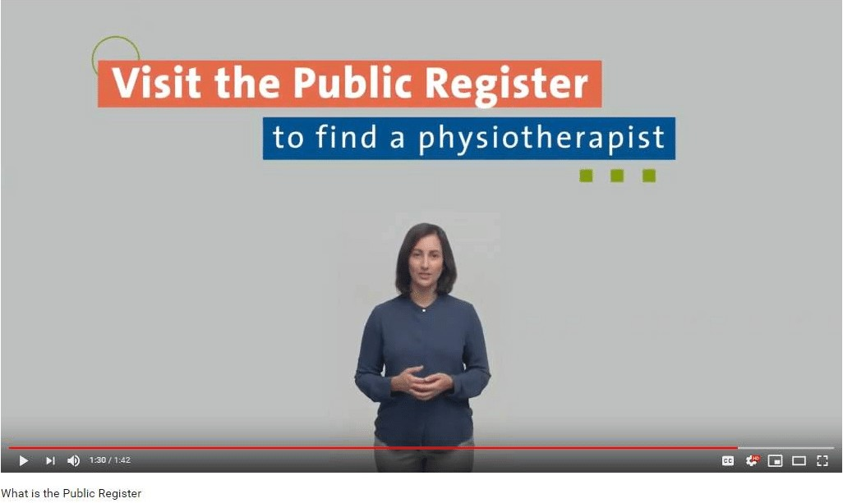

Before you see a physiotherapist in Ontario be sure to check the Public Register, a free online tool that can help you f,nd a physiotherapist who suits your needs and make informed decisions about your care.

Do you have a physiotherapist working for you or your clinic? Learn more about how you can support them and meet your own obligations as their employer.

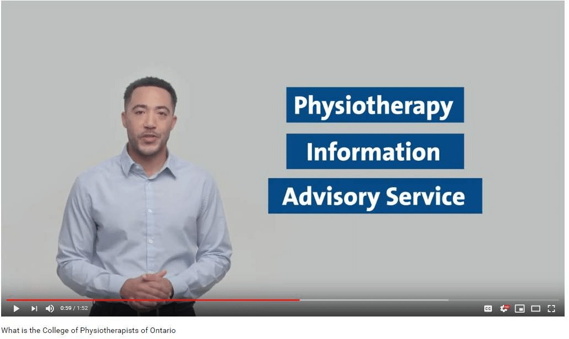

Looking for a physiotherapist or have questions about the care you received? The College of Physiotherapists of Ontario has a team of Physiotherapy Information Advisors ready to answer your questions and offer free, confidential advice.

Connecting with Our Stakeholders

An important part of the College’s work in support of our mandated purpose and our strategic goals is to engage and connect with stakeholders.

This includes patients, caregivers and other members of the public, physiotherapy students educated within and outside of Canada, registrants, the academic community, employers, the insurance industry, physiotherapy assistants and the broader regulatory community.

Outreach

Over the past year, CPO engaged in significant outreach and relationship building to help connect with each of our stakeholder groups. We did this by:

Visiting all physiotherapy programs in Ontario at least twice—including the University of Toronto, Western University, Queen’s University, McMaster University, University of Ottawa and the University of Toronto Bridging Program.

Participating in the Zoomer Show targeting senior patients and caregivers, as well as being a part of the Ontario Health Regulators group.

Engaging with the insurance industry and building a productive relationship by hosting education sessions, sharing information, co-presenting on panels and participating at conferences.

Hosted education sessions virtually and in-person for physiotherapy assistant schools, hospitals and employers.

Presented and participated in the Ontario Physiotherapy Association’s InterACTION conference, Physio North and the Canadian Physiotherapy Association conference.

 Watch our Video:
The Citizen Advisory Group helps bring the patient voice and perspective to health care regulation in Ontario. Learn more about the group and how you can get involved.

Meeting Regulatory Obligations

1

Advertising Standard

The College of Physiotherapists of Ontario revised and updated the Advertising Standard to better reflect the current environment and address stakeholder feedback. Council considered the way that patients often search for reputable health care providers using modern technology and taking into consideration the recommendations of others. Council also considered feedback from physiotherapists who expressed an interest in using modern technology to raise awareness for their services and reach a broader audience.

2

Governance Review Working Group

The Executive Committee has been designated by Council to be the Governance Review Working Group.

3

Entry to Practice Scoping Review

Council directed that a proposal for an Entry to Practice Scoping Review be circulated.

CONTI NUE

Page 7 of 10

Summary Financial Statements

Report of the Independent Auditor on the Summary Financial Statements

To the Council of the College of Physiotherapists of Ontario

Opinion

The summary financial statements, which comprise the summary statement of financial position as at March 31, 2019, and the summary statement of operations for the year then ended, and related note, are derived from the audited financial statements of the College of Physiotherapists of Ontario (the "College") for the year ended March 31, 2019.

In our opinion, the accompanying summary financial statements are a fair summary of the audited financial statements, on the basis described in the note to the summary financial statements.

Summary Financial Statements

The summary financial statements do not contain all the disclosures required by Canadian accounting standards for not-for-profit organizations. Reading the summary financial statements and the auditor's

report thereon, therefore, is not a substitute for reading the audited financial statements of the College and the auditor's report thereon.

The Audited Financial Statements and Our Report Thereon

We expressed an unmodified audit opinion on the audited financial statements in our report dated June 24, 2019.

Management's Responsibility for the Summary Financial Statements

Management is responsible for the preparation of the summary financial statements on the basis described in the note to the summary financial statements.

Auditor's Responsibility

Our responsibility is to express an opinion on whether the summary financial statements are a fair summary of the audited financial statements based on our procedures, which were conducted in accordance with Canadian Auditing Standard (CAS) 810, Engagements to Report on Summary Financial Statements.

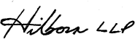

Chartered Professional Accountants Licensed Public Accountants Toronto, Ontario
June 24, 2019

401 Bay Street • Suite 3100 • P.O. Box 49 • Toronto • ON • CA • M5H 2Y4 • P 416- 364-1359 • F 416-364-9503 • hilbornca.com

CONTI NUE

Summary Statement of Financial Position
March 31

 | 2019  $ | 2018  $
ASSETS
Current assets
Cash | 7,035,323 | 6,119,060
Investments | 722,934 | 1,185,153
Prepaid expenses | 277,988 | 260,779
 | 8,036,245 | 7,564,992
Investments | 4,204,278 | 3,637,499
Capital assets | 838,479 | 965,574
 | 5,042,757 | 4,603,073
 | 13,079,002 | 12,168,065

 | 2019  $ | 2018  $
LIABILITIES
Current liabilities
Accounts payable and accrued liabilities | 1,338,418 | 626,927
Deferred registration fees | 5,638,274 | 4,862,751
 | 6,976,692 | 5,489,678
Deferred lease incentives | 219,118 | 246,225
 | 7,195,810 | 5,735,903
NET ASSETS
Invested in capital assets | 619,361 | 719,349
Internally restricted for complaints and discipline | 1,000,000 | 1,000,000
Internally restricted for sexual abuse therapy | 100,000 | 100,000

 | 2019  $ | 2018  $
Internally restricted for strategic initiatives | 500,000 | 500,000
Internally restricted for IT improvements | 250,000 | 250,000
Unrestricted | 3,413,831 | 3,862,813
 | 5,883,192 | 6,432,162
 | 13,079,002 | 12,168,065

Summary Statement of Operations
Year ended March 31

 | 2019  $ | 2018  $
Revenues
Registration fees | 5,839,607 | 5,575,488

 | 2019  $ | 2018  $
Investment income | 169,878 | 158,158
 | 6,009,485 | 5,733,646
Expenses
Salaries and benefits | 3,635,617 | 3,091,727
Administration and office | 965,201 | 916,542
Programs | 264,215 | 246,373
Communications | 153,867 | 176,671
Professional fees | 555,352 | 358,308
Organizational effectiveness | 69,218 | 123,220
Committee fees and expenses | 270,712 | 239,796
Information technology | 467,149 | 860,323
Networking, representation and travel | 22,611 | 33,502

 | 2019  $ | 2018  $
Amortization | 154,513 | 145,621
 | 6,558,455 | 6,192,083
Excess of expenses over revenues  for year | (548,970) | (458,437)

CONTI NUE

Note to Summary Financial Statements
March 31, 2019

1. Basis of presentation

These summary financial statements have been prepared from the audited financial statements of the College of Physiotherapists of Ontario (the "College") for the year ended March 31, 2019, on a basis that is consistent, in all material respects, with the audited financial statements of the College except that the statements of changes in net assets and cash flows and the information disclosed in the notes to the audited financial statements have not been presented.

Complete audited financial statements are available to members upon request from the College.

Contact the College
For a complete set of audited financial statements, contact Fazal Raza at fraza@collegept.org or 1-800- 583-5885 ext. 221.

CONTI NUE

Page 8 of 10

Program Review

Practice Advice

Patients, caregivers, physiotherapists, students, assistants, employers, insurers and others can contact the College for confidential advice about the practice of physiotherapy. This service is offered to support quality of practice and to help the public better understand their rights as physiotherapy patients.

Watch our Video: What is a Physiotherapy Information Advisor?

Practice Advice Team Contact Numbers

In 2018–2019, there were 5,410 calls and emails in comparison to the 4,807 contacts in 2017-2018.

This was a 13% increase.

69% of calls and emails were from physiotherapists, while 31% of contacts were from patients, caregivers, employers, PTAs, insurers and others.

Breakdown of Practice Advice Calls and Emails

 | 2017-2018 | 2018-2019
Q1 | 807 | 1000
Q2 | 1200 | 1100
Q3 | 1100 | 1460
Q4 | 1700 | 1850
TOTAL | 4807 | 5410

Top Five Practice Advice Questions in 2018-2019

Practice Management
1

Professional Obligations
2

Patient Care
3

Supervision
4

Record Keeping
5

CONTI NUE

Registration

The College is responsible for ensuring individuals applying to become registered physiotherapists in Ontario are qualified. Those who use the title physiotherapist, physical therapist or PT in Ontario must be registered with the College. To maintain a registration or licence, physiotherapists must renew annually. This ensures public safety.

In 2018-2019,
there were 9,537 registrants, of those, 604 were new.

New Registrants

There were 604 new registrants in 2018-2019, compared to 613 new registrants in 2017-2018.

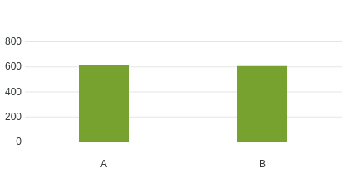

Year
Number of Registrants

A. 2017-2018 | 613

B. 2018-2019 | 604

Total Registrants

There were 9,537 total registrants in 2018-2019, compared to 9,478 total registrants in 2017-2018.
Number of Registrants
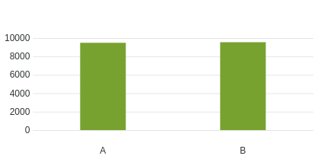
Year

A. 2017-2018 | 9478

B. 2018-2019 | 9537

Top Five Source Countries for International Graduates

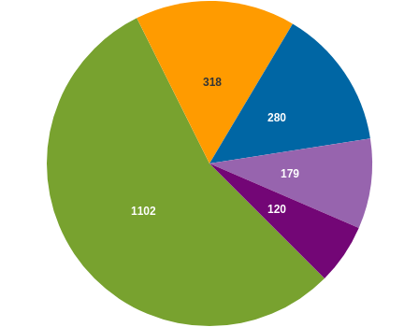

India

United Kingdom

United States of America Philippines
Australia

Gender Breakdown of Registrants

Registrants

Gender

Gender | Registrants
Female | 6834
Male | 2696
X | 7

Registrant Education

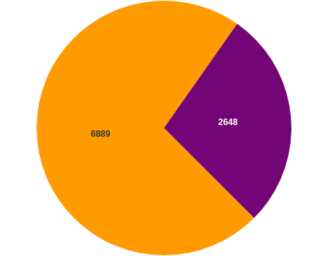

Educated in Canada Educated Outside of Canada

Canadian Labour Mobility (AIT)
51 individuals registered in Ontario using the Canadian Free Trade Agreement (CFTA) provisions
between April 1, 2018 to March 31, 2019.

Registration Committee Decisions

 | 2017-2018 | 2018-2019
Total Number of Decisions | 8 | 7
Certificates Granted | 0 | 0
Certificate of Registration Granted with Additional Terms, Conditions and Limitations | 3 | 3
Certificates Denied | 5 | 4

There was one appeal of a Registration Committee Decision to the Health Professions Appeal and Review Board (HPARB), which was later withdrawn.

CONTI NUE

Quality Assurance

The College’s Quality Assurance program underwent a Council- directed review and was paused for the majority of the 2018-2019 year.
This resulted in few practice assessments being initiated during this time period.

If you have specific questions about the Quality Assurance program or data related to practice assessments, practice enhancements or Quality Assurance Committee decisions, please contact Shelley Martin, Quality Assurance Manager at smartin@collegept.org.

CONTI NUE

Patient Relations

There were no applications for funding for therapy and counselling.

The Patient Relations Committee met once to discuss additional funding for one patient.

CONTI NUE

Professional Conduct

The College receives complaints and reports about the practice or conduct of physiotherapists. All complaints made by the public are investigated. The College Registrar may also initiate investigations where reported information suggests reasonable and probable grounds to believe a physiotherapist may have engaged in professional misconduct or is incompetent.

The results of investigations are considered by the Inquiries, Complaints and Reports Committee, which may take no action, order a range of educational or remedial activities, or refer a physiotherapist to the Discipline Committee or Fitness to Practise Committee for a hearing.

The College also receives information about individuals who are not registered to practice but refer to themselves as physiotherapists or physical therapists (holding out).

In 2018–2019, the College received 247 concerns about physiotherapists and individuals holding out. 97 of these matters were complaints filed by members of the public. Of this number 53 individuals proceeded through the formal complaints process. The 44 matters that did not go through the complaints process in addition to the other 150 concerns brought to the College’s attention were considered by the Registrar to determine if the appointment of an investigator was warranted.

The College received the following concerns from physiotherapists and members of the public about physiotherapists:

Complaints

Mandatory reports—sexual abuse, termination, incapacity

Self reports—offences, charges/conviction and bail conditions

Physiotherapists reporting that their names and registration numbers have been used inappropriately

Physiotherapists who failed to complete the Professional Issues Self Assessment (PISA)

Other practice/conduct concerns

The Registrar appointed an investigator on 11 occasions in 2018-2019. Where an investigator was not appointed, the Registrar may have closed the file, issued an education letter, invited the physiotherapist to participate in an educational session or meeting with the Practice Advisor.

Divisional Court Reviews

 | 2018-2019
Divisional Court Reviews | 2

Dispositions of the Inquiries, Complaints and Reports Committee
* Some decisions may include more than one outcome.

 | 2017-2018 | 2018-2019
Total Decisions | 62 | 68
No Action | 24 | 26
Advice and Recommendations | 19 | 21
Caution | 6 | 6
Specified Continuing Education and Remediation Program (SCERP) | 3 | 1
Referral to Discipline Committee | 9 | 8
Referral to Fitness to Practise Committee | 0 | 0

 | 2017-2018 | 2018-2019
SCERP and Caution | 0 | 2
Undertakings | 1 | 2
SCERP and Undertaking |  | 1
Withdrawal |  | 1

Health Professions Appeal and Review Board (HPARB) Review Process (Complaints)

 | 2018-2019
Number of Cases Appealed to the Board | 20
Number of Decisions Received from HPARB | 7
Number of Decisions Confirmed by HPARB | 4
Number of Decisions Returned for Reconsideration | 2
Number Withdrawn | 1

Hearings

 | 2018-2019
Number of Hearings | 4
Number of Hearing Days | 4
Hearings Adjourned Sine Die | 0
Discipline Hearings Completed | 4
Findings of Professional Misconduct | 4
Fitness of Practise Hearings | 0
Findings of Incapacity | 0
Reinstatement of Hearings | 0

CONTI NUE

Page 9 of 10
Discipline Summaries 2018-2019

Discipline Hearings
In 2018-2019 we had four Discipline Hearings that took place at the College of Physiotherapists of Ontario.

See a complete list of past Discipline Hearings and decisions by visiting CanLII.org or www.collegept.org.

Be sure to visit the College’s Public Register, also known as Find a Physiotherapist to access important information before visiting a physiotherapist. All regulated healthcare providers have a similar Public Register on their College’s website. See a complete list of Public Registers at ontariohealthregulators.ca

View a Complete List
of Discipline Summaries at www.collegept.org
or at www.canlii.org

 Please click on the name below to view the Discipline hearing details.

Mohannad Bakri, Registration #12180 (Case #2015 0099 and #2016 0120) –
On December 7, 2017 the Inquiries, Complaints and Reports Committee referred a matter involving Mohannad Bakri, Registration Number 12180 to the Discipline Committee for a hearing. The hearing took place on December 6, 2018. The panel’s decision will be made available on CanLII (www.canlii.org).

Overview of the Allegations

The allegations refer to the following headings of professional misconduct:

- At all material times Mohannad Bakri (“Mr. Bakri” or the “Member”) was registered as a Physiotherapist in the Province of Ontario, providing services through Physio Art Rehabilitation clinic in Hamilton, Ontario (the “Clinic”). At all material times, Mr. Bakri was the owner of the Clinic.

- Between the period of January 1, 2013 and December 31, 2015, Mr. Bakri engaged in professional misconduct within the meaning of the following paragraphs of section 1 of the Professional Misconduct Regulation, 0. Reg. 388/08:

  - paragraph 1 (failing to maintain the standards of the profession);

  - paragraph 18 (engaging in conduct or performing an act relevant to the practice of the profession that, having regard to all the circumstances, would reasonably be regarded by members as disgraceful, dishonourable or unprofessional);

  - paragraph 26 (failing to keep records in accordance with the standards of the profession);

  - paragraph 28 (signing or issuing a document containing a statement that the member knows or ought to know contains a false or misleading statement);

  - paragraph 32 (submitting an account or charge for services that the member knows or ought to know is false or misleading);

- paragraph 33 (failing to take reasonable steps to ensure that any accounts submitted in the member’s name or billing number are fair and accurate);

- paragraph 40 (continuing the treatment of a patient where it is no longer indicated, has ceased to be effective or is unnecessary).

Findings

At the conclusion of the hearing the panel found that Mr. Bakri had committed several act(s) of professional misconduct and they ordered the following penalty.

Penalty
- a reprimand (delivered on December 6, 2018)

- a suspension of 15 months with 8 months remitted if the following remedial activities are completed within the required timelines

A - successful completion of the PROBE Ethics and Boundaries Program B - a review of various College standards, tools and resources

In the event that Mr. Bakri chooses to work as a PTA during the period of his suspension, the supervising physiotherapist must work at Mr. Bakri's practice location and must approved by the Registrar.

Mr. Bakri will be required to work with a practice coach for no more than three years during which time he will not be able to supervise physiotherapy students or PTA students, or members of the College who hold a provisional practice certificate of registration.

Mr. Bakri will be subjected to spot audits for a period of no more than three years

In addition, Mr. Bakri was ordered to pay costs in the amount of $8,000 to the College to offset some of the costs of investigating and prosecuting this matter.
Steven Brown, Registration #09752 (Case #2015 0302 and #2015 0310) –
On September 19, 2017 the Inquiries, Complaints and Reports Committee referred a matter involving Steven Brown, Registration Number 09752 to the Discipline Committee for a hearing. The hearing was held on June 13, 2018. The panel’s decision will be made available on CanLII (www.canlii.org).

Overview of the Allegations

The allegations refer to the following headings of professional misconduct:

Failing to maintain the standards of practice of the profession

Engaging in conduct or performing an act relevant to the practice of the profession that, having regard to all the circumstances, would reasonably be regarded by members as disgraceful, dishonourable or unprofessional

Advertising, unless the advertisement accurately and fairly presents verifiable information to assist a patient in choosing whether to engage the services of the member

Penalty
At the conclusion of the hearing the panel found that Mr. Brown had committed acts of professional misconduct and ordered the following penalty:

- That the Member appear before the panel of the Discipline Committee to be reprimanded at the conclusion of this hearing held on June 13, 2018.

- That the Registrar suspend the Member’s certificate of registration for two (2) months, with one (1) month of the suspension to be suspended on condition that the Member successfully complete the remedial activities specified in paragraphs 3 (a) and (b) below. The suspension shall commence on a date to be determined by the Member but no later than September 1, 2018. That if the balance of the suspension is required to be served by the Member because he does not complete the remedial activities set out in paragraphs 3 (a) and (b) proposed below, the remaining one-month suspension shall commence 60 days from the date of the Member failing to successfully complete the PROBE Ethics and Boundaries Program in accordance with paragraph 3(a) below and/or failing to undertake the remedial activities set out in paragraph 3(b) below, whichever comes first.

- That the Registrar impose specified terms, conditions or limitations on the Member’s certificate of registration, namely that:

- within the 30 days of the date of this Order, the Member shall register in the first available PROBE Ethics and Boundaries Program. The Member shall at his own expense, complete the PROBE Ethics and Boundaries Program, with an unconditional pass;

- within 60 days of the date of this Order, the Member shall complete a review of the following College standards, tools, and resources and send written confirmation to the Registrar confirming that he has done so. (Code of Ethics, Ethics E-Learning Module (videos and print), Professional Misconduct Regulation, Advertising Standard and resources, Conflict of Interest Standard, Essential Competency Profile for Physiotherapists in Canada)

- for greater clarity, the remedial activities and set out in (a) and (b) above must be completed by the Member regardless of whether the Member serves the second month of the suspension as set out in

paragraph 2 of this Order.

- for a period of twelve (12) months following the date of this order, Mr. Brown shall submit all proposed advertising for Family Physio and/or any other physiotherapy clinic under Mr. Brown’s direction or control, to the College for review in advance of publication of the advertising. The draft text, scripts, clips and/or images for advertisements shall be provided to the College for review a minimum of one week prior to publication. Where the College identifies a concern with respect to the advertisement’s compliance with the College’s standards of professional practice, Mr. Brown shall amend the advertisement consistent with the College’s direction. For greater clarity, Mr. Brown’s television show where he conducts interviews with health professionals and others, is not “advertising” for the purpose of this paragraph.

- the Member shall not provide physiotherapy services as a physiotherapist assistant during the period in which he is suspended from practice in accordance with paragraph 2 above.

That the Member pay costs to the College in the amount of $7,500, payable by way of post-dated cheques dated June 30, 2018 ($2,000), August 30, 2018 ($2,000), October 30, 2018 ($2,000) and December 30, 2018 ($1,500) and provided to the College on or before June 30, 2018.
David Munro Registration #09747 (Case #2015 0076) –
On September 19, 2017 the Inquiries, Complaints and Reports Committee referred a matter involving David Munro, Registration Number 09747 to the Discipline Committee for a hearing. The hearing was held on May 30, 2018. The panel’s decision will be made available on CanLII (www.canlii.org).

Overview of the Allegations
The allegations refer to the following headings of professional misconduct: 1 Failing to maintain the standards of practice of the profession
18 Engaging in conduct or performing an act relevant to the practice of the profession that, having regard to all the circumstances, would reasonably be regarded by members as disgraceful, dishonourable or unprofessional.

- Advertising, unless the advertisement accurately and fairly presents verifiable information to assist a patient in choosing whether to engage the services of the member.

- Failing to keep records in accordance with the standards of practice of the profession.

28 Signing or issuing a document containing a statement that the member knows or ought to know contains a false or misleading statement.

- Submitting an account or charge for services that the member knows or ought to know is false or misleading.

- Failing to take reasonable steps to ensure that any accounts submitted in the member’s name or billing number are fair and accurate.

Findings

At the conclusion of the hearing the panel found that Mr. Munro had committed several act(s) of professional misconduct and they ordered the following penalty.

Penalty
- a reprimand (delivered on May 30, 2018)

- a suspension of 12 months with 10 months remitted if the following remedial activities are completed within the required timelines

A - successful completion of the PROBE Ethics and Boundaries Program B - a review of various College standards, tools and resources

Mr. Munro will be required to work with a practice coach for no more than one year during which time he will not be able to supervise physiotherapy students or PTA students, or members of the College who hold a provisional practice certificate of registration.

In addition David Munro was ordered to pay costs in the amount of $2,000 to the College to offset some of the costs of investigating and prosecuting this matter.
Samuel Shepherd, Registration #13208 (Case #2017 0002) –
On September 18, 2018 the Inquiries, Complaints and Reports Committee referred a matter involving Samuel Shepherd, Registration Number 13208 to the Discipline Committee for a hearing. The hearing took place on December 11, 2018. The panel’s decision will be made available on CanLII (www.canlii.org).

Overview of the Allegations

The allegations refer to the following headings of professional misconduct:

1. At all materials times, Samuel Shepherd was a registered member of the College.

- During the period September 1, 2014 and July 31, 2017, Mr. Shepherd engaged in professional misconduct within the meaning of the following paragraphs of section 1 of the Professional Misconduct Regulation, 0. Reg. 388/08:

  - paragraph 1 (failing to maintain the standards of the profession);

  - paragraph 18 (engaging in conduct or performing an act relevant to the practice of the profession that, having regard to all the circumstances, would reasonably be regarded by members as disgraceful, dishonourable or unprofessional);

  - paragraph 26 (failing to keep records in accordance with the standards of practice of the profession);

  - paragraph 28 (signing or issuing a document containing a statement that the member knows or ought to know contains a false or misleading statement);

  - paragraph 32 (submitting an account or charge for services that the member knows or ought to know is false or misleading);

  - paragraph 33 (failing to take reasonable steps to ensure that any accounts in the member's name or billing number are fair and accurate);

  - paragraph 40 (continuing the treatment of a patient where it is no longer indicated, has ceased to be effective or is unnecessary).

Penalty

At the conclusion of the hearing the panel found that Mr. Shepherd had committed acts of professional misconduct and ordered the following penalty:

That the member receives a reprimand.

That the Member’s certificate of registration be suspended for a period of six (6) months, with three (3) months of the suspension to be suspended provided the Member completes the remediation activities set out in paragraphs 3(a) and (b) below. If the remedial activities are not completed by December 31, 2019 the remainder of the suspension will need to be served.

That the Registrar impose specified terms, conditions or limitations on the Member’s certificate of registration, requiring that the member successfully complete the PROBE Ethics and Boundaries Program and the member complete a review of the College standards, tools, and resources and send written confirmation to the Registrar confirming that he has done so.

Professional Misconduct Regulation

Standard—Fees, Billing and Accounts

Standard—Record Keeping

Essential Competency Profile for Physiotherapists in Canada and the Quick Reference Document

Code of Ethics
- That the Member participate in a practice enhancement coaching program of no more than four sessions.

- While the Member is participating in the practice enhancement coaching, he may not supervise physiotherapy students, PTA students, or members of the College who hold a provisional practice certificate of registration.

- That the member pays costs to the College in the amount of $1,500, by January 30, 2019.

CONTI NUE

Page 10 of 10

Contact the College

College of Physiotherapists of Ontario 375 University Avenue, Suite 800 Toronto, Ontario M5G 2J5

www.collegept.org

Concerns or Complaints
1-800-583-5885 ext. 227
416-591-3828 ext. 227
investigations@collegept.org

Contact the Practice Advisor
1-800-583-5885 ext. 241
647-484-8800
advice@collegept.org

Financial Statements
To request a copy of the audited financial statements, please contact: 1-800-583-5885 ext. 221
416-591-3828 ext. 221
fraza@collegept.org

www.collegept.org

