College of Physiotherapists of Ontario
Annual Report (April 1, 2020 to March 31, 2021)

College of Physiotherapists of Ontario Annual Report (April 1, 2020 to March 31, 2021)

About the College

Strategic Plan

College Council and Committees

The Year in Review

Financial Statements

Program Review

Discipline Summaries 2020-2021

Contact the College

Page 1 of 8

About the College
College of Physiotherapists of Ontario

The College of Physiotherapists of Ontario

The College of Physiotherapists of Ontario protects the public by ensuring that more than 10,000 physiotherapists across the province are delivering safe, competent and ethical physiotherapy care.

The College fulﬁlls this mandate by:

Ensuring that anyone registering with the College is qualiﬁed to become a physiotherapist in Ontario.
Maintaining a public list of all qualiﬁed physiotherapists (also known as PTs or physical therapists) in the province, called the Public Register.
Developing rules and standards for physiotherapy practice and supporting physiotherapists in meeting these requirements.
Investigating complaints and concerns about the practice of physiotherapists and taking disciplinary action as required.
Requiring all physiotherapists to participate in a quality assurance program to ensure they maintain current knowledge and skills.

The College’s work is guided by a Council that includes:

Members of the public (appointed by the Lieutenant Governor of Ontario) Physiotherapists (elected by their peers)
Academic representatives (teachers and researchers)

 Watch our Video: What is the College of Physiotherapists of Ontario?

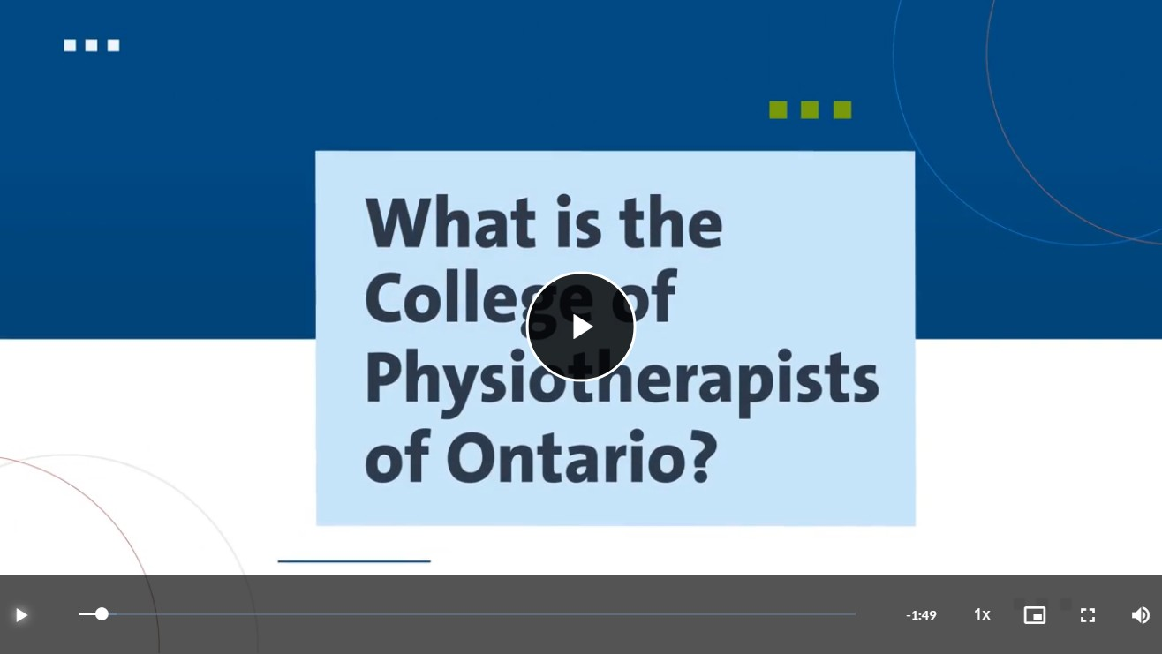

CONTI NUE

Page 2 of 8

Strategic Plan

College of Physiotherapists of Ontario

VISION

Innovative Regulatory Leadership Promoting a Healthier Ontario

MISSION STATEMENT

To protect and serve the public interest by promoting collaboration and accountability for self-regulation and enabling a culture of continuous improvement to ensure that physiotherapists provide competent and ethical services.

In support of our mandate to protect the public, the College has been working under the framework of a strategic plan, effective through 2021. This strategic plan has helped shape the work of Council and College staff in pursuit of our vision, mission and strategic goals.

1

Ensure physiotherapists’
business practices meet professional standards and do not damage the reputation of the profession.

2

Promote quality
physiotherapy services by ensuring registered physiotherapists are aware of and adhere to professional standards and expectations.

3

Increase the value and awareness of the services the College provides for Ontarians.

Review the College’s Strategic Plan www.collegept.org

CONTI NUE

Page 3 of 8

College Council and Committees
College of Physiotherapists of Ontario

The Council is the governing body for more than 10,000 PTs practicing in Ontario. Council is made up of eight elected physiotherapists, two academic representatives and seven

government-appointed public members. Councillors are responsible for ensuring the protection of the public interest.

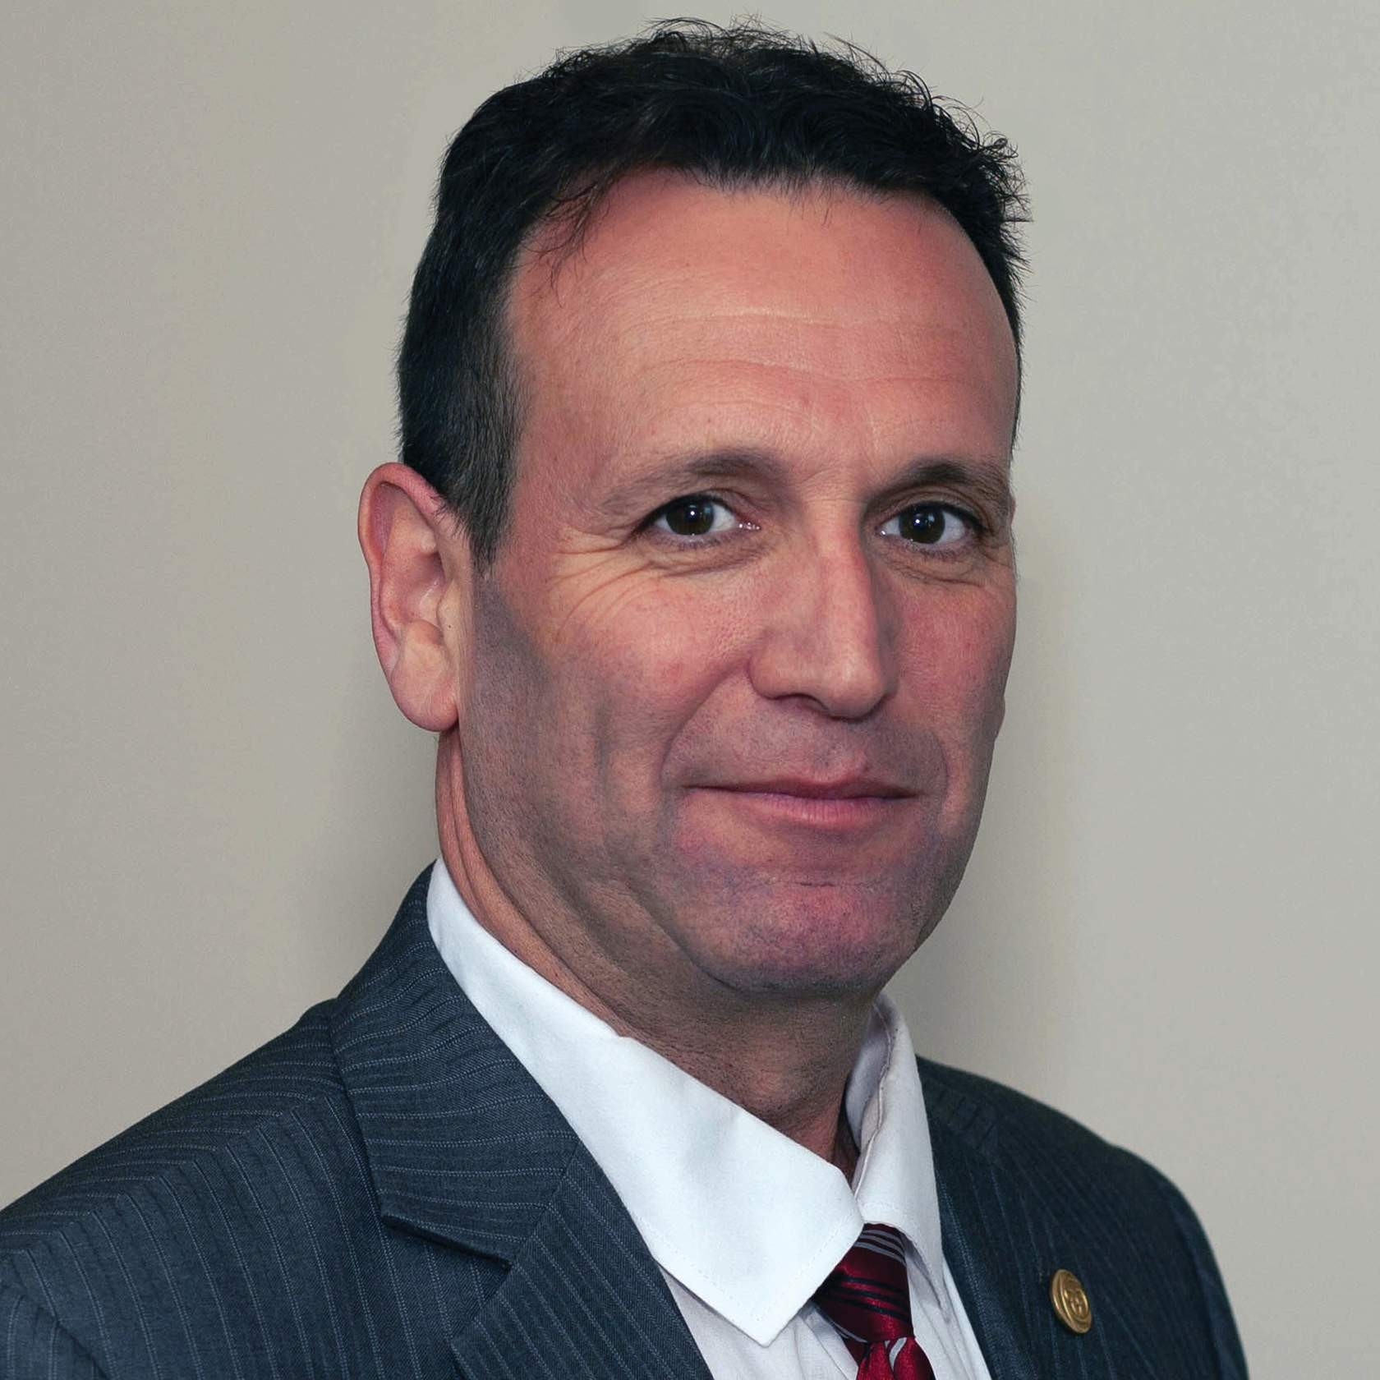

Darryn Mandel, Council President (Elected Representative)

Theresa Stevens, Council Vice- President (Elected Representative)

Elected Representatives

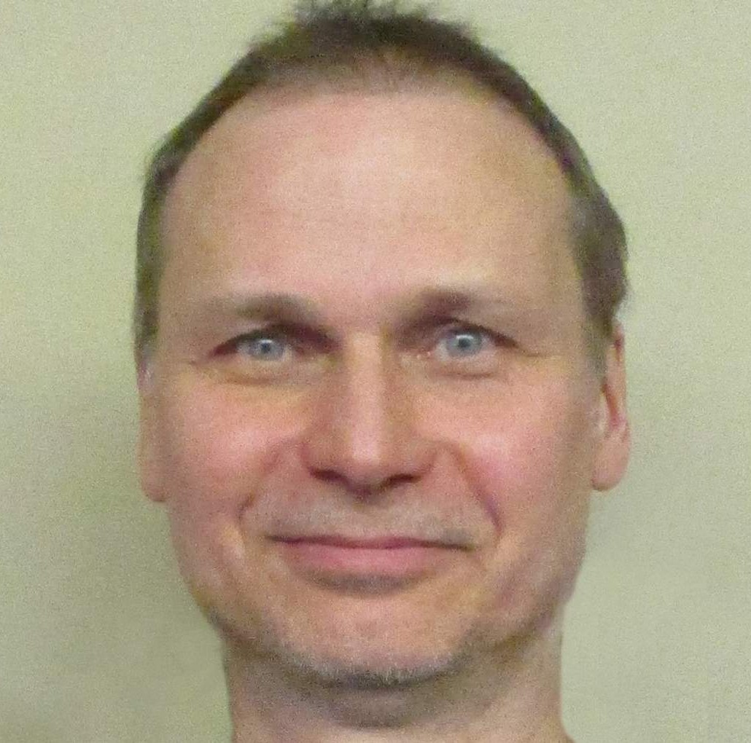

Hervé Cavanagh (from Sept 2020)
Jennifer Clifford (from Sept 2020)
Nicole Graham (until Sept 2020)
Janet Law

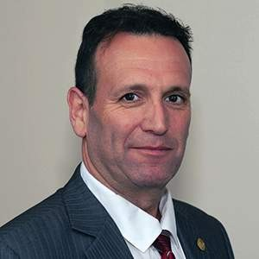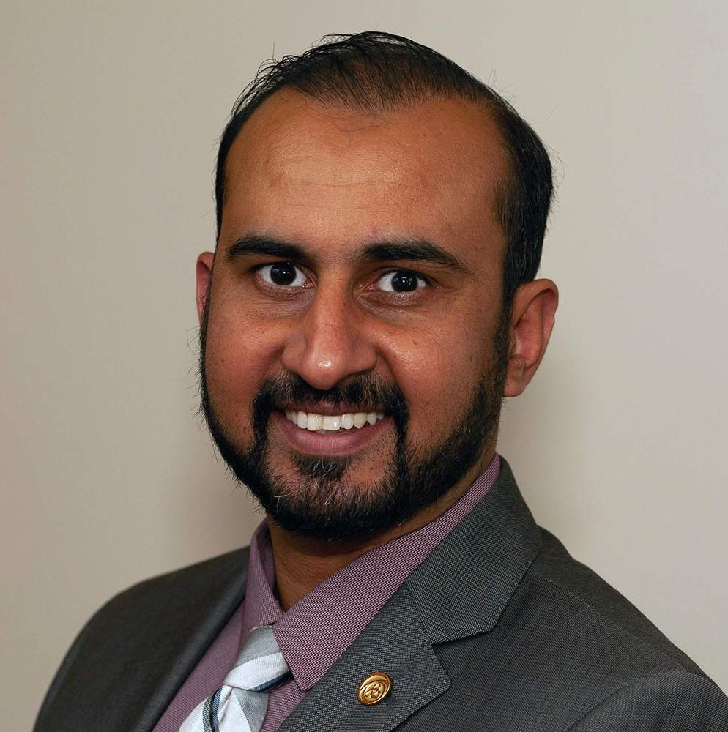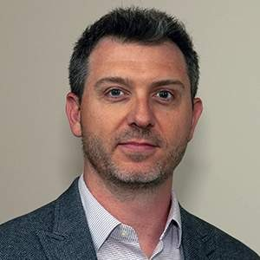

Darryn Mandel Sharee Mandel-
Benyacar
Gary Rehan (until September 2020)
Mark Ruggiero (until June 2020)

Katie Schulz Theresa Stevens Karen St.
Jacques (from September 2020)

Academic Representatives

Martin Bilodeau
—University of Ottawa
Kathleen Norman— Queen’s University (until June 2020)
Sharon Switzer- McIntyre— University of Toronto
(from

September 2020
to April 2021)

Public Appointees

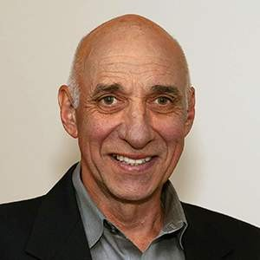
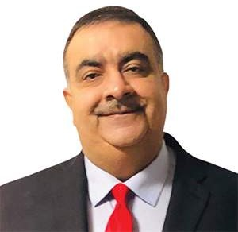

Ronald Bourret (until February 2021)
Jane Darville (until May 2020)
Jesse Finn (from February 2020)
Karim Kanji (from May 2020
to October 2020)

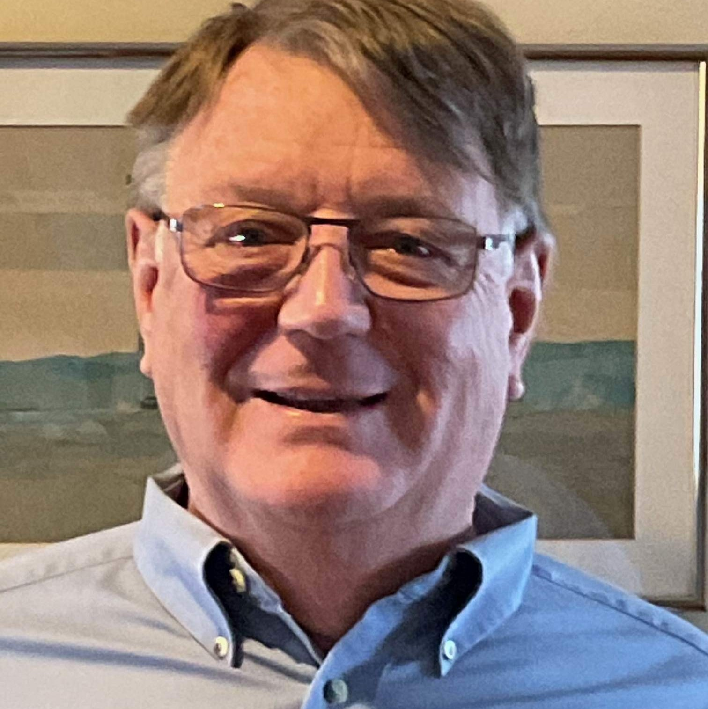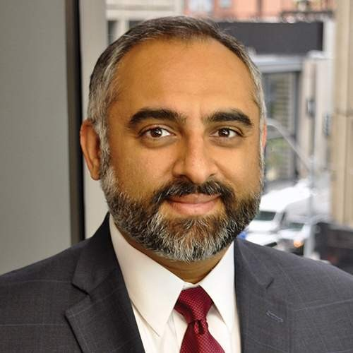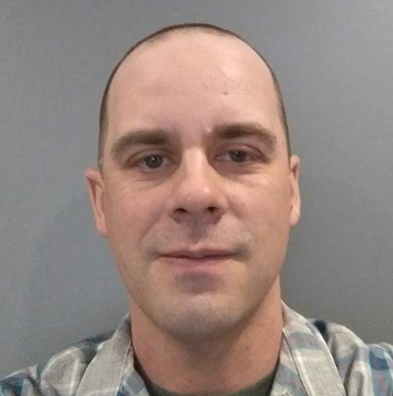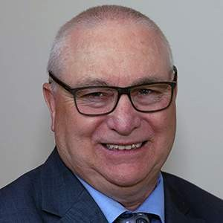

Myles MacLeod (from February
Nitin Madhvani Tom McAfee
(from May 2020)
Tyrone Skanes

2021)

Professional Committee Members

Elizabeth Bergmann Monica Clarke
Sue Grebe Angelo Karalekas Antoinette Megens
Daniel Negro Anastasia Newman Richa Rehan James Wernham

College of Physiotherapists of Ontario Committees

In addition to Council, the College has statutory Committees described in the legislation. The College also has one non- statutory Committee. These Committees are made of a combination of Council and Committee members.
Executive Committee
–
Darryn Mandel (Chair) Sharee Mandel-Benyacar
Ron Bourret, Public Representative (September 2020 to February 2021) Tyrone Skanes
Theresa Stevens

Inquiries, Complaints and Reports Committee –
Tyrone Skanes Gary Rehan Monica Clarke
Jennifer Clifford (from September 2020) Nitin Madhvani (until September 2020) Tom McAfee (from September 2020) Mark Ruggiero (until September 2020) Theresa Stevens (from September 2020)
Discipline and Fitness to Practise Committee –
Sharee Mandel-Benyacar (Chair) Martin Bilodeau
Ron Bourret (until February 2020) Hervé Cavanagh (from September 2020) Jennifer Clifford (from September 2020)

Jesse Finn (from April 2020) Nicole Graham
Sue Grebe
Karim Kanji (from September 2020 to October 2020) Angelo Karalekas
Janet Law
Myles MacLeod (from February 2021) Nitin Madhvani (from April 2020) Tom McAfee (from September 2020) Daniel Negro
Kathleen Norman (until June 2020) Richa Rehan
Katie Shultz
Sharon Switzer-McIntrye (from September 2020) James Wernham
Quality Assurance Committee  Theresa Stevens (Chair) Elizabeth Bergmann  Ron Bourret (from April 2020 until February 2021) Hervé Cavanagh (from September 2020)  Jane Darville (until May 2020)  Karim Kanji (from September 2020-Oct 2020) Janet Law  Myles MacLeod (from February 2021) Nitin Madhvani (from November 2020) Tom McAfee (from September 2020) Antoinette Megens  Kathleen Norman (until September 2020)  Tyrone Skanes (from April 2020 until September 2020) | –
Registration Committee | –
Tyrone Skanes (Chair)
Martin Bilodeau
Jesse Finn (from June 2020)

Anastasia Newman Katie Schulz

Patient Relations Committee –
Sharee Mandel-Benyacar (Chair from September 2020) Ron Bourret (from September 2020 until February 2021) Jane Darville (until May 2020)
Nicole Graham (Chair until September 2020) Martin Bilodeau (until September 2020) Myles MacLeod (from February 2021) Antoinette Megens
Karen St. Jacques (from September 2020)

Finance Committee –
Gary Rehan (Chair until September 2020) Janet Law (Chair from November 2020) Jennifer Clifford (from September 2020) Nitin Madhvani (from September 2020) Darryn Mandel
Theresa Stevens

The Canadian Alliance of Physiotherapy Regulators Representative –
Gary Rehan

CONTI NUE

Page 4 of 8

The Year in Review
College of Physiotherapists of Ontario

Annual Report (April 1, 2020 to March 31, 2021)

COVID-19:
Communication, Information and Resources

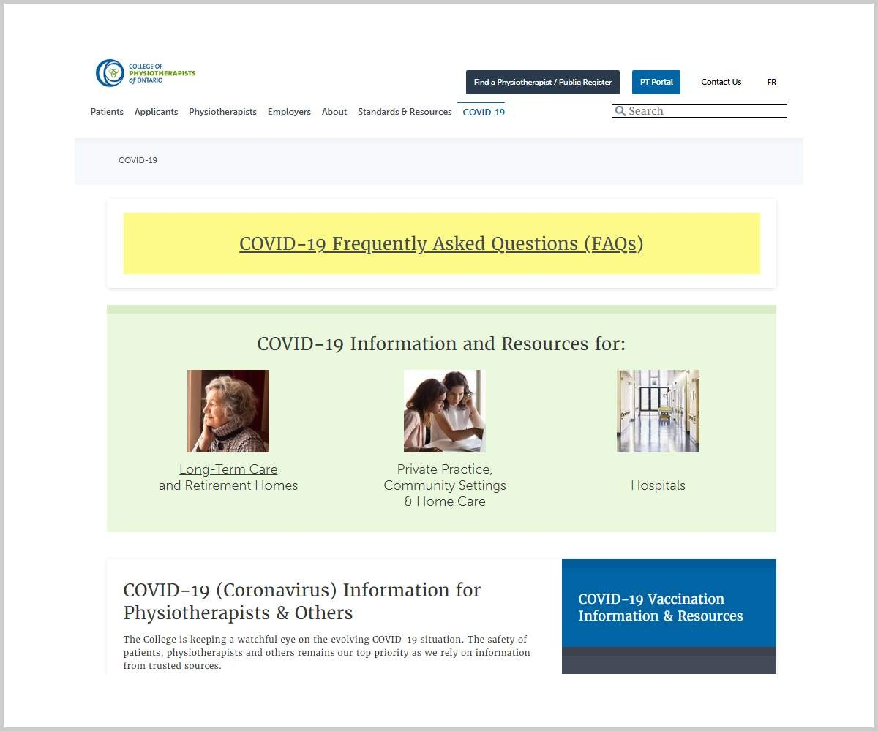

College Information and Resources
The COVID-19 pandemic was a strong focus for College communication and initiatives this past year. Information has evolved since we entered the ﬁrst lockdown in March 2020 and physiotherapists,

employers, patients and other stakeholders have regularly looked to the College for information and resources.

The College worked alongside the Ministry of Health, Public Health Ontario, local public health units and other organizations to deliver guidance to physiotherapists, employers, patients and others quickly and eﬃciently.

Here is a snapshot of our COVID related communications and initiatives over the past year. (Click on the tabs to reveal more details).

R ESO U R C ES F O R PHY SIO THER A PISTS | R ESO U R C ES F O R PATIEN TS | R ESO U R C ES F O R EM PL O Y ER S
Email Updates

Sector-speciﬁc COVID pages

- Private Practice, Community Settings and Home Care

- Long-Term Care and Retirement Homes

- Hospitals

- PTs Working in Schools

Additional COVID webpages

- Infection Prevention and Control

- Personal Protective Equipment (PPE)

- Free Resources and Training

- Mental Health Resources

Vaccination Information

- Dedicated webpage with information and resources

- Emails sent on behalf of Public Health Units across the province to advise of eligibility COVID Frequently Asked Questions (FAQs)

R ESO U R C ES F O R PHY SIO THER A PISTS | R ESO U R C ES F O R PATIEN TS | R ESO U R C ES F O R EM PL O Y ER S
Dedicated webpage Frequently Asked Questions
Information about Virtual Physiotherapy

Mental Health Resources

R ESO U R C ES F O R PHY SIO THER A PISTS | R ESO U R C ES F O R PATIEN TS | R ESO U R C ES F O R EM PL O Y ER S
Dedicated webpage Frequently Asked Questions Return to Work Guidance Mental Health Resources

Visit the COLLEGE WEBSITE: COVID-19 Information and Resources

COVID-19 Information and Resources

Return to Work Guidance for Physiotherapists and PT Employers

When the Ministry of Health started easing restrictions to allow regulated health professionals to slowly and safely return to practice, the College developed guidance and resources for physiotherapists who were re-opening their practices or returning to work.

The return-to-work guidance was prepared based on information and resources from the Ministry of Health and Public Health Ontario, and in collaboration with other health care regulators — the Colleges of Kinesiologists, Massage Therapists, and Occupational Therapists.

Return to Work Guidance

Virtual Practice

Throughout the pandemic the Ministry of Health continued to recommend virtual practice as the preferred option for regulated health professionals whenever possible. Many physiotherapists started moving toward virtual practice. The College developed guidance for physiotherapists about virtual care that highlighted the existing standards as well as special considerations for privacy, technology and patient safety. We will continue to seek ways that we can expand upon and improve the guidance for delivering virtual care.

Virtual Practice

Webinar: COVID-19 Infection Prevention and Control for Regulated Health Professionals
We partnered with the Colleges of Kinesiologists, Massage Therapists and Occupational Therapists, as well as Public Health Ontario to provide a comprehensive look at best practices in infection prevention and control during COVID. The webinar and sup porting resources are available on our website.

E-LEARNING MODULES:
Bringing the Standards to Life

This year we focused our attention on creating an e-learning module covering an issue that generates a lot of questions from physiotherapists: boundaries. This interactive e-learning module is available to everyone and is a great tool for new and experienced PTs, students, employers and physiotherapist assistants. It uses tangible examples and real-life scenarios to build on the requirements of the standard and resources.

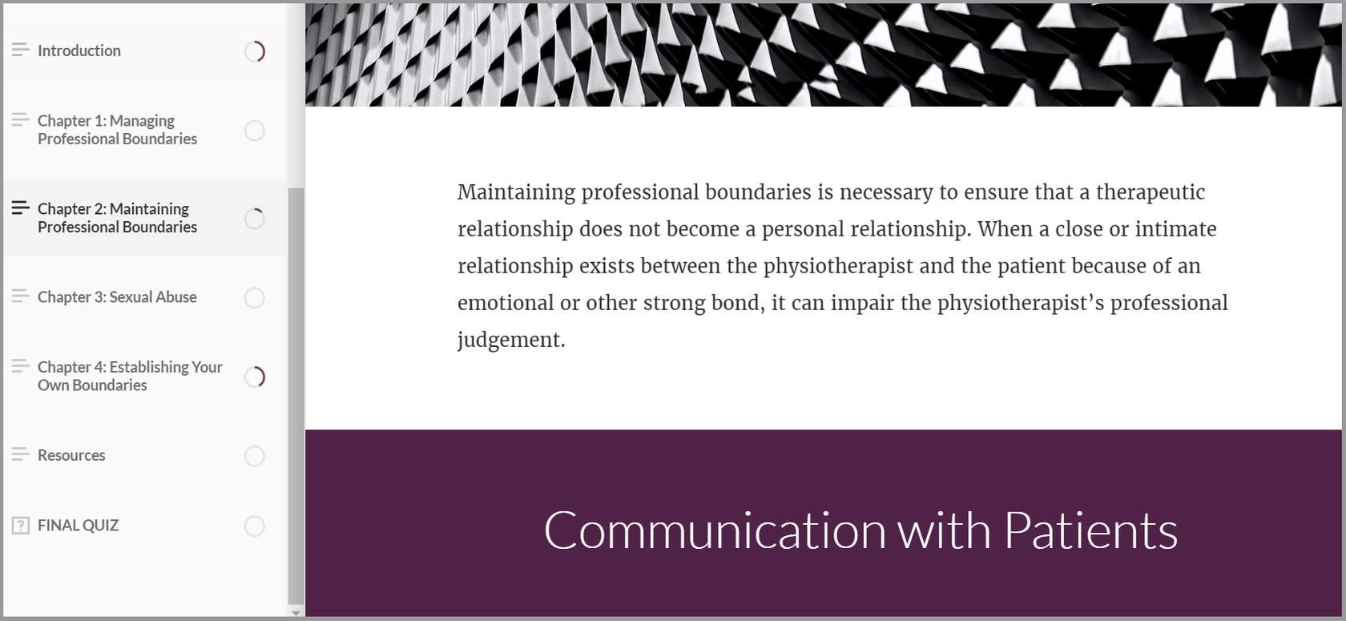

Review the new e-learning module: Boundaries and Sexual Abuse Standard E- Learning Module

We are pleased to offer e-learning modules in English, French and audio formats to make them accessible to the widest possible audience.

QUALITY ASSURANCE: New Program Launch

In accordance with the Regulated Health Professions Act (RHPA), the College is required to have a Quality Assurance program designed to promote continuing competence and quality improvement among physiotherapists in Ontario.

Over the past couple years, we have worked to redevelop our Quality Assurance program including conducting extensive research and a comprehensive pilot program to test the new assessment process. The new Quality Assurance program oﬃcially launched in January 2021 as the ﬁrst group of eligible physiotherapists were selected for a screening interview.

About the Screening Interview
The screening interview is a one-hour remote session between a physiotherapist and a College assessor. The screening interview is a part of the College’s Quality Assurance program and one way the College ensures physiotherapists are providing safe, competent and ethical care. Every physiotherapist will complete a screening interview every seven to ten years.

Following the screening interview, the assessor completes a scored report that is submitted to the College. If the College needs more information about how the physiotherapist applies knowledge of the rules and standards to their practice, the PT will be asked to complete an on-site assessment.

About the On-Site Assessment

The on-site assessment provides a comprehensive look at a physiotherapist’s practice. The on-site assessment is conducted by a College assessor. It is approximately four hours long and is meant to take place at the location where the physiotherapist delivers the most patient care.

Physiotherapists whose screening interview results indicate that the College requires more information about their practice will be required to complete the on-site assessment. The College estimates that ﬁve to 10 percent of physiotherapists who complete the screening interview will also complete the on- site assessment.

Due to the pandemic, only one complete on-site assessment and three modiﬁed versions of the on-site assessment were carried out in the past year. The College is monitoring the pandemic and will ensure the safety of physiotherapists and assessors when on-site assessments begin.

Learn more about the new assessment process:

Screening Interview On-Site Assessment

The Screening Interview: In Their Own Words

“I felt immediately at ease with the assessor. I felt that they were really neutral, non-judgmental and very professional. The assessor seemed to really listen to all

of my answers, and they were quite mindful to stay into the time allowed for the interview.”
- Physiotherapist

“The variety of questions challenged me to think about my overall practice and reminded me that there is a lot more to keep in mind than just clinical.”
- Physiotherapist

“The instructions were clear, and I found the YouTube videos helpful. I also liked the completion timeline summary.”
- Physiotherapist

“My assessor was very professional yet personable throughout the process. Their communication skills both via email and via ZOOM were excellent (clear, concise, courteous). I was quite nervous, and the assessor made me feel at ease. They did a good job at re-directing me when needed and refocused me in a very respectful manner.”
- Physiotherapist

“I’m a new assessor for the QA program and am really enjoying participating in the screening interview. I believe it is a fair process that is not meant to be stressful. With the core questions provided in advance, the whole process is very much about self-reﬂection.
The PTs share stories that answer these core questions with the goal of stimulating thoughtful reﬂection about their practice. I feel this QA process is another

mechanism that supports lifelong learning, and I am pleased to be a part of it.”
- College Assessor

COMMUNITY OUTREACH

Although we were unable to meet with community partners in person, the College’s Practice Advice team continued to conduct virtual sessions with physiotherapy schools and other organizations to chat about the role of the College and the standards of practice.

This year the Practice Advisor participated in virtual sessions with:

PTA Program at Conestoga College
1

McMaster University
2

The Ontario Internationally Educated Physical Therapy Bridging Program
3

Queen’s University
4

University of Ottawa
5

University of Toronto
6

Western University
7

CONTI NUE

Page 5 of 8

Financial Statements
College of Physiotherapists of Ontario

Annual Report (April 1, 2020 to March 31, 2021)

Contact the College

The ﬁnancial statements are available for viewing or downloading.

For a complete set of audited ﬁnancial statements or an accessible format of the ﬁnancial statements, contact Zoe Robinson, Director, Corporate Services at zrobinson@collegept.org
or 1-800-583-5885 ext. 244.

View the College of Physiotherapists of Ontario Financial Statements

College of Physiotherapists of Ontario Financial Statements 2021.pdf
484.7 KB

CONTI NUE

Page 6 of 8

Program Review
College of Physiotherapists of Ontario

Practice Advice

Information Service
Patients, caregivers, physiotherapists, students, assistants, employers, insurers, and others can contact the College for conﬁdential advice about the practice of physiotherapy. This service is offered to support quality of practice and to help the public better understand their rights as physiotherapy patients.

Watch our Video: What is a Physiotherapy Information Advisor?

Practice Advice Team
In 2020-2021 the number of inquiries to the Advice Team was 7885. This represents an almost 30% increase in the volume of College inquiries from the previous year.

An increasing number of PT employers contacted the College over the past year.

Percentage of Calls

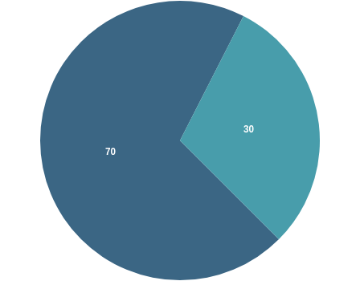

PTs

Public, Insurers & Employers

The percentage number of calls from PTs was 70% while 30% was from patients, insurers, public and others.

There is an increasing numbers of PT employers (25%) who contacted the College in Q4 2021. This is a new trend and the impact likely came from the intentional outreach to this group.

Breakdown of Practice Advice Calls and Emails

 | 2019–2020 | 2020–2021
Q1 | 1,300 | 2,835
Q2 | 1,370 | 1,725

Q3 | 1,250 | 1,625
Q4 | 2,200 | 1,700
TOTAL | 6,120 | 7,885

Top Five Practice Advice Themes in 2020- 2021

The top themes helped the College develop timely educational resources for all stakeholders.

Infection Control requirements to use in a PT’s practice (PPE, screening, environmental cleaning) related to the COVID-19 pandemic. Advisors assisted PTs/employers/public to locate relevant Ministry and Public Health Ontario documents to inform practice.
1

Business Practices (billing, marketing, starting and leaving a PT practice).
2

Patient Care (scope issues, expectations for performing controlled acts through delegation, or to clarify education requirements to roster with the College)
3

Privacy, security and conﬁdentiality of personal health information.
4

Supervision requirements of PTAs, PT Residents and students
5

Environmental Updates
Updates and trends are gathered from regular meetings with insurers, Ministry representatives, other advisors across Ontario and Canada. We hear about billing or practice concerns, emerging issues or changes to care models. The information assists the College to remain current and respond to environmental changes.

CONTI NUE

Registration

The College is responsible for ensuring individuals applying to become registered physiotherapists in Ontario are qualiﬁed. Those who use the titles physiotherapist, physical therapist or PT in Ontario must be registered with the College. To maintain a registration or licence, physiotherapists must renew annually.

In 2020-2021, there were 10,514 registrants, of those, 577 were new.

New Registrants
There were 577 new registrants in 2020- 2021,
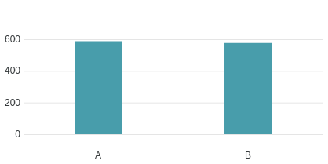
compared to 588 new registrants in 2019- 2020.
Number of Registrants

Year

A. 2019-2020 | 588

B. 2020-2021 | 577

Total Registrants
There were 10,544 total registrants in 2020- 2021,
compared to 10,061 total registrants in 2019-2020.

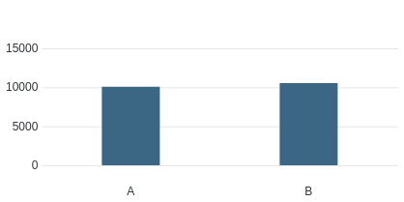

Year
Number of Registrants

A. 2019-2020 | 10061

B. 2020-2021 | 10544

Top Five Source Countries for International Graduates

India: 1352

United Kingdom: 192

United States of America: 307 Philippines: 188
Australia: 156

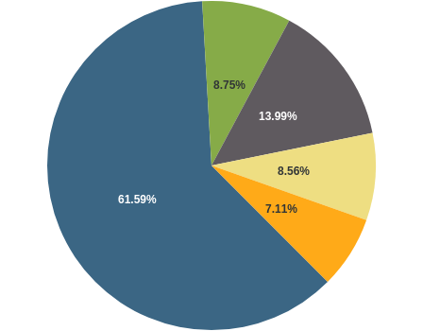
Gender Breakdown of Registrants

Gender | Registrants
Female | 7504
Male | 3036
X | 4

Registrant Education

There were 7,433 registrants educated in Canada and 3,111 educated outside of Canada.

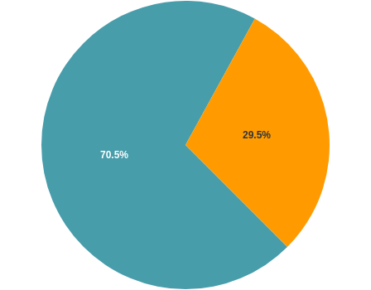

Educated in Canada Educated Outside of Canada

Canadian Labour Mobility (AIT)
42 individuals registered in Ontario using the Canadian Free Trade Agreement (CFTA)

provisions
between April 1, 2020 to March 31, 2021.

Registration Committee Decisions

 | 2019–2020 | 2020–2021
Total Number of Decisions | 14 | 10
Certiﬁcates Granted | 3 | 0
Certiﬁcate of Registration Granted with Additional Terms, Conditions and Limitations | 5 | 2
Certiﬁcates Denied | 6 | 8

There was 2 appeals of a Registration Committee Decision to the

Health Professions Appeal and Review Board (HPARB), which are ongoing.

CONTI NUE

Quality Assurance

Due to the uncertainty around the start of the pandemic, the Quality Assurance Committee did not meet until June 2020. During the meetings of 2020, the Committee mainly considered case ﬁles that were part of the College’s pilot project to develop new quality assurance tools. Two meetings addressed cases from the earlier Quality Assurance program where the physiotherapist was completing the requirements of a Speciﬁed Continuing Education or Remediation Program.

The Committee reviewed the following issues identiﬁed during the on-site assessment:

Clinical reasoning
Use of evidence in practice
Adverse outcomes associated with use of controlled acts

Working with physiotherapist assistants Setting patient goals
Patient safety Treatment planning Assessments Conﬂict resolution
Equipment maintenance Record keeping Professional boundaries Consent
Privacy

Number of Matters Considered and Breakdown of Outcomes

2020–2021
Number of quality assurance ﬁles closed 13
following the screening interview
Number of physiotherapists referred to
participate in an on-site assessment 0
based on results of the screening
interviews

2020–2021
Number of on-site assessments
completed between April 1, 2020 – 4
March 31, 2021
Number of matters considered by the 27
QA Committee
Number of decisions issued by QA 26
Committee

CONTI NUE

Professional Conduct

The College of Physiotherapists of Ontario receives complaints and reports about the practice or conduct of physiotherapists. All complaints are investigated. The College Registrar may also initiate investigations where reported information suggests reasonable and probable grounds to believe a physiotherapist may have engaged in professional misconduct or is incompetent.

The results of investigations are considered by the Inquiries, Complaints and Reports Committee, which may take no action, order a range of educational or remedial activities, or refer a physiotherapist

to the Discipline Committee or Fitness to Practise Committee for a hearing.

The College also receives information about individuals who are not registered to practice but refer to themselves as physiotherapists or physical therapists (holding out).

Dispositions of the Inquiries, Complaints and Reports Committee
* Some decisions may include more than one outcome.

 | 2019–2020 | 2020–2021
Total Decisions | 81 | 63
No Action | 28 | 23
Advice and Recommendations | 22 | 7
Caution | 2 | 1
Speciﬁed Continuing Education and Remediation Program (SCERP) | 3 | 1
Referral to Discipline Committee | 6 | 6
Referral to Fitness to Practise Committee | 0 | 0
SCERP and Caution | 1 | 2

 | 2019–2020 | 2020–2021
Undertakings | 7 | 5
SCERP and Undertakings | 1 | 0
Frivolous and Vexatious | 7 | 18
Withdrawal | 2 | 0

Health Professions Appeal and Review Board (HPARB) Review Process (Complaints)

 | 2020–2021
Number of Cases Appealed to the Board | 14
Number of Decisions Received from HPARB | 16
Number of Decisions Conﬁrmed by HPARB | 14
Number of Decisions Returned for Reconsideration | 1
Number Withdrawn | 1

Hearings

 | 2020–2021
Number of Hearings | 8
Uncontested Hearings | 6
Contested Hearings | 1
Hearings Adjourned Sine Die | 0
Discipline Hearings Completed | 7
Findings of Professional Misconduct | 7
Fitness of Practise Hearings | 0
Findings of Incapacity | 0
Reinstatement of Hearings | 0

Divisional Court Reviews

 | 2020-2021
Divisional Court Reviews | 1

CONTI NUE

Patient Relations

The role of the Patient Relations Committee is to advise Council with respect to the patient relations program and to administer the program to provide funding for therapy and counselling to patients. The Committee is made up of two professional Council members, one public Council member and one member who is a physiotherapist registered with the College.

Funding for Therapy and Counselling
The College maintains a program to provide funding for therapy and/or counselling for individuals who have been sexually abused by a physiotherapist. Individuals can submit an application for funding to the College, and the applications are reviewed by the Patient Relations Committee.

The Patient Relations Committee met once to consider two applications for therapy.
Both applications were approved.

CONTI NUE

Page 7 of 8

Discipline Summaries 2020-2021
College of Physiotherapists of Ontario

Discipline Hearings
(April 1, 2020 to March 31, 2021)

In 2020–2021 there were 8 Discipline Hearings that took place at the College of Physiotherapists of Ontario.

See a complete list of past Discipline Hearings and decisions by visiting CanLII.org or

www.collegept.org.

Be sure to visit the College’s Public Register, also known as Find a Physiotherapist to access important information before visiting a physiotherapist. All regulated health care providers have a similar Public Register on their College’s website. See a complete list of Public Registers at ontariohealthregulators.ca

 Please click on the name below to view the Discipline hearing details.

Bird, Jeff—Registration #09136 Case: 2019 0083 –

On November 5, 2019 the Inquiries, Complaints and Reports Committee (ICRC) referred a matter involving Jeff Bird to the Discipline Committee for a hearing.

The hearing took place on May 11, 2020. This matter was resolved by way of an Agreed Statement of Facts and a Joint Submission on Penalty.

Finding

The Discipline Committee issued a decision on the ﬁnding on May 11, 2020, on penalty on May 11, 2020 and on costs on May 11, 2020.

After having considered all of the evidence, a panel of the Discipline Committee found Jeff Bird to have committed the following acts of professional misconduct:
Paragraph 2 (Reg 861/93) and Paragraph 1 (Reg 388/08) (failing to maintain the standards of the profession);
Paragraph 25 (Reg 861/93) and Paragraph 18 (Reg 388/08)(engaging in conduct or performing an act relevant to the practice of the profession that, having regard to all the circumstances, would reasonably be regarded by Registrants as disgraceful, dishonourable or unprofessional);

Penalty

The panel of the Discipline Committee ordered the following penalty. That Mr. Bird: Receive a reprimand at the conclusion of the hearing (delivered on May 11, 2020)
Serve a suspension for the period of May 12, 2020 through to an including August 11, 2020. The suspension could be extended if Mr. Bird is unable to complete the remaining requirements
Complete a review of various College standards, tools and resources Meet with a practice coach on no more than four occasions Successfully complete the PROBE program
Practice as a PTA during his suspension only under the supervision of an approved registered member of the College who is a physiotherapist in Mr. Bird’s practice location

The Committee also ordered Jeff Bird to pay costs to the College in the amount of $3,400 to offset some of the costs associated with investigating and prosecuting this case.

As a part of the penalty the Committee also issued a reprimand which read as follows:

Mr. Bird, the panel has found that you engaged in professional misconduct. And, by doing so, you have adversely affected the reputation of the physiotherapy profession. Your actions harmed an individual, and actions such as those undermine the public conﬁdence in physiotherapists.

While acknowledging the remorse that you expressed through your counsel, the ﬁndings of professional misconduct are serious. We expect that the remediation activities that have been ordered will allow you a much higher level of insight in regards to the issues that brought you before the Discipline Committee today. We further expect that when you resume practice as a physiotherapist, you are acutely aware of boundary issues in all interactions with patients.

Status

The physiotherapist is working on completing the following requirements of the order as outlined by the panel of the Discipline Committee:
The suspension

The review of the College standards, tools and resources The meetings with the practice coach
The PROBE program

You can read the full decision of the Discipline Committee of the College of Physiotherapists of Ontario at: www.canlii.org.

Luff, Noshin—Registration #13269 Case: 2018 0059 and 2019 0090 –
On March 10, 2020 the Inquiries, Complaints and Reports Committee (ICRC) referred a matter involving Noshin Luff to the Discipline Committee for a hearing.

The hearing took place on May 19, 2020. This matter was resolved by way of an Agreed Statement of Facts and a Joint Submission on Penalty.

Finding

The Discipline Committee issued a decision on the ﬁnding on May 19, 2020, on penalty on May 19, 2020 and on costs on May 19, 2020.

After having considered all of the evidence, a panel of the Discipline Committee found Noshin Luff to have committed the following acts of professional misconduct:
Paragraph 1 (failing to maintain the standards of practice of the profession),

Paragraph 18 (engaging in conduct or performing an act relevant to the practice of the profession that, having regard to all the circumstances, would reasonably be regarded by members as

disgraceful, dishonourable or unprofessional),

Paragraph 26 (failing to keep records in accordance with the standards of practice of the profession),
Paragraph 27 (falsifying a record),

Paragraph 28 (signing or issuing a document containing a statement that the member knows or ought to know is false or misleading),
Paragraph 32 (submitting an account or charge for services that the member knows or ought to know is false or misleading),
Paragraph 33 (failing to take reasonable steps to ensure that any accounts submitted in the member's name or billing number are fair and accurate,
Paragraph 40 (continuing the treatment of a patient where it is no longer indicated, has ceased to be effective or is unnecessary); and
Paragraph 41 (failing to supervise in accordance with the standards of practice of the profession)

Penalty

The panel of the Discipline Committee ordered the following penalty. That Ms. Luff: Receive a reprimand at the conclusion of the hearing (delivered on May 19, 2020)
Serve a suspension for the period of May 20, 2020 through to an including November 19, 2020. The suspension could be extended if Ms. Luff is unable to complete the remaining requirements
Complete a review of various College standards, tools and resources Meet with a practice coach on four occasions
Successfully complete the PROBE program

Practice as a PTA during her suspension only under the supervision of an approved registered member of the College who is a full-time physiotherapist in Ms. Luff’s practice location

The Committee also ordered Noshin Luff to pay costs to the College in the amount of $2,000 to offset some of the costs associated with investigating and prosecuting this case.

As a part of the penalty the Committee also issued a reprimand which read as follows:

The panel ﬁnds that your conduct during this period has been unprofessional. As a physiotherapist, it is imperative for you to understand your role as an autonomous professional to ensure public safety by knowing and adhering to the standards of your profession.

While we acknowledge the remorse that you express today, the ﬁndings of professional misconduct are serious. It is the panel’s hope that the penalties imposed will be followed and will provide you with an

opportunity to reﬂect on the behaviour that has brought you before us today. The panel has provided you with an opportunity to correct your behaviours and return to the profession. We hope that you will use this as a learning experience.

Please remember that although the College is here to protect the public and uphold the standards of the profession, it is also here to support its members. We encourage you to use the resources available to you as a registered professional. The panel does not expect to see you before us again.

Status

The physiotherapist is working on completing the following requirements of the order as outlined by the panel of the Discipline Committee:
The suspension

The review of the College standards, tools and resources The meetings with the practice coach
The PROBE program

You can read the full decision of the Discipline Committee of the College of Physiotherapists of Ontario at: www.canlii.org.

Luo, Feng—Registration #11753 Case: 2016-0175 and 2019-0166 –
On December 11, 2019 the Inquiries, Complaints and Reports Committee (ICRC) referred a matter involving Feng Luo to the Discipline Committee for a hearing.

The hearing took place on July 3, 2020. This matter was resolved by way of an Agreed Statement of Facts and a Joint Submission on Penalty.

Finding

The Discipline Committee issued a decision on the ﬁnding on July 3, 2020, on penalty on July 3, 2020 and on costs on July 3, 2020.

After having considered all of the evidence, a panel of the Discipline Committee found Feng Luo to have committed the following acts of professional misconduct:
Paragraph 1 (Reg 388/08) (failing to maintain the standards of the profession);

Paragraph 18 (Reg 388/08) (engaging in conduct or performing an act relevant to the practice of the profession that, having regard to all the circumstances, would reasonably be regarded by Registrants as disgraceful, dishonourable or unprofessional);
Paragraph 26 (Reg 388/08) (failing to keep records in accordance with the standards of practice of the profession);
Paragraph 28 (Reg 388/08) (signing or issuing a document that the Registrant knows or ought to know contains a false or misleading statement);
Paragraph 32 (Reg 388/08) (submitting an account or charge for services that the Registrant knows or ought to know is false or misleading);
Paragraph 40 (Reg 388/08) (continuing the treatment of a patient where it is no longer indicated, has ceased to be effective or is unnecessary)

Penalty

The panel of the Discipline Committee ordered the following penalty, that Feng Luo: Receive a reprimand at the conclusion of the hearing (delivered on July 3, 2020)
Serve a suspension for the period of July 4, 2020 through to and including February 4, 2021. The suspension could be extended if Feng Luo is unable to complete the remaining requirements
Complete a review of various College standards, tools and resources

Comply with the terms and conditions of the Acknowledgement & Undertaking (see below) Meet with a practice coach on no more than eight occasions
Submit to random spot audits/inspections for a two-year period following his return to practice

Practice as a PTA only under the supervision of a pre-approved, registered member of the College who is a full-time physiotherapist in the Registrant’s practice location

The Committee also ordered Feng Luo to pay costs to the College in the amount of $8,000 to offset some of the costs associated with investigating and prosecuting this case.

Terms of the Undertaking

Feng Luo agreed to the following:

Feng Luo acknowledged and accepted that the “art of symmetry” approach does not constitute physiotherapy, does not fall within the scope of practice of physiotherapy, and cannot be promoted, represented, described, referred to as, or otherwise billed or invoiced as physiotherapy assessments, treatments or services;

Feng Luo undertook to practice only physiotherapy, within the scope of practice deﬁned in the

Physiotherapy Act, at his two practice locations, as set out below, and at any other practice location where he may provide or otherwise promote myself as providing, physiotherapy services:
Oakville, Ontario: 1545 Cornwall Road, Unit 39, Oakville, Ontario L6J 0B2 Markham Ontario: 8392 Kennedy Road, Unit 2, Markham, Ontario L3R 9W5

Feng Luo agreed to not practice the “art of symmetry” approach at the above clinic locations or at any other clinic or site where he is providing, or representing that he is providing, physiotherapy treatments or services.

Feng Luo voluntarily agreed to change the business and operating name of his clinic(s) (the “Clinic”) where he will be practicing physiotherapy, as well as all promotional materials for his Clinic, including exterior and interior signage, business cards and any other promotional materials, and will not refer to “AOS” or “Art of Symmetry” in the new Clinic name or promotional materials. Feng Luo will effect these changes to the Clinic name and promotional materials by no later than February 4, 2021.

As a part of the penalty the Committee also issued a reprimand which read as follows:

The panel has found that your behaviour failed to maintain the standards of practice of the profession and wishes to comment on those elements. Had it not been a joint submission by you and the College, this panel would have imposed a much stricter penalty. The number of ways in which you did not adhere to the standards is concerning. It is troubling to us that you, as a licenced physiotherapist in Ontario, failed to practise physiotherapy within the scope as directed by the College of Physiotherapists of Ontario.

We trust that the order imposed will ensure that your practice will meet all the standards of the profession. There is an inherent danger to the public by performing unveriﬁed treatment techniques and in doing so, while holding oneself out as a physiotherapist, degrades the profession in the eyes of the public. To be clear, that should you appear before a disciplinary panel in the future, this proceeding will weigh heavily on the penalty consideration at that time.

Status

The physiotherapist is working on completing the following requirements of the order as outlined by the panel of the Discipline Committee:
The suspension

The review of the College standards, tools and resources The meetings with the practice coach
The spot audits

The requirements of the Undertaking

You can read the full decision of the Discipline Committee of the College of Physiotherapists of Ontario at: www.canlii.org.

Pillai, Sanu Gopinathan—Registration #17374 Case: 2018 0043 –
On October 11, 2018 the Inquiries, Complaints and Reports Committee (ICRC) referred a matter involving Sanu Gopinathan Pillai to the Discipline Committee for a hearing. The hearing took place on June 18–20, 2019.

The panel of the Discipline Committee conﬁrmed its decision on the ﬁnding on April 30, 2020 and the Order was released on May 28, 2020. The decision and reasons on ﬁnding and the Order were released on May 28, 2020.

After having considered all of the evidence, the panel found Sanu Gopinathan Pillai to have committed the following acts of professional misconduct under section 1 of the Professional Misconduct Regulation, O. Reg. 388/08:
paragraph 1 (failing to maintain the standards of practice of the profession); paragraph 10 (sexual abuse of a patient);
paragraph 18 (engaging in conduct or performing an act relevant to the practice of the profession that, having regard to all the circumstances, would reasonably be regarded by members as disgraceful, dishonourable or unprofessional); and
paragraph 19 (conduct unbecoming a physiotherapist)

The panel also found Sanu Gopinathan Pillai to have engaged in sexual abuse of a patient as deﬁned under ss. 1(3), 1(4) and s.51(1)(b.1) of the Health Professions Procedural Code, which is Schedule 2 to the Regulated Health Professions Act, 1991, S.O. 1991, c.18 (the "Code").

The panel issued an interim order on May 28, 2020 suspending Sanu Gopinathan Pillai’s certiﬁcate of registration until such time as the panel makes an order with respect to penalty.

Penalty

The panel of the Discipline Committee reconvened on August 20, 2020 for a penalty hearing. This hearing proceeded by way of a Joint Submission on Penalty and Cost. The panel conﬁrmed its decision on penalty and decision on costs on August 20, 2020.

The panel of the Discipline Committee ordered the following penalty, that Sanu Gopinathan Pillai: Receive a reprimand at the conclusion of the hearing (delivered on August 20, 2020)
Serve a suspension for the period of May 29, 2020 - August 29, 2021. The suspension could be extended if Sanu Gopinathan Pillai is unable to complete the remaining requirements

Successfully complete (having received an unconditional pass) the ProBe ethics program offered through the CPEP Attend one-on-one coaching sessions with a consultant selected by the College
Complete a review of various College, standards, tools and resources

Sanu Gopinathan Pillai may not supervise physiotherapy students and/or PTA students and will not be eligible to be considered by the Registrar to be a practice supervisor for a physiotherapist who holds a provisional practice certiﬁcate of registration until all of the terms of the Order have been met and the registrant has practiced for a period of ﬁve years from the date of his return to practice without being the subject of any new concerns reported to the College.
Practice as a PTA only under the supervision of a pre-approved, registrant of the College who is a full-time physiotherapist in the registrant’s practice location. The practice location may only be either a hospital or a practice location owned by a regulated health care provider.

The Committee ordered Sanu Gopinathan Pillai to pay costs to the College in the amount of $15,000 to offset some of the costs associated with investigating and prosecuting this case.

The Committee also ordered Sanu Pillai to pay $5,000 into the College’s fund for therapy and counselling As a part of the penalty the Committee also issued a reprimand which read as follows:
Let me begin by saying that this panel takes matters of this nature very seriously. The physiotherapist- patient relationship is one that is based on trust. Preserving this trust and protecting members of the public is our paramount duty. Your actions in this matter have undermined these important and fundamental tenets of the profession.

The panel acknowledges your representation and comments today. We accept them as genuine and self- reﬂective. We equally acknowledge your acceptance of your behaviours and actions and your willingness to take steps to ensure that they do not happen again.

As a result, this panel accepts the joint submission on penalty, and it is our hope and expectation that you will undertake the steps outlined in the submission with a desire to ultimately understand and improve as a professional physiotherapist. It is our sincere hope that you will return to the profession with a renewed approach to being a physiotherapist, have good patient relationships and that you will not again repeat the behaviours that have brought you before this panel today.

You can read the full decision of the Discipline Committee of the College of Physiotherapists of Ontario at: www.canlii.org.

Nogourani, Kamran Sadeghi—Registration #11445 Case: 2017 0239 –

On January 20, 2020 the Inquiries, Complaints and Reports Committee (ICRC) referred a matter involving Kamran Sadeghi Nogourani to the Discipline Committee for a hearing.

The hearing took place on January 13, 2021. This matter was resolved by way of an Agreed Statement of Facts and a Joint Submission on Penalty.

Finding

The Discipline Committee issued a decision on the ﬁnding on January 13, 2021, on penalty on January 13, 2021 and on costs on January 13, 2021.

After having considered all of the evidence, a panel of the Discipline Committee found Kamran Sadeghi Nogourani to have committed the following acts of professional misconduct:
Paragraph 1 (failing to maintain the standards of practice of the profession),

Paragraph 18 (engaging in conduct or performing an act relevant to the practice of the profession that, having regard to all the circumstances, would reasonably be regarded by members as disgraceful, dishonourable or unprofessional),
Paragraph 26 (failing to keep records in accordance with the standards of practice of the profession),
Paragraph 27 (falsifying a record),

Paragraph 28 (signing or issuing a document containing a statement that the member knows or ought to know is false or misleading),
Paragraph 32 (submitting an account or charge for services that the member knows or ought to know is false or misleading),
Paragraph 33 (failing to take reasonable steps to ensure that any accounts submitted in the member's name or billing number are fair and accurate,
Paragraph 40 (continuing the treatment of a patient where it is no longer indicated, has ceased to be effective or is unnecessary); and
Paragraph 41 (failing to supervise in accordance with the standards of practice of the profession)

Penalty

The panel of the Discipline Committee ordered the following penalty. That Kamran Sadeghi Nogourani: Receive a reprimand at the conclusion of the hearing (delivered on January 13, 2021)
Serve a suspension for the period of January 14, 2021 through to and including August 14, 2021. The suspension could be extended if they are unable to complete certain requirements.
Complete a review of various College, standards, tools and resources.

Meet with a practice coach on no more than eight occasions.

May not supervise physiotherapy students, PTA students or registrants of the profession who hold a provisional practice certiﬁcate of registration during the coaching period.
Successfully complete the ProBe program.

Practice as a PTA during their suspension only under the supervision of an approved, registered member of the College who is a physiotherapist in their practice location. This location must be owned by a regulated health professional.

The Committee also ordered Kamran Sadeghi Nogourani to pay costs to the College in the amount of
$4,000 to offset some of the costs associated with investigating and prosecuting this case. As a part of the penalty the Committee also issued a reprimand which read as follows:
The panel has found that your behaviour constituted professional misconduct and wishes to comment on four speciﬁc elements.

Firstly, it was viewed by this panel that your behaviour reﬂects negatively on the profession. We strongly emphasize that your professional obligations demand that you maintain proper billing and record keeping practices.

Secondly, the College has a zero-tolerance policy on inappropriate billing practices and as a member of this profession, you are required to adhere to our College’s professional standards. The lack of oversight on the invoicing process in inadequate recordkeeping could give the impression of falsiﬁed and/or fraudulent behaviour. The panel wishes to reinforce the importance of maintaining the standards.

Third, the panel wants to highlight that this is a recurring behaviour on your part over the years. Based on the prior history with the Inquiries, Complaints and Reports Committee in 2006, this panel found that you previously were made aware of similar shortcomings; therefore, you should have been able to avoid being in this setting today.

Finally, although you were not the clinic owner related to these allegations, it is a serious concern for this panel that you are a business owner of another practice and did not appear to have a full understanding of the obligations for billing and record keeping practices. In light of the joint submission and cooperation on your part, it is hope that you will take the learnings from this case and transfer them to your practice in all settings.

Should you appear before a disciplinary panel for similar behaviour in the future, this proceeding will weigh heavily on penalty consideration at that time.

You can read the full decision of the Discipline Committee of the College of Physiotherapists of Ontario at: www.canlii.org.

Selvaraj, Satish Kumar—Registration #16720 Case: 2019 0172 –
On May 22, 2020 the Inquiries, Complaints and Reports Committee (ICRC) referred a matter involving Satish Kumar Selvaraj to the Discipline Committee for a hearing.

The hearing took place on January 22, 2021. This matter was resolved by way of an Agreed Statement of Facts and a Joint Submission on Penalty.

Finding

The Discipline Committee issued a decision on the ﬁnding on January 22, 2021, on penalty on January 22, 2021 and on costs on January 22, 2021.

After having considered all of the evidence, a panel of the Discipline Committee found Satish Kumar Selvaraj to have committed the following acts of professional misconduct:
paragraph 1 (failing to maintain the standards of practice of the profession);

paragraph 18 (engaging in conduct or performing an act relevant to the practice of the profession that, having regard to all the circumstances, would reasonably be regarded by members as disgraceful, dishonourable or unprofessional);
paragraph 26 (failing to keep records in accordance with the standards of practice of the profession);
paragraph 27 (falsifying a record);

paragraph 28 (signing or issuing a document containing a statement that the member knows or ought to know is false or misleading);
paragraph 32 (submitting an account or charge for services that the member knows or ought to know is false or misleading);
paragraph 33 (failing to take reasonable steps to ensure that any accounts submitted in the member's name or billing number are fair and accurate); and
paragraph 41 (failing to supervise in accordance with the standards of practice of the profession).

Penalty

The panel of the Discipline Committee ordered the following penalty. That Satish Kumar Selvaraj: Receive a reprimand at the conclusion of the hearing (delivered on January 22, 2021)
Serve a suspension for the period of January 23, 2021 through to and including August 23, 2021. The suspension could be extended if they are unable to complete certain requirements.

Complete a review of various College, standards, tools and resources. Meet with a practice coach on no more than eight occasions.
May not supervise physiotherapy students, PTA students or registrants of the profession who hold a provisional practice certiﬁcate of registration during the coaching period.
Successfully complete the ProBe program

Practice as a PTA during their suspension only under the supervision of an approved, registered member of the College who is a physiotherapist at their practice location. If this is in a private practice setting, this location must be owned by a regulated health professional.

The Committee also ordered Satish Kumar Selvaraj to pay costs to the College in the amount of $3,000 to offset some of the costs associated with investigating and prosecuting this case.

As a part of the penalty the Committee also issued a reprimand which read as follows:

The panel has found that your behaviour constituted professional misconduct and wish to comment on two speciﬁc elements. Firstly, it was viewed by this panel that your behaviour reﬂects negatively on your profession. We strongly emphasize that your professional obligations demand that you maintain proper billing and recordkeeping practices.

Secondly, the College has a zero-tolerance policy on inappropriate billing practices. And, as a member of this profession, you are required to adhere to our College’s professional standards. The lack of oversight on the invoicing process and the inadequate recordkeeping could give the impression of falsiﬁed and/or fraudulent behaviour. The panel wishes to reinforce the importance of maintaining the standards.

Finally, although you were not the business owner related to these allegations, it is a serious concern for this panel that you did not appear to have a full understanding of the obligations for billing and recordkeeping practices. In light of the joint submission and cooperation on your part, it is hoped that you will take the learnings from this case and transfer them to your practice in all settings.

Should you appear before a disciplinary panel for similar behaviour in the future, this proceeding will weigh heavily on penalty consideration at that time.

You can read the full decision of the Discipline Committee of the College of Physiotherapists of Ontario at: www.canlii.org.

Taddeo, Jason—Registration #12526 Case: 2017 0168 –
On December 10, 2018 the Inquiries, Complaints and Reports Committee (ICRC) referred a matter involving Jason Taddeo to the Discipline Committee for a hearing.

The hearing took place on February 24, 2021 and April 22, 2021. This matter was resolved by way of an Agreed Statement of Facts and a Joint Submission on Penalty.

Finding

The panel of the Discipline Committee issued a decision on the ﬁnding on April 22, 2021, on the penalty on April 22, 2021 and on costs on April 22, 2021.

After having considered all of the evidence, a panel of the Discipline Committee found Jason Taddeo to have committed the following acts of professional misconduct:
Paragraph 1 (Reg 388/08) failing to maintain the standards of the profession); Paragraph 27 (Reg 388/08) (falsifying a record);
Paragraph 28 (Reg 388/08) (signing or issuing a document that the Registrant knows or ought to know contains a false or misleading statement);
Paragraph 32 (Reg 388/08) (submitting an account or charge for services that the Registrant knows or ought to know is false or misleading);
Paragraph 18 (Reg 388/08) (engaging in conduct or performing an act relevant to the practice of the profession that, having regard to all the circumstances, would reasonably be regarded by Registrants as disgraceful, dishonourable or unprofessional

Penalty

The panel of the Discipline Committee ordered the following penalty. That Jason Taddeo: Receive a reprimand at the conclusion of the hearing (delivered on April 22, 2021).
Serve a suspension for the period of April 23, 2021 through to and including April 22, 2022. Complete a review of various College, standards, tools and resources.
Successfully complete the ProBe program.

Meet with a practice coach on no more than three occasions.

The physiotherapist shall not practice as a physiotherapist assistant (PTA) during the period of the served suspended.

The panel also ordered Jason Taddeo to pay costs to the College in the amount of $25,000 to offset some of the costs associated with investigating and prosecuting this case.

As a part of the penalty the Committee issued a reprimand which read as follows:

The panel ﬁnds that your behaviour constituted serious misconduct, and this sort of misconduct cannot be tolerated by the profession. The public interest depends on the integrity of the profession. Protecting the integrity of the profession depends on a zero-tolerance of inappropriate business practices. The submission of false statements on several occasions brings into question your honesty, integrity, and professionalism.

We trust that this experience will allow you to reﬂect on your actions and grow as a therapist. The panel would like to advise you that any further ﬁndings of misconduct could result in a more severe outcome than that which has been imposed here today. The panel does not expect to see you before us again.

You can read the full decision of the Discipline Committee of the College of Physiotherapists of Ontario at: www.canlii.org.

Ragheb, Usama Safwat Louis—Registration #18894 Case: 2019 0033 –
On January 23, 2020 the Inquiries, Complaints and Reports Committee (ICRC) referred a matter involving Usama Ragheb to the Discipline Committee for a hearing.

The hearing took place on March 31, 2021. This matter was resolved by way of an Agreed Statement of Facts and a Joint Submission on Penalty and Cost.

Finding

The Discipline Committee issued a decision on the ﬁnding on March 31, 2021, on penalty on March 31, 2021 and on costs on March 31, 2021.

After having considered all of the evidence, a panel of the Discipline Committee found Usama Ragheb to have committed the following acts of professional misconduct:
paragraph 1 (failing to maintain the standards of practice of the profession)

paragraph 18 (engaging in conduct or performing an act relevant to the practice of the profession that, having regard to all the circumstances, would reasonably be regarded by members as disgraceful, dishonourable or unprofessional)
paragraph 26 (failing to keep records in accordance with the standards of practice of the profession)

Penalty

The panel of the Discipline Committee ordered the following penalty. That Usama Ragheb: Receive a reprimand at the conclusion of the hearing (delivered on March 31, 2021).

Serve a suspension for the period of April 10, 2021 through to and including October 9, 2021. The suspension could be extended if they are unable to complete certain requirements.
Complete a review of various College, standards, tools and resources. Successfully complete the ProBe program.
Meet with a practice coach on no more than eight occasions.

The physiotherapist may not supervise physiotherapy students and/or physiotherapy assistant (PTA) students.
The physiotherapist may not be a practice supervisor for a physiotherapist who holds a provisional practice certiﬁcate of registration.
The physiotherapist may not provide physiotherapy services as a physiotherapist assistant (PTA) during the period that his certiﬁcate of registration is suspended.

The panel also ordered Usama Ragheb to pay costs to the College in the amount of $3,000 to offset some of the costs associated with investigating and prosecuting this case.

As a part of the penalty the Committee also issued a reprimand which read as follows:

The panel has found that you engaged in signiﬁcant professional misconduct, and by doing so, you have adversely affected the reputation of the physiotherapy profession.

Your conduct was unprofessional and lacked the required respect for patient boundaries, appropriate considerations when treating sensitive areas and, by your own admission, lacked appropriate consent. Your actions harmed an individual, and actions such as those undermine the public conﬁdence in physiotherapists.

Mr. Ragheb, while we acknowledge your statements today, the ﬁndings of professional misconduct are serious. It is the panel’s hope that your stated commitment to your remediation is followed through with and will result in a positive change to your practice.

We expect that when you resume your practice as a physiotherapist, you are acutely aware of your patient’s needs and always put the needs of your patient before your own. Further, we expect that you will never appear before a Discipline Committee panel again.

You can read the full decision of the Discipline Committee of the College of Physiotherapists of Ontario at: www.canlii.org.

CONTI NUE

Page 8 of 8

Contact the College

College of Physiotherapists of Ontario

College of Physiotherapists of Ontario 375 University Avenue, Suite 800 Toronto, Ontario M5G 2J5

www.collegept.org

Concerns or Complaints
1-800-583-5885 ext. 227
416-591-3828 ext. 227
investigations@collegept.org

Practice Advisor/Physiotherapy Information Advisors
1-800-583-5885 ext. 241
647-484-8800
advice@collegept.org

Registration & Renewal
1-800-583-5885 ext. 222
registration@collegept.org

Screening Interviews/On-site Assessments
1-800-583-5885 ext. 212
qualityassurance@collegept.org

Financial Statements
To request a copy of the audited ﬁnancial statements, please contact:

Zoe Robinson
Director of Corporate Services 1-800-583-5885 ext. 244
416-591-3828 ext. 244
zrobinson@collegept.org

www.collegept.org

Facebook | YouTube | Twitter | Linked In

