MEETING OF THE COUNCIL OF THE COLLEGE OF PHYSIOTHERAPISTS OF ONTARIO

MINUTES

October 22-23, 2020
College of Physiotherapist Boardroom & Virtually via Zoom

In-person Attendees: | Zoom Attendees: | Staff on Zoom:
Darryn Mandel, President Theresa Stevens, Vice President Jennifer Clifford, PT | Martin Bilodeau, PT Janet Law, PT  Tyrone Skanes, Public Sharee Mandel, PT  Sharon Switzer-McIntyre, PT Hervé Cavanagh, PT  Nitin Madhvani, Public Ronald Bourret, Public Katie Schulz, PT  Jesse Finn, Public Karen St. Jacques, PT  Regrets: Tom McAfee, Public (Oct 22 and 23, 2020) | Rod Hamilton, Registrar Justin Rafton  Olivia Kisil Barbara Hou  Recorder: Barbara Hou
Guests on zoom: Anastasia Newman Beth Bergman
Jim Wernham Daniel Negro Sue Grebe Angelo Karalekas Monica Clarke Gary Rehan Nicole Graham Richa Rehan
Antoinette Megens

 | October 22, 2020
1:00 PM | Welcome  D. Mandel, welcomed guests, Council members, and speakers for the Council education session.
Sexual Abuse Awareness Training
Joanne Birenbaum and Dr. Lori Haskell facilitated sexual abuse awareness training with councilors, committee members, and staff. Key concepts included sexual abuse, the neurobiology of sexual assault trauma, barriers in reporting sexual assault, and how complaints/cases are handled within the context of the criminal justice system and society as a whole.
Bias and Conflict of Interest
Elyse Sunshine and Lonny Rosen facilitated Conflict of Interest and Bias training. Key concepts included perceived v. real conflict, decision making responsibility of Council/Committee members
when fulfilling their fiduciary duties, and the duty of disclosure.

1.0  Motion | Approval of the Agenda  1.0  It was moved by S. Switzer-McIntyre and seconded by K. St. Jacques that:  The agenda be accepted as presented with the possibility for changes to the order of items to address time constraints.  Amendment to add Canadian Alliance of Physiotherapy Regulators (CAPR) clinical examination status update for discussion in-camera. Gary Rehan, CAPR Board representative advised confidential materials would be circulated ahead of that discussion.
 |  | CARRIED.
2.0  Motion | Approval of the Council Meeting Minutes of September 23, 2020 2.0  It was moved by R. Bourret and seconded by T. Skanes that:  the Council meeting minutes of September 23, 2020, be approved.
 |  | CARRIED.
3.0 | Registrar’s Report  R. Hamilton, Registrar provided a brief overview on two issues:  - the Registration Committee process for managing provisional practice requests from failed examination candidates and  - the College performance management framework (CPMF) that has nearly been finalized by the Ministry of Health  J. Rafton, Policy Manager, provided Council with more detail on the CPMF highlighting the key measurement domains and how the College might be expected to perform on them:  - System Partner  - Resources  - Information Management  - Regulatory Policies  - Suitability to Practice  - Measurement Reporting and Improvement  - Governance  Council would be provided the complete document once released by the Ministry of Health.
 | Meeting adjourned at 5:00 PM

 |  | October 23, 2020
9:00 AM | 4.0 | President’s Report  D.Mandel updated Council with an update on public member appointments. K. Kanji tendered his resignation as a Public Member. N. Madhvani was re-appointed. J. Finn and R. Bourret are next up for re-appointment as public members on Council.  D. Mandel also acknowledged Council will provide direction and guidance in response to CAPR related legal matter.
 | 5.0  Motion | By-law and Governance Review-Recommended changes 5.0  It was moved by T. Skanes and seconded by J. Clifford that: Council approve the by-laws and governance policies with the  Executive Committee’s recommended changes in principle with the  following amendments:  - Ensure consistency of terminology, spelling/grammar, and the non-classification of gender throughout the document;  1a. Change terminology from ‘pandemic’ to ‘public health crises’  - By-law Section 2.9 Membership in Associations: Remove reference requiring continued membership in CAPR.  - Governance Policy 7.6 Performance Review for Registrar: Annual performance review to be coordinated by the President and involve Executive Committee.  3a. Align new process in both the Governance policies re: ‘Registrar review policy’ and ‘Terms of Reference - Executive Committee’.  Staff will coordinate a legal review and consultation on the proposed changes.
 |  |  | CARRIED
 | 6.0  Motion | Motion to go in camera pursuant to section 7(2)(d) of the Health Professions Procedural Code  6.0  It was moved by T. Stevens and seconded by R. Bourret that:  Council move in-camera to discuss matters in keeping with Section 7(2)(d) of the Health Professions Procedural Code.  Council moved in camera at 12:00 p.m. and moved back into the public portion of the meeting at 1:15 p.m.
 |  |  | CARRIED.

Adjournment
It was moved by S. Mandel and H. Cavanagh that the meeting be adjourned.  The meeting was adjourned at 1:15 p.m. | CARRIED.

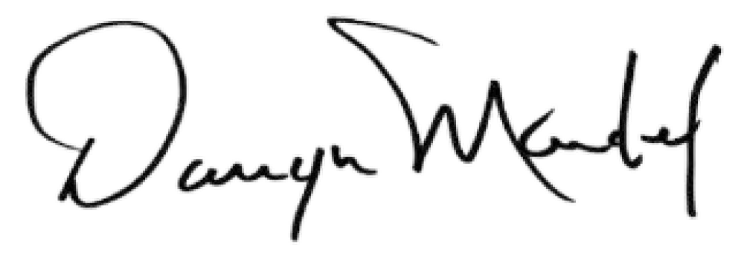Mr. Darryn Mandel, President

