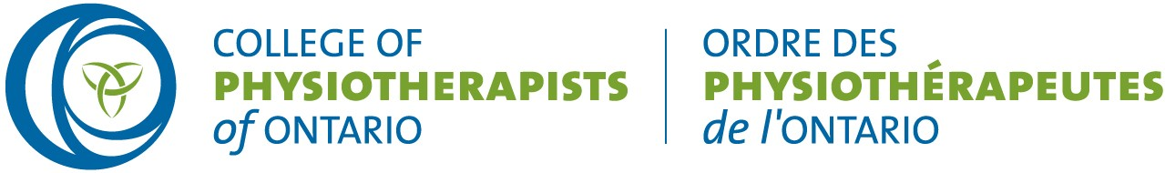

MEETING OF THE COUNCIL OF THE COLLEGE OF PHYSIOTHERAPISTS OF ONTARIO

MINUTES
Special Council meeting December 21, 2020
Virtually via Zoom

Zoom Attendees: |  | Staff on Zoom:
Darryn Mandel, President  Theresa Stevens, PT Janet Law, PT  Tyrone Skanes, Public Sharee Mandel, PT  Sharon Switzer-McIntyre, PT Hervé Cavanagh, PT  Nitin Madhvani, Public | Ronald Bourret, Public  Katie Schulz, PT Karen St. Jacques, PT Jennifer Clifford, PT Regrets:  Tom McAfee, Public Jesse Finn, Public  Martin Bilodeau, PT | Rod Hamilton, Registrar  Justin Rafton Taylor Turner Barbara Hou  Recorder: Barbara Hou

 |  | December 21, 2020
6:00 pm. | 1.0  Motion | Ontario Government Provincewide Shutdown Announcement  On December 21, 2020, the Ontario government announced additional restrictions to stop the spread of COVID-19. These additional measures included a provincewide shutdown beginning Saturday, Dec 26, 2020. The restrictions will remain in place across the province until January 9, 2021, and in Southern Ontario will remain in effect until January 23, 2021.  Following a review of the public health and workplace safety measures, no further restrictions had been applied to the physiotherapy practice. Physiotherapists and other health regulated health professionals would be able to continue to operate consistent with current guidelines for regulated health professionals. Staff had developed a draft communication to provide this update to Ontario physiotherapists. Council reviewed the draft communication and agreed it should be circulated immediately.  It was moved by J. Clifford and seconded by S. Switzer-McIntyre that: Council approve the communication for immediate release to all registrants.  The meeting was adjourned at 6:15pm
 |  |  | CARRIED.
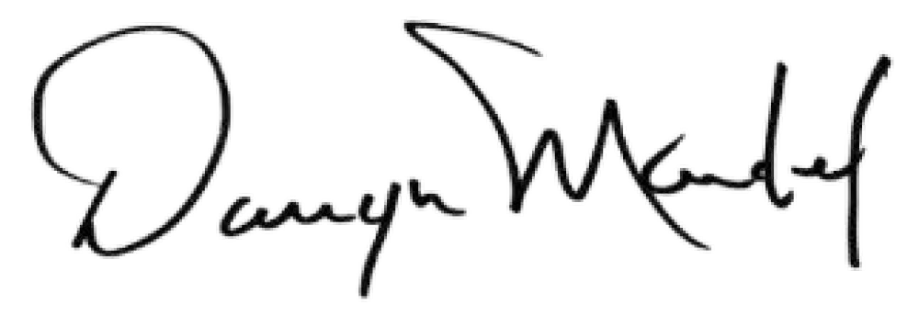
Darryn Mandel, President

