June 2019 | www.collegept.org | info@collegept.org

Summer is officially around the corner, even if the weather has not been very cooperative lately! I hope you all will find some time in the coming months to kick back and enjoy some well-deserved relaxation.

At the College we are looking forward to our Council meeting in June where we will be discussing some of the projects we will be working on over the coming months.

These projects include the continuation of the pilot test for our new practice assessment process. The work done so far has highlighted a lot of the strengths with the new program and as well as a few challenges. We are addressing these few issues and look forward to an official launch later in the year.

It seems like we just wrapped last year’s outreach events, but we are already looking forward to the next round. Stay tuned for further details – we are looking forward to seeing many of you on the road.

Rod Hamilton Registrar
College of Physiotherapists of Ontario

Updated Ethics E-Learning Module

We're happy to announce that we've re-designed our Ethics E-Learning Module to allow for a much better user experience.

The content is the same, but this is a great opportunity to run through the module again and brush up on your understanding of your ethical responsibilities.

The refreshed Ethics Module will teach you about:

Ethics in general The REACH values
An ethical decision-making module
How to apply ethical values and the decision-making module to determine the most appropriate action in the best interest of patients

Be sure to check it out! There are three chapters that you can complete separately or all at once. If you have any questions about the Ethics Module please reach out to our Practice Advice team at 1-800-583-5885 ext. 241.

Try the Module

Who You Gonna Call? PRACTICE ADVICE!

A reminder that our Practice Advice team is always available to answer your questions about pretty much anything! Our four Practice Advisors are all registered physiotherapists with a wealth of knowledge and experience in different areas of practice. They are a great resource if you need to talk though a sensitive or challenging situation.

Call the Practice Advisors for free, confidential advice about: Privacy
Fees and billing
Boundaries with patients
Collaboration with other health care providers and more!

You can also encourage your patients, physiotherapist assistants or students to call. Practice Advice is a valuable resource for everyone.

Call 1-800-583-5885 ext. 241 for anonymous live answer calls on weekdays from 8:30 am to 5 pm or email advice@collegept.org .
Practice Adv ice Info & FAQs

Video: Case of the Month

Are you reading Case of the Month? You should be! Check out this brief video to find out why.

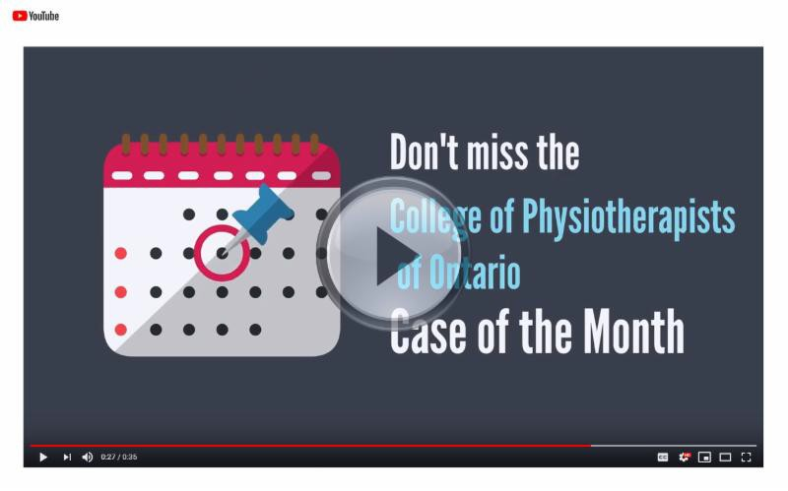

Read all of the Cases of the Month

YouTube Contest: Win a $50 Gift Card

We're kicking off summer with a fun social media contest! Enter for your chance to win a
$50 gift card of your choice.

All you have to do is head on over to our YouTube channel, watch one of our videos and leave a comment before June 30. A name will be chosen at random and we'll respond to your comment letting you know that you've won.

Good luck!
Watch Now

New Case of the Month: Faking It

In a previous Case of the Month, The Clinic Owner Doesn't Always Know Best, we told you about a Physiotherapy Resident who felt pressured by their boss to hold out as a physiotherapist.

Now, in a follow up story, find out what happens when the College initiates an investigation into the physiotherapist who owns the clinic.
Read the Case

What is a Conflict of Interest?

A conflict of interest arises when a PT’s professional judgment and decision making may be biased as the result of a competing financial interest - this includes perceived, potential or real.

Examples include things like receiving or giving payment or gift cards for patient referrals. Be sure to have a quick look at the Conflict of Interest Standard. It can’t hurt and it might even help!
Read the Standard

Remember to Protect Your Registration Number

As a PT your registration number is like your fingerprint and can be traced back to you if something goes wrong. But what if your registration number was misused by another physiotherapist, a different regulated health professional or even your boss?

We occasionally hear from PTs that their registration number has been used by someone else for billing purposes. This can be distressing as the College takes a zero tolerance approach to inappropriate business practices.

Learn how to best protect your registration number and steps you can take if it has been misused.

Tips and Resources

Practice Advice Question

A PT employee accessed the wrong patient file but it was a one-off error.

Do I as the clinic owner and the health information custodian (HIC) need to report the patient information breach?
Get the Answer
Myth vs Fact

A Physiotherapy Resident is able to perform a controlled act such as acupuncture.

Is this a myth or a fact?
Get the Answer

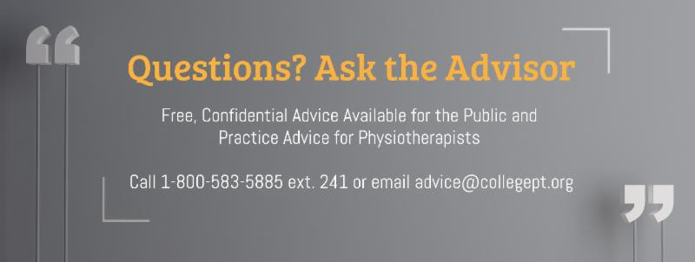

The College would like to welcome our newly registered physiotherapists.
View the List

Comments or questions related to Perspectives?
Get in touch at communications@collegept.org or 1-800-583-5885 ext. 234.

www.collegept.org

