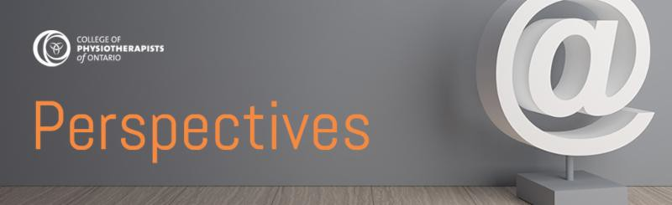

February 2022 | www.collegept.org | info@collegept.org

Welcome to the February edition of Perspectives.

There are a number of important initiatives currently underway at the College so we are even busier than usual for this time of year. Notably, staff are working diligently to review and process applications under the Registration Committee's Exam Exemption Policy. More than 150 Independent Practice certificates have been issued and this number is steadily increasing.

We are also helping registrants complete PISA and annual renewals are ongoing. Both must be completed by March 31.

Stay safe,

Rod Hamilton Registrar
College of Physiotherapists of Ontario

Exam Exemption: Expanded Eligibility Coming Soon

To date we have received more than 250 applications for Independent Practice under the Registration Committee's Exam Exemption Policy.

The Registration Committee has been meeting regularly to consider changes to the eligibility requirements. We will be announcing details about expanded eligibility on March 7, 2022. On that date, please check the news section of the website or your email if you have a Provisional Practice certificate of registration. Please do not call the College prior to March 7 as we are unable to provide more information at this time.

We will start accepting applications under the expanded eligibility criteria on March 14, 2022.

If you meet the current eligibility requirements, we encourage you to submit your application by March 7. Please ensure that you read the eligibility requirements carefully, and submit all completed documents and forms so that we can process your application as quickly as possible.
Exam Exemption 2021

COVID Updates, Information and Resources

The Chief Medical Officer of Health has revoked Directive #2. Public hospitals may cautiously and gradually resume non-urgent and non-emergent surgeries. Review the Directive #2: Questions and Answers document from the Ministry of Health for more information.

In consideration of the evolving circumstances with COVID, we have updated our website to include information and resources from official sources in one place.
COVID Information & Resources

New Case of the Month: Missing in Action

Physiotherapists have accountabilities to their patients, the College and their employer. Some of these responsibilities include being professional, always acting in the best interest of their patients and making sure their employment information is up to date.

In a new Case of the Month, we explore what happens when one physiotherapist has extended, unexplained absences from work, leaving their employer and patients in a tricky situation. Mix in some lost patient records and you have a case that's not to missed.
Read the Case

Practice Advice Question

How can I manage a situation where there is a disagreement or conflict between myself and a patient, or between myself and another service provider?
Get the Answer
Myth vs Fact

A physiotherapist must carefully balance the risks of assigning and supervising care with the patient’s best interests and quality of care.

Is this a myth or a fact?
Find Out

Privacy Reminders

Annual statistical reporting and other important reminders from the College and the IPC

Annual Statistical Reporting - Deadline Approaching

The Office of the Information and Privacy Commissioner (IPC) of Ontario’s Annual Statistics Submission website is now open. All Ontario institutions and Health Information Custodians must submit annual statistics.

The deadline to submit your 2021 statistical report is Thursday, March 31, 2022.
The deadline to submit your 2021 report on privacy breaches under PHIPA is Tuesday, March 1, 2022.

Learn more about your reporting obligations and access resource guides on the IPC website. Privacy Training - an Annual Requirement
The IPC has also confirmed that all agents (employees, staff, and volunteers) of health information custodians (HICs) should receive comprehensive privacy training on an annual basis. HICs should update training annually to include changes in processes, policies or legislation, and track agents’ completion.

Privacy training requirements were explored in this recent decision from the IPC. We will share future resources about privacy training if they become available.

Be sure to check out the privacy information and resources on the College website for more information about your professional obligations.
Privacy Information & Resources

Working with PTAs: Sample Communication Plans

According to the Working with Physiotherapist Assistants Standard , a physiotherapist must have written communications protocol that states:

How and when they will discuss patient care with the physiotherapist assistant How to contact the physiotherapist
How to contact the alternate supervisor if the physiotherapist cannot be reached

The College has samples of different kinds of communication plans that physiotherapists may consider using or adapting when creating their own written protocols.
View the Samples

Practice Advice: Free, Confidential Advice for Everyone

Have questions about practice? Need to talk through a challenging situation? Looking for a specific resource?

The Practice Advisors are here to help! The advisors are available to offer free, confidential advice to everyone including physiotherapists, Physiotherapy Residents, students, academics, employers of physiotherapists and patients/caregivers.

The College has three advisors on staff, each with varied clinical experience. We can also answer your questions in French, if you prefer.

Do not hesitate to take advantage of this service. Call the advisors at 1-800-583-5885 (extension 241) or email advice@collegept.org.

You can also review common frequently asked questions on the website.

Review FAQs

Notice from the Ministry of Health – Cyber Security

Given the rising geopolitical tensions related to developments in the Russia/Ukraine region, the Ministry of Health has advised Ontario health colleges of the growing potential of a cyber- attack on systems in Canada, specifically those targeting health care settings.

To help protect your systems and sensitive health data, consider signing up for cyber security services including alerts and advisories from the Ministry of Government and Consumer Services, Cyber Security. These alerts are available to anyone and will help ensure that your organization is aware of potential or imminent cyber threats.
Sign Up Now

Annual Renewal and PISA: One Month Left to Complete

Annual Renewal 2022

The 2022 annual renewal process will run from February 1 to March 31. All PTs in Independent Practice must complete annual renewal and pay the registration fee of $575 by 11:59 p.m. on March 31 to avoid additional late fees.

Just like last year, you will complete annual renewal online using the PT Portal .

If you have questions, please contact the Renewal Team at renewal@collegept.org or 1-800- 583-5885 ext. 235.
About Annual Renewal

PISA 2022

The Professional Issues Self Assessment (PISA) runs concurrently with annual renewal between February 1 and March 31. PISA is a mandatory self-reflection exercise that all PTs must complete each year. This includes people with both Provisional Practice and Independent Practice certificates.

PISA is not scored so there is no pass or fail. There are 10 multiple choice questions designed to get you thinking about the standards and resources and how to apply them in your practice.

Please log in to the PT Portal to complete PISA.

If you have questions about PISA, please contact PISA@collegept.org or 1-800-583-5885 ext. 235.
About PISA

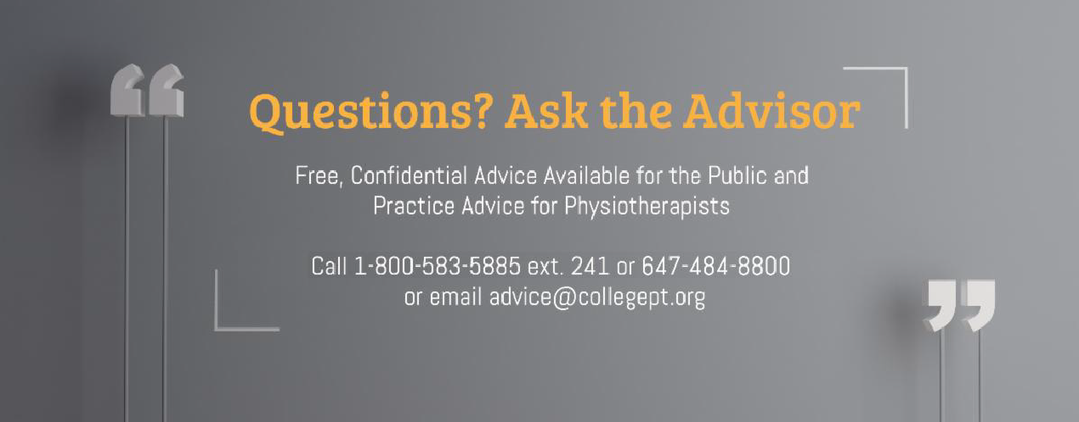

The College would like to welcome our newly registered physiotherapists.
View the List

Comments or questions related to Perspectives?
Get in touch at communications@collegept.org or 1-800-583-5885 ext. 234. www.collegept.org

