WWWW.COLLEGEPT.ORG

Welcome to the College of Physiotherapists of Ontario!
All your hard work has paid off and you’re now a registered physiotherapist in Ontario — congratulations! We look forward to working with you and supporting you during your career. There are a few things you should know as you continue on this exciting journey. This welcome guide will help you get started.

Scroll to Continue

Physiotherapist

Restricted Titles
Now that you’re registered you can officially use the titles: physiotherapist and physical therapist, and the abbreviation PT. You can now use any of these designations after your name. For example: Fiona Campbell, PT

These three titles are protected by law and can only be used by individuals who are registered with the College.

Learn more about restricted titles

Your Registration Number
You now have a unique registration number. This is like your fingerprint as a PT and is a way for the College and other stakeholders like insurance companies to identify you.

It’s important that you protect your registration number and use it appropriately when providing and billing for treatment. Do not allow someone else to use your registration number.

Misuse may have consequences including disciplinary action and being de-listed by insurance companies.

WWhat to do if your name/registration number have been misused.

The Public Register/Find a Physiotherapist

The Public Register is an online directory of all registered physiotherapists in Ontario.
It’s an important tool that anyone can use to find a physiotherapist or search for publicly available information about their PT including registration status, place of employment and professional conduct history.

Note that in order to help protect your registration number, it’s partially hidden on the
Public Register to prevent anyone else from using it. For example: Registration number XXX50.

Since you will not receive a hard or electronic copy of your certificate of registration, you should direct any current or potential employers to the Public Register, as it provides your most current professional information and confirms that you’re a registered PT in Ontario.

Why not check out your own profile? Go to the Public Register, type in your name and see what comes up!

Learn More: Public Register

Visit www.collegept.org

Our website will be an important tool for you throughout your career.

There are a number of materials that you should review regularly to ensure you continue
to meet College requirements
and expectations in your practice.

VVisit the College website

Standards, Rules, Legislation and Resources
Standards are set by the College and support provincial legislation by outlining the minimum expectation for an aspect of practice. The College has standards for:
- Advertising
- Boundaries and Sexual Abuse
- Collaborative Care
- Conflict of Interest
- Controlled Acts and Restricted Activities
- Fees, Billings and Accounts
- Infection Control and Equipment Maintenance
- Providing or Refusing Care
- Record Keeping
- Restricted Titles, Credentials and Specialty Designations
- Working with Physiotherapist Assistants

A MUST READ
Additional Resources
Additional resources are available to help you practice and bring the regulations and standards to life. The College has many checklists, e-learning modules, frequently asked questions and learning tools available.

Other topics include:
- Consent
- Privacy
- Essential Competencies for Physiotherapists
- Code of Ethics
- Record Keeping E-Learning Module
- Opening a Practice Checklist
- Leaving a Practice Checklist

Be sure you review the standards and rules carefully before you start practicing.

SStarting a
NNew Job
CChecklist

LLearn more: Rules and Resources

All of the professional obligations you should consider before signing an employment contract.

Regulations
Regulations are laws published under the Regulated Health Professions Act (RHPA) and the Physiotherapy Act. These are not set by the College, but the provincial government as they address aspects of practice that have the greatest potential to result in harm to the public.

Important New Act
The Protecting Patients Act (Bill 87) was passed by the Ontario government on May 30, 2017, making a variety of changes to the regulation of health professions, primarily related to protecting patients from sexual abuse. There is now a zero-tolerance approach and if a member is found guilty of sexual abuse the College is required, by law, to take away their license.
Note that spouses are not exempt from sexual abuse and under no circumstances are PTs permitted to date their patients.

LLearn more: Understanding Sexual Abuse

The PT Portal
Visit to make changes to your employment or personal information, roster for any higher risk activities (controlled acts) that you wish to perform and complete annual renewal.

How to Log in:
  - Visit www.collegept.org

  - Click the ‘PT Portal’ button on the homepage

  - Log in with the username and password you set during the registration process.

You should already have a profile set up.

Through the PT portal
you can also download or print your annual renewal invoice using the ‘Invoice’ button on the left side of the page.

pportal.collegept.org

PPT Portal

A nnual renewal runs each year from February 1 to March 31.
Annual Renewal and Fees
To practice as a PT in Ontario you must be registered with the College and you're required to renew your registration annually. Reminders are sent via email so be sure to keep your contact information up-to-date.

The annual renewal process is completed online in the PT Portal. You will be asked to verify or update your employment and personal information, answer questions to confirm you meet registration requirements and pay your annual registration fee of $575.

If you do not complete renewal by the March 31 deadline, you will be charged an additional late fee of $225 for a total of $800—so be sure to renew on time!

Practice Hours

During annual renewal you’ll be asked to sign a declaration indicating that you have accumulated at least 1,200 practice hours over the previous five-year period.

Practice hours may include hours worked that you’ve been paid for, ongoing learning, or volunteer activities that require physiotherapy knowledge and theory.

You don’t need to have the official title of physiotherapist, physical therapist or PT to claim practice hours.

LLearn More: Practice Hours

Controlled Acts and Rostering
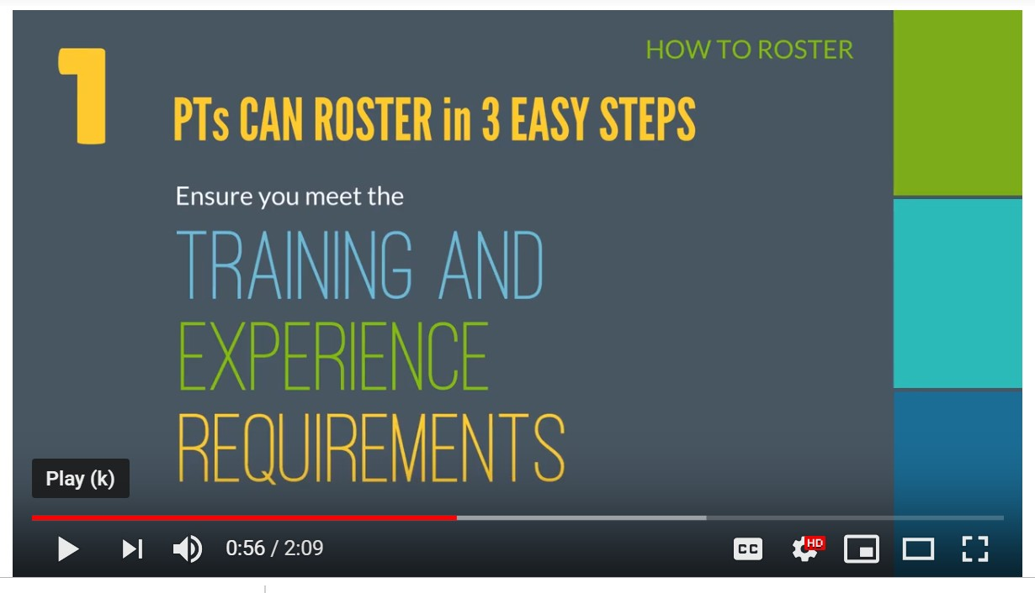
Rostering is mandatory in Ontario and is a way for PTs to show that they have the education, training and experience to perform the controlled acts listed above.

If you have the appropriate training and experience you can roster to perform these activities by signing a declaration in the PT Portal.

Controlled Acts include:
- Tracheal suctioning
- Spinal manipulation
- Acupuncture (including dry needling)
- Treating a wound below the dermis
- Assessing or rehabilitating pelvic musculature
- Administering a substance by inhalation

LLearn More: How to Roster for Controlled Acts

Switching Jobs? Moving? Changing Your Phone Number?
You’re required to inform the College of any updates to your personal or employment information within 30 days of the change.

Changes can be made using the PT Portal and must be made throughout the year, not only during annual renewal.

Changes to Your Information
Some changes (like a name change) need to be made by College staff so please contact the Registration team at registration@collegept.org
or 1-800-583-5885 ext. 222

PPT Portal: Update Your Information

PISA

PISA (Professional Issues Self Assessment) is a short, multiple choice, online exercise that must be completed annually by all physiotherapists—both Independent Practice and Provisional Practice Certificate holders. It happens every year from February 1 to March 31 so you can complete it while you’re doing your annual renewal.

PISA is an opportunity for you to assess your awareness of practice issues, reflect on
Now that you’re a registered PT there are
certain professional obligations you need to meet including completing PISA, Jurisprudence and practice assessments, having adequate liability insurance and making mandatory and self-reports.

practice-related questions and review resources and standards. There is no pass or fail, you just
need to complete it before the deadline, and you can complete it with your peers if you’d like.

Learn More:

LLearn More: PISA

Your Professional Obligations
P Professional Obligations

Jurisprudence

Your Professional Obligations

Jurisprudence Module is an online, 50-question multiple choice exercise that tests your understanding and application of practice standards, legislation and rules related to practice in Ontario. You must pass Jurisprudence with a score of 72% or higher. You will have two attempts to successfully complete the module.

You are required to complete the Jurisprudence Module within the first year of registering for an
Independent Practice Certificate. You will receive an email from us when you need to complete it.
After that, PTs are required to complete it on a five-year rotation, with the next all PT round

coming in fall 2021.
LLearn More: Jurisprudence

Practice Assessments

Your Professional Obligations

Practice Assessments are a key part of your professional development and help ensure that you’re meeting the minimum standards for safety and quality and that patients are receiving appropriate care. After being registered for Independent Practice for two years, you will be eligible for a practice assessment. PTs will be selected in sequence every 10 years or so and will complete a remote assessment and possibly an on-site assessment with a College-appointed assessor. When you’re selected, you’ll be notified by email and given further instructions.

LLearn More:
PPractice Assessments

Continuing Professional Development

Your Professional Obligations

It’s your responsibility to participate in continuing professional development which includes evidence of ongoing learning and improvement, note of critical instances, self-assessments and peer feedback. Ongoing learning can include attending courses or lectures, participating in peer discussion groups or reading physiotherapy-related journals, and you need to keep a written record of what you’ve done.

Questions about practice assessments or continuing professional development? Contact:
qualityassurance@collegept.org or 1-800-583-5885 ext. 233.
LLearn More:
PProfessional Development

Liability Insurance
All registered PTs are required to maintain professional liability insurance and provide confirmation of insurance at annual renewal or within 30 days if requested by the College. Note that you can update your liability insurance at any time in the PT Portal.

Please check with your employer to see if their clinic or hospital has insurance coverage, and whether that coverage protects you. If not, it’s your responsibility to arrange your own.

To register with the College, you need:
- A minimum coverage of $5 million for the annual policy period
- A liability limit of at least $5 million per incident
- No additional terms, conditions or exclusions, other than standard
- No deductible
- Tail insurance for a minimum of 10 years

Remember:
If you work in multiple practice environments (at many clinics and hospitals),
don’t assume your insurance at one location covers you for the others. You may have to arrange coverage for other locations, either separately or jointly.

LLearn More: Liability Insurance

Mandatory Reporting
Under the Regulated Health Professions Act (RHPA), regulated health professionals (like physiotherapists) and those who work with or employ them have legal and ethical obligations to make reports to the College and other colleges and agencies as required.

Some common types of mandatory reports include sexual abuse, incapacity and incompetence, charges and bail restrictions, and privacy breaches. Remember, the law says you must report and not doing so could impact your career. It’s always better to be safe than sorry.

LLearn More: Mandatory Reporting

Self-Reporting
Ontario physiotherapists are legally required to make self-reports to the College in a timely manner if they:

  - Have been charged with OR have been found guilty of any offence in any jurisdiction (this includes anywhere in Canada or elsewhere in the world)

  - Have bail conditions

  - Have a finding of professional misconduct, incompetence or incapacity related to any regulated profession in any jurisdiction

  - Are the subject of a current investigation for professional misconduct, incompetence, or incapacity related to any regulated profession in any jurisdiction

Examples of Charges or Offences:
Distracted driving, driving under the influence, disturbances of the peace, traffic violations, theft, assault or fraud

LLearn More: Self-Reporting

About the College
What is Self-Regulation?

Self-regulation is a privilege given to professions that have shown they are able to put the interests of the public first. While we do set some
of the rules that physiotherapists must follow, there are some rules that are laid out in provincial legislation and we are ultimately accountable to the government.

For example, the Regulated Health Professions Act, 1991 (RHPA) gives the College its mandate to regulate the practice of physiotherapists in Ontario, while the Physiotherapy Act, 1991 provides the framework for things like scope of practice and professional misconduct. Everything that
the College does must support the provincial legislation.

A Little More About Us
OOntario Health Regulators

The College of Physiotherapists of Ontario is one of 26 health regulatory organizations established by the provincial government to ensure the public receives safe, competent and ethical care. Our sole purpose is protecting the public by overseeing the practice of physiotherapists.

We protect the public by:
- Setting the requirements for entry into the profession
- Establishing standards of practice that PTs must follow
- Monitoring practice and promoting continuing competency
- Investigating complaints and concerns about PTs from patients, caregivers or others
- Protecting the integrity of the profession with a zero-tolerance approach to inappropriate business practices

College Council
The College is governed by a board of directors called a Council which is made up of:
- PTs elected by members of the College (like you!)
- Public members appointed by the provincial government
- Academic members appointed by the physiotherapy programs at five Ontario universities (University of Toronto, Queen’s, Western, McMaster and the University of Ottawa)

Staff fulfills the day-to-day duties of the College, under the leadership of the Registrar (like a CEO). Council meetings are open to the public so you—and anyone else—are welcome to come observe. Council meetings are held at the College office in Toronto and upcoming dates are posted on the website.

LLearn More: Strategic Goals

Complaints Process
A key responsibility of the College is to consider concerns and complaints about physiotherapists and their practice.
Patients, caregivers, other PTs and employers can all submit complaints. In protecting the public interest, the College must give serious consideration to each complaint, while ensuring a fair and just process.

Questions about investigations and complaints? Feel free to contact: investigations@collegept.org or 1-800-583-5885 ext. 227

LLearn More: Complaints Process

Bookmark our Website: WWW.COLLEGEPT.ORG

Questions?
Call the Practice Advisor
We know this is a ton of information, so don’t be afraid to ask questions!

We have a team of Practice Advisors—all experienced physiotherapists—available to answer your questions by phone and email throughout your career. Whether you have questions about the standards or need advice on how to handle a difficult situation, our advisors are available with answers and guidance. They can also share helpful resources as needed.

Call Practice Advice at: 1-800-583-5885 ext. 241 or email Practice Advice at: advice@collegept.org

LLearn More: Practice Advice

Case of the Month

College News
Every month we publish a short story called Case of the Month detailing a real situation where a PT may or may not have followed the rules, and the outcome of that situation. It’s a great read! Sometimes shocking, always entertaining and a good cautionary tale for you as you begin practice.
PPast Cases of the Month
Email Communication

Important information will be shared by email so please make sure your information is up to date and you read everything from the College.

Please don’t unsubscribe as email is the only way we communicate with members.

Always read your College email!
Perspectives E-Newsletter
Once a month we send out our e-newsletter Perspectives which contains updates to standards and College programs, reminders for important deadlines, helpful resources, and more. Be sure to give it a read!

BBookmark our Website: WWW.COLLEGEPT.ORG

Stay Connected
Tweets by @CollegeofPTs

College of PTs
@CollegeofPTs
Effective communication can improve the therapeutic relationship between a #physiotherapist and a #patient.

Review the six keys of
Embed
View on Twitter

Interested in Getting Involved?
The work of the College is possible because of the dedication of our registrants. In the future you may be interested in running for Council or serving on a Committee. We also regularly hold consultations when developing new standards and policies and physiotherapists, members of the public, and other stakeholders are invited to share their feedback.

LLearn More: Get Involved

Keep in Touch!
College of Physiotherapists of Ontario
375 University Avenue, Suite 800, Toronto, Ontario M5G 2J5

General Inquiries: 416-591-3828 ext. 201 or 1-800-583-5885 ext. 201
Fax: 416-591-3834 | info@collegept.org

New Application and Registration Questions
registration@collegept.org | 416-591-3828 ext. 222 or 1-800-583-5885 ext. 222

Practice Advice Questions
practiceadvice@collegept.org | 647-484-8800 or 1-800-583-5885 ext. 241

Assessments & Continuing Professional Development Questions qualityassurance@collegept.org | 416-591-3828 ext. 233 or 1-800-583-5885 ext. 233

Pour l'information en français
communications@collegept.org | 416-591-3828 ext. 234 or 1-800-583-5885 ext. 234

Website, Perspectives e-newsletter or Social Media Questions or Suggestions or if You Need Information in an Accessible Format communications@collegept.org | 416-591-3828 ext. 234 or 1-800-583-5885 ext. 234

Self Report or Mandatory Report Questions or Submissions investigations@collegept.org | 416-591-3828 ext. 227 or 1-800-583-5885 ext. 227

