WWW.COLLEGEPT.ORG

Provisional Practice Members:

WELCOME

to the College of Physiotherapists of Ontario!
Your hard work is paying off and youʼre now a Physiotherapy Resident – congratulations!
There are a few things you should know as you continue on this exciting journey to become a registered physiotherapist in Ontario.

This guide will help you better understand what it means to be a Physiotherapy Resident, learn more about provisional practice and outline the role of the College. Please read this important information.

Scroll to Continue

What is Provisional Practice?

Provisional Practice

Provisional Practice is a category of registration that allows those with a physiotherapy degree who have successfully completed the written part of the Physiotherapy Competency Exam (PCE) to work under the supervision of an approved registered physiotherapist.

Currently, Provisional Practice certificates do not expire. The College will extend your provisional license and you can continue to work until a clinical exam is in place.

Physiotherapy Residents will no longer complete the clinical component of the Physiotherapy Competency Exam previously administered by the Canadian Alliance of Physiotherapy Regulators.

Physiotherapy Residents may choose to pursue the exam exemption implemented by the Collegeʼs Registration Committee in December 2021. Please note that you must practice as a PT Resident for at least 12 months and meet additional eligibility criteria.

Alternatively, the College is developing a behaviour-based exam that we anticipate will be available to all candidates in 2022.

The PT Portal

How to Log in:
- Visit www.collegept.org

- Click the ʻPT Portalʼ button on the homepage, top right

- Log in with the username and password you set when you submitted your application

You already have a profile set up – this is how the College keeps track of your personal and employment details.

Always make sure your contact information and employment information are current in the PT Portal.

If you are still using your university email address, you might want to update your primary email to something that you plan to use long-term.

It is very important that you provide the College with an active email that you check regularly.

portal.collegept.org

What is Supervision?
As a Physiotherapy Resident, you can only practice physiotherapy under the supervision of a registered physiotherapist. This means that you must f ind one or more physiotherapists who will act as your Practice Supervisor. Your Practice Supervisor
must have an Independent Practice Certificate of Registration. Your Practice Supervisor must have held an IPC for at least 3 years in Ontario

If you do not have a Practice Supervisor, you can still hold a Provisional Practice Certificate, but you cannot deliver patient care and a restriction will be placed on your certificate until you f ind a supervisor.

Read the Supervision Standard

How Do I Get a Supervisor?
Once you have an employment offer you can chat with your employer about arranging to be a Supervisor.

When you f ind a Supervisor, log in to the PT Portal and follow these steps:
- Go to your profile
- Select Supervision Requests
- Select Request Supervisor and enter the full name and registration number of your proposed supervisor. You need this information to submit a request.
The College will need approximately one week to approve that person. Be sure to give yourself time to get your approval before you start delivering patient care.

You cannot provide patient care until
the College receives a signed supervision agreement f rom your Practice Supervisor.

Once the Supervisor is approved, the Supervisor is sent an email asking them to log into the PT Portal and complete the supervision declaration. After making the declaration, the previous restriction on your certificate is lifted.

If you need to change Supervisors and you do not have
more than one, you must email registration@collegept.org
and repeat the approval process.

More about Supervision

Things to Consider When Choosing a Supervisor

They must be registered for Independent Practice with the College for at least three years.

They canʼt be related or closely associated to you (for example, a family member or close family f riend).

If the College is unable to approve your approved supervisor, sometimes we may not be able to disclose the reason why to the PT Resident for confidentiality reasons.
You can have more than one supervisor, but a Supervisor can only supervise three PT Residents at any given time.

If they have a history with the College (are being investigated, are involved in remedial activities or have a history of practice concerns for example) the College will need to consider whether or not they are a suitable

Your Registration Number
You now have a unique registration number – this is like your f ingerprint and is used as a way for the College and other stakeholders like insurance companies to identify you.

Itʼs important that you protect your registration number as someone with a Provisional Practice Certificate and use it appropriately when providing any billing
for treatment. Do not allow someone else to use your registration number and be sure to ensure your employer uses it appropriately.

You have the right to ask your employer to see billings that use your registration number.

Learn More

Restricted Titles
Now that youʼre registered for provisional practice, you can officially use the titles of Physiotherapy Resident, Physical Therapy Resident or
PT Resident. You can now use these designations after your name. For example: Fiona Campbell, Physiotherapy Resident
These titles are protected by law and can only be used by individuals who are registered with the College.

Note that you cannot use the titles Physiotherapist, Physical Therapist or PT until you have an Independent Practice Certificate.

Learn More: Restricted Titles

Liability Insurance
Physiotherapy Residents are required to maintain professional liability insurance and provide confirmation of insurance within 30 days if requested by the College.

Please check with your employer to see if their clinic or hospital has insurance coverage, and whether that coverage protects you. If not, itʼs your responsibility to arrange your own.

Note that you can update your liability insurance at any time in the PT Portal.

You need:
- A minimum coverage of $5 million for the annual policy period
- A liability limit of at least $5 million per incident
- No additional terms, conditions or exclusions, other than standard
- No deductible
- Extended leave (tail) insurance for a minimum of 10 years

Learn More: Liability Insurance Requirements

The Advisor is In —
Free Advice as You Begin Practice

One amazing resource offered by the College is the Practice Advice team. The Practice Advisors are experienced physiotherapists available to answer your questions by phone and email.

They can help set you up for success by explaining the rules in more detail, answering any questions you might have and sharing helpful resources. Even if youʼve encountered a dif f icult situation early on in your career and donʼt know who to turn to, the Practice Advisors can guide you. All calls are confidential, there is no need to give your name or tell them where you work.

Call Practice Advice at: 1-800-583-5885 ext. 241
Email Practice Advice at: advice@collegept.org
Bookmark our Website: WWW.COLLEGEPT.ORG

Learn More: Practice Advice

www.collegept.org
Our website will be an important tool for you now and throughout your career. There are materials that you should review regularly to ensure you continue to meet College requirements and expectations in your practice. This information can be found under
the Rules and Resources tab on the homepage.
Be sure you review the standards and guidelines carefully before you start
practicing – these are the rules that you will be held accountable to meeting.
There are standards specific to things like working with physiotherapist
assistants, fees, billing and accounts, supervision, advertising, boundaries, providing and refusing care and more.

Be Sure to Bookmark our Website

Rules, Resources & Guidelines

Staying Connected with the College is Very Important

Case of the Month
Every month we publish a short story called Case of the Month detailing a real situation where a PT may or may not have followed the rules, and the outcome of that situation. Itʼs a great read and can help you better understand the types of complaints the College receives.
Past Cases of the Month

Email Communication

Important information will be shared by email so please make sure your information is up to date and you read everything f rom the College.

Please donʼt unsubscribe as email is the only way we communicate with registrants.

If you are using a university email, please change it as soon as possible.

Perspectives E-Newsletter
Once a month we send out our e-newsletter Perspectives which contains updates to standards and College programs, reminders for important deadlines, helpful resources, and more. If thereʼs something you need to know about, it will be in Perspectives so be sure to read it every month.

As a new physiotherapist be sure to read regular features such as Case of the Month, the blog, practice advice questions
and myth vs fact.

The Public Register/ Find a Physiotherapist
The Public Register is an online directory of all registered physiotherapists in Ontario. Itʼs an important tool that anyone can use to f ind a physiotherapist or learn more about their current PT.

Employers also use the Public Register to ensure PTs are registered before hiring them.

Simply search your name and your profile will come up. Your profile notes that you hold a Provisional Practice Certificate of Registration so that patients and employers know that youʼre a Physiotherapy Resident working under supervision.

Your name is now officially part of the Public Register so be sure to check it out!

PISA

(Professional Issues Self Assessment)

PISA is a short, multiple choice, online exercise, that must be completed annually by all physiotherapists — both Independent Practice and Provisional Practice Certificate holders.
It happens every year f rom February 1 to March 31 and if it happens while you have a Provisional Practice Certificate, you will be required to complete it.

PISA is a self-reflective exercise designed to get you thinking about the rules and standards of practice.
There is no pass or fail – you just need to complete it before the deadline. If you need to complete it the College will email you to let you know.

Rostering for Controlled Acts
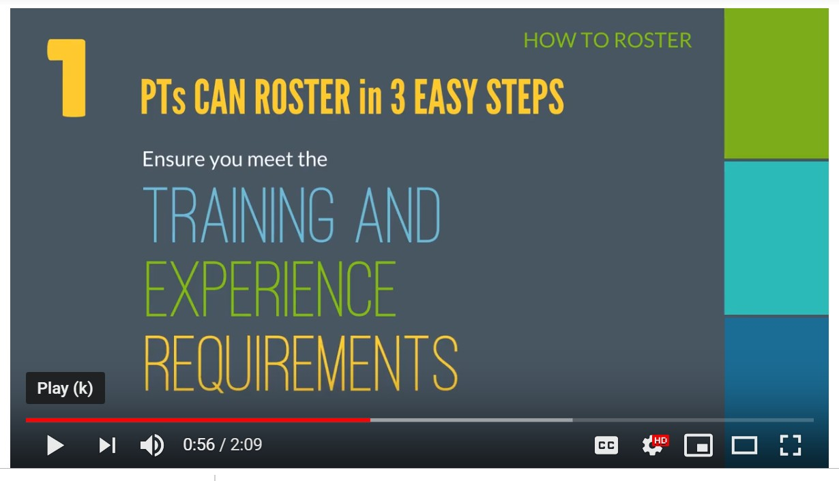
As a Physiotherapy Resident you can now roster for any controlled acts that you have the education to safely perform. Rostering means completing an online declaration confirming your competency and skill in these higher risk areas. This information will appear on the Public Register.

How to Roster for Controlled Acts

Rostering for Controlled Acts

To roster, your education must meet the following criteria:
- The education included a theoretical component (learning, for example, about risks, contraindications)
- The education included a practical component (such as practice on other students)
- The education included an evaluation component of your knowledge (theory) and skills (practice)

Additionally, your approved Practice Supervisor must be rostered to perform the same controlled acts. For example, you can only roster for acupuncture if your Practice Supervisor is also rostered for acupuncture and can supervise you safely.

Remember, you must roster if you are doing any of the following high-risk activities:
- tracheal suctioning
- spinal manipulation
- acupuncture (including dry needling)
- treating a wound below the dermis
- pelvic internal exams (this includes putting an instrument, hand or f inger, beyond the labia majora, or beyond the anal verge)

How to Roster for Controlled Acts

Complaints Process
Learn More: Complaints Process

A key responsibility of the College is to consider concerns and complaints about physiotherapists and their practice. Patients, caregivers, other PTs and employers can all submit complaints.

In protecting the public interest, the College must give serious consideration to each complaint, while ensuring a fair and just process.

As a Physiotherapy Resident, a complaint can be made about you. However, keep in mind that each year the College receives approximately 300 complaints. Approximately 19% of those are reviewed by a College Committee and less than 5% are public decisions reviewed by the Discipline Committee.

Questions about investigations and complaints? Feel f ree to contact: investigations@collegept.org or 1-800-583-5885 ext. 227

Mandatory Reporting
Physiotherapists and those who work with or employ them have legal obligations to make reports to the College and other colleges and agencies as required.

Some common types of mandatory reports include sexual abuse, incapacity and incompetence, charges and bail restrictions, and privacy breaches.

Remember, the law says you must report and not doing so could impact your career. Itʼs always better to be safe than sorry.

Get in touch! We are available to advise you on what you need to report. advice@collegept.org
1-800-583-5885 ext. 241

Learn More: Mandatory Reporting

Self-Reporting
Ontario physiotherapists are legally required to make self-reports to the College in a timely manner if they:

Have been charged with OR have been found guilty of any offence in any jurisdiction (this includes anywhere in Canada or elsewhere in the world). Examples include distracted driving, driving under the inf luence, disturbances of the peace, traffic violations, theft, assault or f raud.
Have bail conditions.
Have a f inding of professional misconduct, incompetence or incapacity related to any regulated profession in any jurisdiction.

Are the subject of a current investigation for professional misconduct, incompetence, or incapacity related to any regulated profession in any jurisdiction. Please note, physiotherapists DO NOT need to report disciplinary action with the College of Physiotherapists of Ontario.

Learn More: Self-Reporting

A Little More about Us
Learn more about the role of the College

The College of Physiotherapists of Ontario is one of 26 health regulatory organizations established by the provincial government to ensure the public receives safe, competent and ethical care. Our sole purpose is protecting the public by overseeing the practice of physiotherapists.

We protect the public by:
- Setting the requirements for entry into the profession.
- Establishing standards of practice that PTs must follow.
- Monitoring practice and promoting continuing competency.
- Investigating complaints and concerns about PTs f rom patients, caregivers or others.
- Protecting the integrity of the profession with a zero-tolerance approach to inappropriate business practices.

Bookmark our Website: WWW.COLLEGEPT.ORG

Keep in Touch!
College of Physiotherapists of Ontario
375 University Avenue, Suite 800, Toronto, Ontario M5G 2J5

General Inquiries: 416-591-3828 ext. 256 or 1-800-583-5885 ext. 256
Fax: 416-591-3834 | info@collegept.org

New Application and Registration Questions registration@collegept.org | 416-591-3828 ext. 222 or 1-800-583-5885 ext. 222

Practice Advice Questions
practiceadvice@collegept.org | 647-484-8800 or 1-800-583-5885 ext. 241

Pour l'information en français
communications@collegept.org | 416-591-3828 ext. 234 or 1-800-583-5885 ext. 234

Self-Report or Mandatory Report Questions or Submissions investigations@collegept.org | 416-591-3828 ext. 227 or 1-800-583-5885 ext. 227

Bookmark our Website: WWW.COLLEGEPT.ORG

Social Media

We’re active on social too! Be sure to follow us on:

Be sure to check out our YouTube channel for video answers to some popular Practice Advice questions!
Tweets by @CollegeofPTs

College of PTs
@CollegeofPTs
Update: Exam Exemption Policy Metrics

As of January 21, the College has received 170 applications. 76 applications are currently in

Embed View on Twitter

