MEETING OF THE COUNCIL OF THE COLLEGE OF PHYSIOTHERAPISTS OF ONTARIO

MINUTES

December 18, 2020
Virtually via Zoom

Zoom Attendees: |  | Staff on Zoom:
Darryn Mandel, President  Theresa Stevens, PT Martin Bilodeau, PT Janet Law, PT  Tyrone Skanes, Public Sharee Mandel, PT  Sharon Switzer-McIntyre, PT Hervé Cavanagh, PT  Nitin Madhvani, Public | Ronald Bourret, Public  Katie Schulz, PT Jesse Finn, Public Karen St. Jacques, PT  Regrets:  Tom McAfee, Public Jennifer Clifford, PT | Rod Hamilton, Registrar  Justin Rafton Shelley Martin Melissa Collimore Olivia Kisil Barbara Hou  Recorder: Barbara Hou

 |  | Friday, December 18, 2020
9:00 am. | 1.0  Motion | Approval of the Agenda  It was moved by H. Cavanagh and seconded by S. Switzer-McIntyre that:  the agenda be accepted as presented with the possibility for changes to the order of items to address time constraints.
 |  |  | CARRIED.
 | 2.0  Motion | Approval of the Council Meeting Minutes of November 27, 2020 2.0  It was moved by T. Skanes and seconded by J. Law that:  the Council meeting minutes of November 27, 2020, including the in- camera minutes be approved.
 |  |  | CARRIED.
 | 3.0 | Canadian Alliance Physiotherapy Regulators (CAPR)  D. Mandel, H. Cavanagh, and M. Bilodeau declared a Conflict of Interest (COI) with the agenda item, their video was turned off and they did not participate in any discussions.  - CAPR Board Representative Update  Gary Rehan, CAPR board representative informed Council of the College’s annual CAPR membership dues owing to remain a regulatory member and obtain services such as credentialing. Council agreed to proceed with full payment for 2021. Further discussion on the CAPR relationship was deferred for future meetings.  - CAPR Governance Review

G. Rehan advised Council that the CAPR board was conducting a
Governance Review in 2021, and had expressed a desire to collaborate with the College. Council will be provided with further materials to examine the challenges identified in the review process for CAPR’s consideration.

3.3 Provisional Practice Extension Request
S. Switzer-McIntrye declared a COI with this part of the discussion, turned off their camera, and did not participate.

R. Hamilton, Registrar provided an overview of applicants who passed the written exam, obtained Provisional Practice Certificate, and subsequently failed the clinical component (OSCE). Due to the COVID pandemic and examination delays, failed applicants were unable to take the clinical exam and are denied provisional practice extensions.

Based on the College’s public protection mandate and the explicit wording of the Registration Regulation, the Chair of the Registration Committee indicated that after considering requests for the extension of provisional practice certificates in this context, the Registration Committee does not have the authority to issue an extension of such provisional practice certificates. Nor does it recommend that Council pursue regulation changes that would give it this authority. At this time, Council agreed with this position.
4.0  Motion | Quality Assurance Program-Confirmation of the Threshold for Successful Completion of the Screening Interview for 2021.  S. Martin, Manager of Quality Assurance provided Council with a presentation on the development of the new Quality Assurance Program from Summer 2017 to April 2020.  Based on data analysis findings following the Pilot program completion, the Quality Assurance Working Group (QAWG), in consultation with the Quality Assurance Committee, recommended that the threshold for successful completion of the screening interview be lowered to 85% from 88% for 2021-2022.  Council suggested that with the collection of increased data, the cut score would again be reviewed after the first year.  It was moved by S. Switzer-McIntrye and seconded by T. Skanes that:  Council approves the threshold for successful completion of the Quality Assurance Program screening interview be set at 85% for 2021-2022.
 | CARRIED.
5.0  Motion | Dissolution of the Quality Assurance Working Group (QAWG)

In 2017, Council appointed a QAWG tasked with providing policy direction regarding the development of the new Quality Assurance Program. As the pilot was complete, any further work required would be absorbed by the Quality Assurance Committee. Council considered the recommendation of the Executive Committee that the QAWG be dissolved.

Council supported a letter of recognition for QAWG members’ dedicated work towards the launch of the QA program in January 2021.

It was moved by R. Bourret and seconded by J. Law that: Council dissolve the QAWG effective December 18, 2020.

CARRIED.

6.0 Entry to Practice Scoping Review

R. Hamilton provided Council with a high-level overview of the Entry to Practice (ETP) program review and recommendations.

Council would be provided with the full report on the review and background materials, including the original request for proposal scope of work. Further discussion on this item was deferred to a later Council meeting.

7.0 College Performance Measurement Framework (CPMF) Update

J. Rafton, Manager of Policy and Governance provided Council with a presentation on the official launch of the CPMF. It was highlighted that the completed CPMF report must be submitted to the Ministry and posted on the College website by March 31, 2021.

Council confirmed that it would be asked to consider the final content of the report prior to its submission to the government.

8.0
Motion

Virtual Practice in Physiotherapy

In April 2020, amidst the early stages of the COVID pandemic, the College released a guidance document on Virtual Practice in Physiotherapy, as it related to the College’s existing standards and rules. Based on this guidance, registrants have reached out to the College regarding the technologies and platforms that can be used to provide virtual care. Staff had developed further clarification, in accordance with relevant legislation.

It was moved by R. Bourret and seconded by M. Bilodeau that :

In accordance with relevant legislation, Council approves additional guidance regarding technology being incorporated into the Colleges virtual practice document.

CARRIED.

9.0 | CNAR Conference Written Report  K.Schulz provided an update on key learnings from attending the CNAR conference.
10.0 | President’s Report  D. Mandel, President, provided an update on the following:  - Public member J. Finn had been reappointed for a three year term;  - College’s pandemic response;  - All College meetings to be held virtually and may return to hybrid once lockdown is lifted;  - Recommendation for Councillors to provide feedback in post- Council survey; and  - Prospective 2021 Council meeting dates.
11.0 | Registrar’s Report  R. Hamilton, Registrar provided an update on the following:  - COVID vaccine rollout;  - CAPR exams;  - HPRO Working Group -Black, Indigenous and People of Color (BIPOC) racism;  - CPMF-formalized education program for Council members;  - 2021-2022 Council election nominations for 3 regions;  - Annual renewal begin February 1, 2021; and  - Executive election in March 2021
12.0 | Members’ Motion/s
 | Adjournment
It was moved by S. Mandel that the Council meeting be adjourned.  The meeting was adjourned at 2:00 p.m. |  | CARRIED.
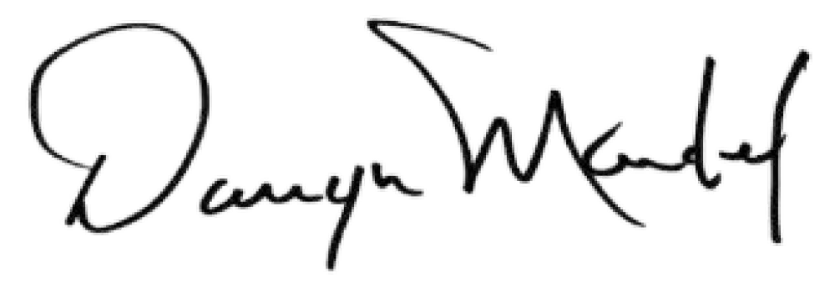

Darryn Mandel, President

