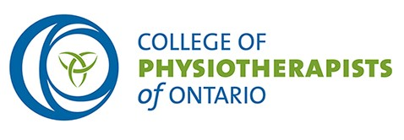

REQUISITION FOR A SPECIAL COUNCIL MEETING

From: Mr. Gary Rehan, President

To: Mr. Rod Hamilton, Interim Registrar

Date: October 3, 2018

I would like to ask you to convene an in-person Special Meeting of Council at 9:00 a.m. on Friday, October 12, 2018. The matters for decision at the meeting will be:
- advice to the College’s Quality Assurance Program working group,
- the College’s Advertising Standard and,
- the Appointment of non-Council Committee Members to the College’s Discipline/Fitness to Practise Committee and its Inquiries, Complaints and Reports Committee.

Gary Rehan, President
College of Physiotherapists of Ontario

NOTICE OF SPECIAL MEETING OF COUNCIL

Friday, October 12, 2018 at 9:00 am

In-person Meeting
A Special Meeting of the College of Physiotherapists of Ontario will take place on Friday, October 12, 2018 in the Council chamber of the College at 375 University Avenue, Suite 800, Toronto, Ontario. The matters for decision at the meeting will be:
- advice to the College’s Quality Assurance Program working group,
- the College’s Advertising Standard and,
- the Appointment of non-Council Committee Members to the College’s Discipline/Fitness to Practise Committee and its Inquiries, Complaints and Reports Committee.
The meeting will convene at 9:00 a.m. on Friday, October 12, 2018.

Gary Rehan, President
College of Physiotherapists of Ontario

