COVID-19: Infection Prevention and Control (IPAC) for Regulated Health Professionals

Anne Augustin MLT CIC, IPAC Specialist – Response and System Support
Catherine Richard PT CIC, Regional IPAC Specialist-East

Current as of June 22, 2020

current as of the date it was presented or recorded
- For any discrepancy between this information and your College’s guidance, please contact your College

Be aware of the routine and COVID-19 specific IPAC measures they need to take to protect patients and staff
  - Know where to obtain Ministry guidance and PHO resources to support safe clinical practice

Our mandate is to provide scientific and technical advice and support to clients working in government, public health, health care, and related sectors

Public Health Units (PHU)

PHU locator

Getty image

Resources (continued)

Public Health Ontario’s Role

Scientific and technical advice on IPAC
- Contact for questions on IPAC best practices and how to implement them within your setting

Public Health Unit’s Role

Responsible for enforcing and direction related to a number of Public Health issues including IPAC
- Involved in Outbreak management
- Contact for questions on exposures, clearance, testing and contact tracing

IPAC Regional Support Teams

- ipaceast@oahpp.ca
613-903-4180 or 1-866-833-8868
- ipacnorth@oahpp.ca
1-888-378-4916
- ipacwest@oahpp.ca
226-779-1940 or 1-866-916-1127
- ipaccentralwest@oahpp.ca
519-624-9781 or 1-866-276-6995
- ipaccentral@oahpp.ca
647-260-7560 or 1-866-285-3525
- Use this map to help locate your region

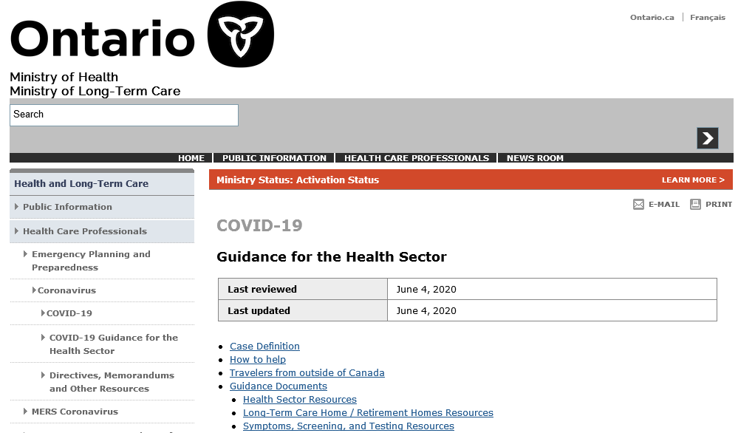
Source: Ontario. Ministry of Health. COVID-19: guidance for the health sector [Internet]. Toronto, ON: Queen’s Printer for Ontario; 2020 [cited 2020 May 25]. Available from: http://www.health.gov.on.ca/en/pro/programs/publichealth/coronavirus/2019_guidance.aspx

Source: Ministry of Labour website https://www.ontario.ca/page/ministry-labour-training-skills- development

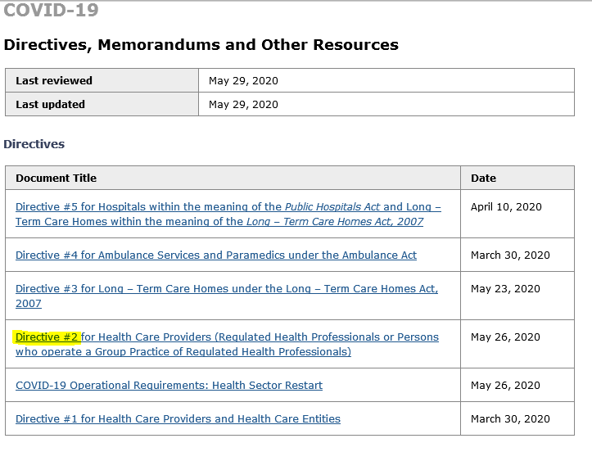
Source: Ontario. Ministry of Health. COVID-19: orders, directives, memorandums and other resources [Internet]. Toronto, ON: Queen’s Printer for Ontario; 2020 [cited 2020 Jun 16]. Available from: http://www.health.gov.on.ca/en/pro/programs/publichealth/coronavirus/dir_mem_res.aspx

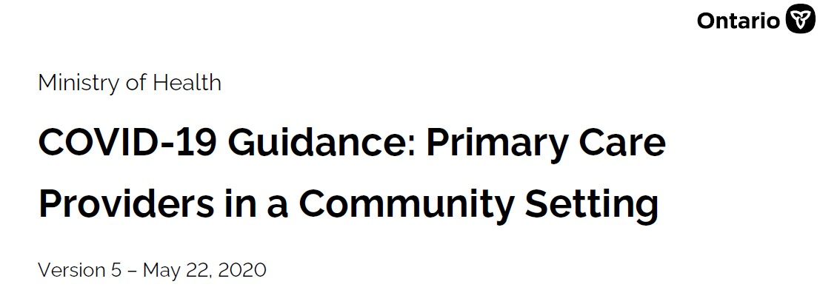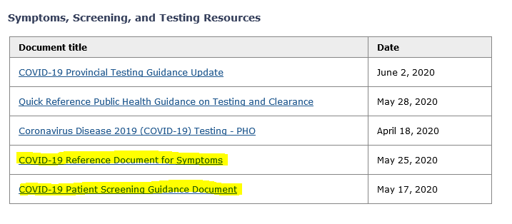MOH Guidance for Primary Care

Source: Ontario. Ministry of Health. COVID-19: guidance for the health sector [Internet]. Toronto, ON: Queen’s Printer for Ontario; 2020 [cited 2020 Jun 16]. Available from: http://www.health.gov.on.ca/en/pro/programs/publichealth/coronavirus/2019_guidance.aspx

Health Care Resources

Ii) MyPHO

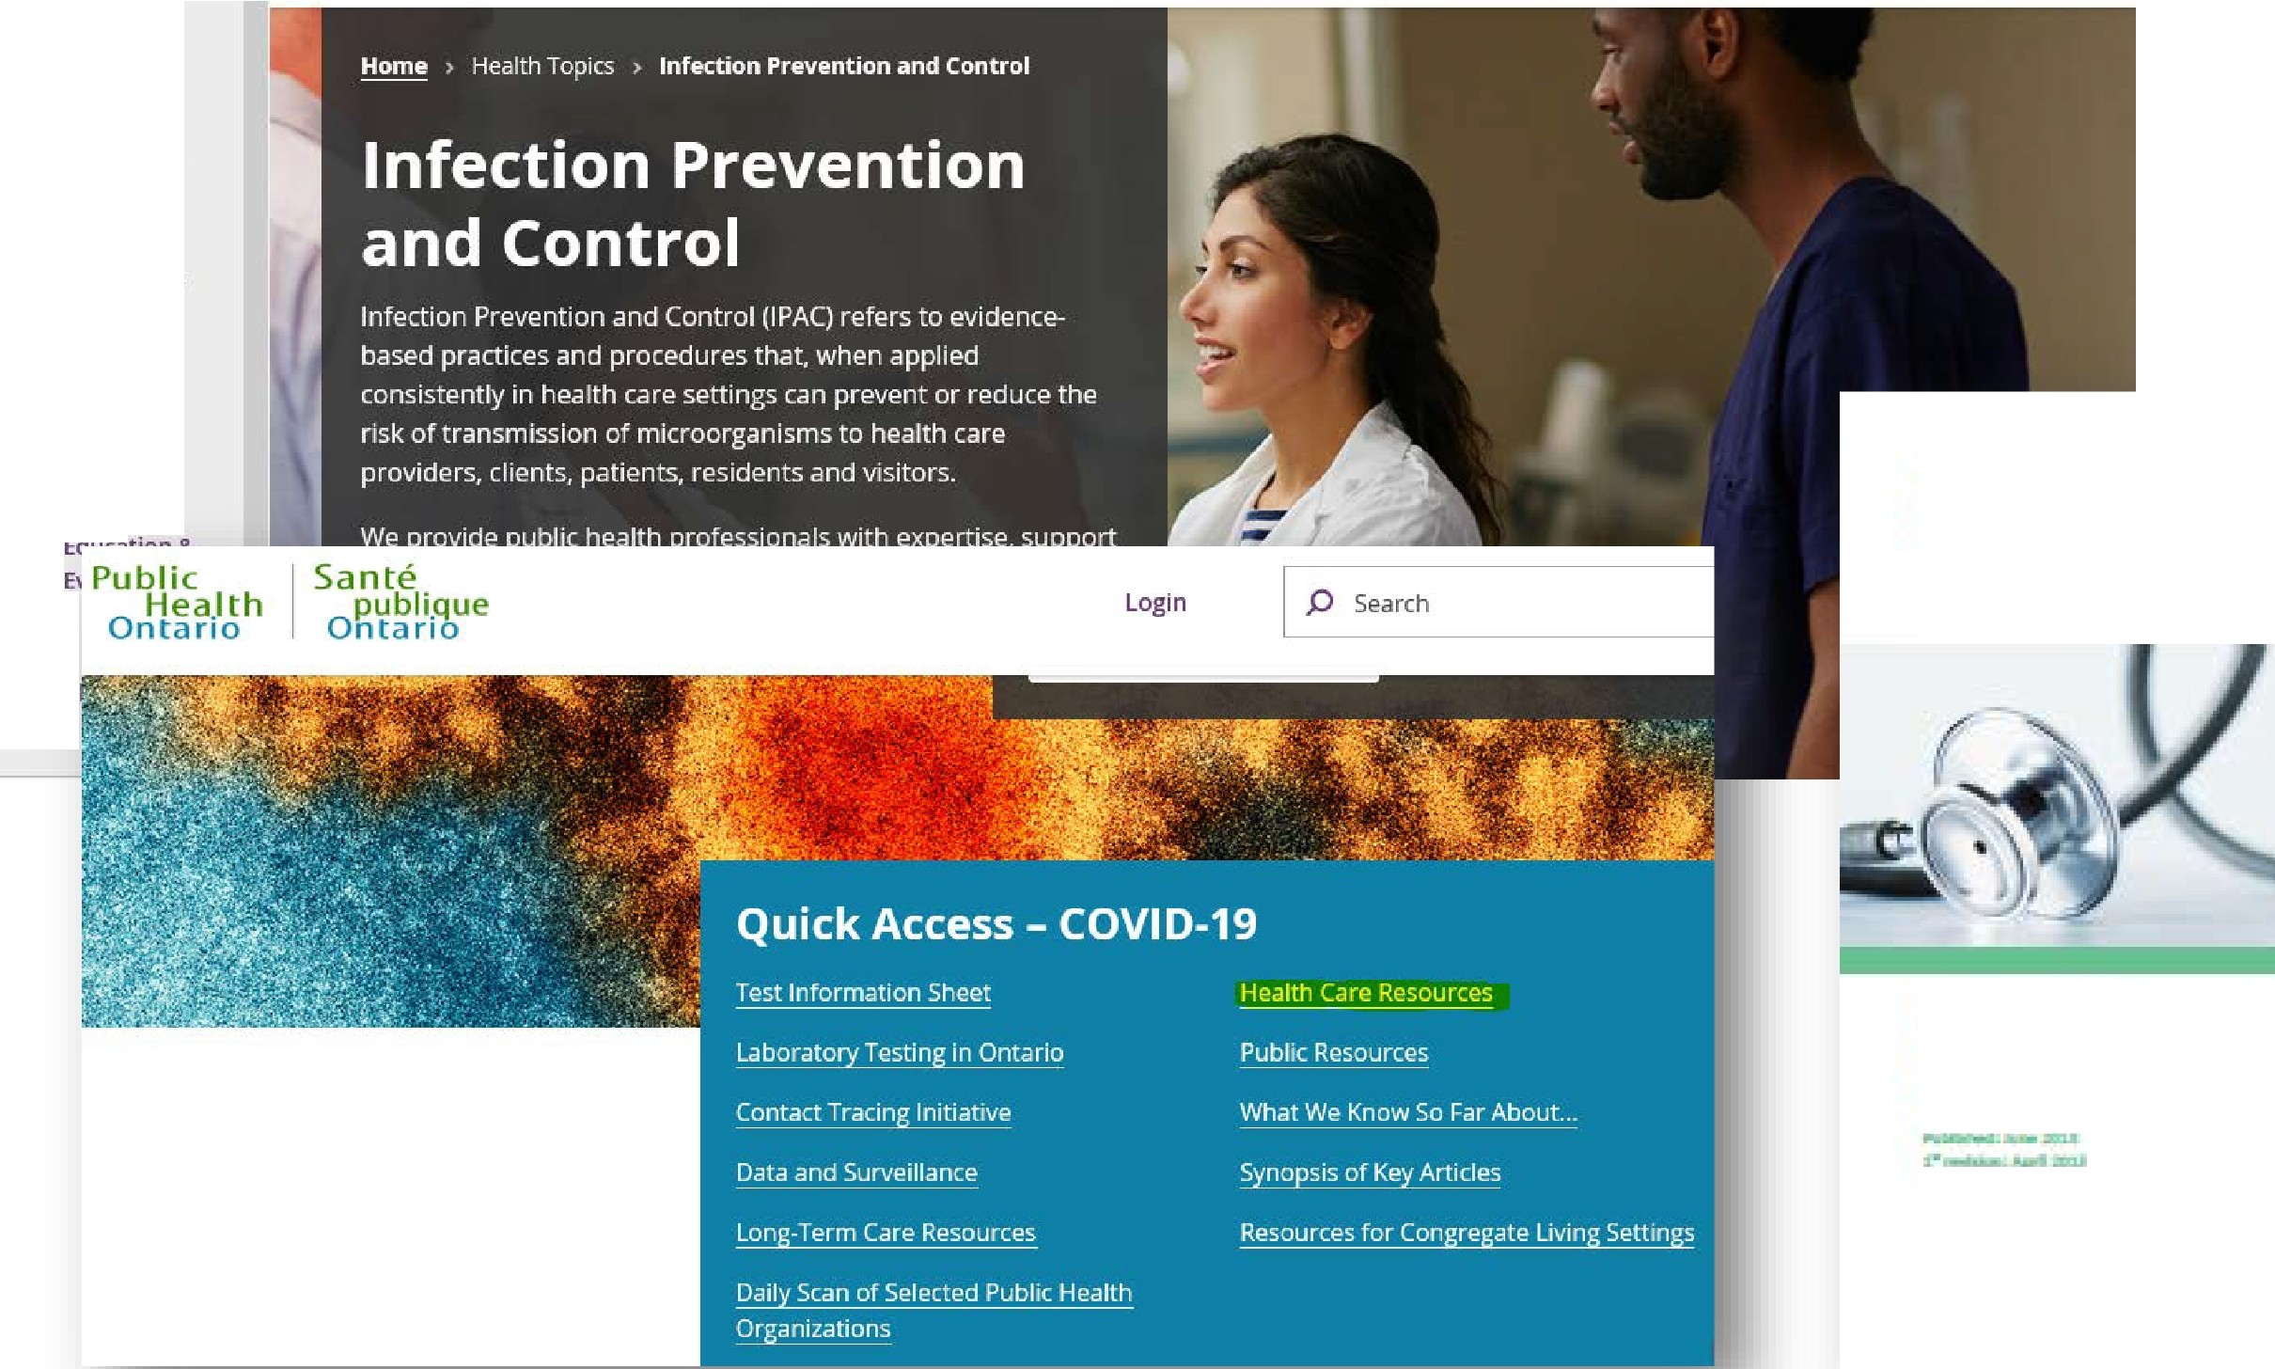Health Topics
I
•

Diseases &
Conditions

Laboratory
Services
r,, Public
Hea.lth
0
ntario
Sante
publi_qu e
Ontario

Login

I P Sear ch

Data &
0
Analysis

IJI
.A

F0l1rt1ilom
,
I 'i .l ll l l'
1 &titli
'
.. -

PublicHealthOntario.ca

lme ct i:a .n Prev e1nt io111 a 111d Co m ro l
for i nk a l Office Pr actice

PlOAC

Public Health Ontario website:

9

Mode of Transmission for COVID-19
- The mode of transmission of COVID-19 is through direct contact and respiratory droplets
- The majority of cases have been linked to person-to-person transmission

People shed the most virus just before their symptoms appear
- Respiratory droplets can be propelled up to 2 metres(m) but occasionally have been found up to 4 m away

Transmission through the ocular surface (eye) is also considered a possible route of transmission

Ontario Agency for Health Protection and Promotion (Public Health Ontario). COVID-19– what we know so far about… routes of transmission [Internet]. Toronto, ON: Queen’s Printer for Ontario; 2020 [cited 2020 Jun 22]. Available from: https://www.publichealthontario.ca/-/media/documents/ncov/wwksf-routes-transmission-mar-06-2020.pdf?la=en

- Most IPAC practices are the same ones that are to be performed at all times (Routine Practices)
- With the COVID-19 pandemic, there are some measures in addition to Routine Practices
Routine Practices COVID-19 Measures
Risk Assessment Universal/Full-shift Masking
Hand Hygiene Signage and Screening
Personal Protective Equipment (PPE) Enhanced Environmental Cleaning

Environmental Controls (e.g., cleaning equipment and environment)
Administrative Controls (e.g. staff education, Occupational Health)
Occupational Health – Self-monitoring, self-isolation
Physical Distancing and Waiting Room Set-up

Ontario Agency for Health Protection and Promotion (Public Health Ontario), Provincial Infectious Diseases Advisory Committee. Routine practices and additional precautions in all health care settings. 3rd ed. Toronto, ON: Queen’s Printer for Ontario; 2012. Available from: https://www.publichealthontario.ca/-/media/documents/b/2012/bp-rpap-healthcare-settings.pdf?la=en

The system of infection prevention and control practices recommended by the Public Health Agency of Canada to be used with all patients during all care to prevent and control transmission of microorganisms in all health care settings
Risk Assessment:

A Point of Care Risk Assessment (PCRA) is to be performed prior to any patient interaction to assess and analyze the potential for exposure to infectious disease
PHO Personal Risk Assessment Modules
Ontario Agency for Health Protection and Promotion (Public Health Ontario), Provincial Infectious Diseases Advisory Committee. Routine
practices and additional precautions in all health care settings. 3rd ed. Toronto, ON: Queen’s Printer for Ontario; 2012. Available from: https://www.publichealthontario.ca/-/media/documents/b/2012/bp-rpap-healthcare-settings.pdf?la=en

Consists of the use of alcohol-based hand rub (ABHR) or hand washing
- In health care, use of ABHR is preferred unless hands are visibly soiled

ABHR 70-90% alcohol preferred
- Ensure hand hygiene products are available at point of care

Gloves are not a substitute for hand hygiene
- Do not use ABHR on gloves
Ontario Agency for Health Protection and Promotion (Public Health Ontario), Provincial Infectious Diseases Advisory Committee. Best practices for hand hygiene in all health care settings. 4th ed. Toronto, ON: Queen’s Printer for Ontario; 2014. Available from: https://www.publichealthontario.ca/-/media/documents/B/2014/bp-hand-hygiene.pdf?la=en

  - Don’t come to work ill (COVID-19 symptoms can be very mild)
  - Respiratory symptoms
  - Vomiting and/or diarrhea
  - Conjunctivitis
- Annual influenza vaccine
- Maintain all other vaccinations

Requirements for the employer to report if the health care provider’s illness is determined to be work-related
  - Consult your Occupational Health department or the Ministry of Labour

are not to be reprocessed and/or reused
- Re-usable critical and semi-critical medical equipment/devices are reprocessed based on Spaulding classification

Examples:
  - Pessary sizing kit – semi-critical – minimum level high level disinfection; sterilization preferred
  - Intramuscular stimulation (IMS) plunger – sterilization
  - Respiratory equipment – high-level disinfection/pasteurization

Ontario Agency for Health Protection and Promotion (Public Health Ontario), Provincial Infectious Diseases Advisory Committee. Best practices for cleaning, disinfection and sterilization of medical equipment/devices in all health care settings. 3rd ed. Toronto, ON: Queen’s Printer for Ontario; 2013. Available from: https://www.publichealthontario.ca/-/media/documents/b/2013/bp-cleaning- disinfection-sterilization-hcs.pdf?la=en

The Same - Reprocessing – Complex Process

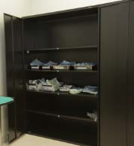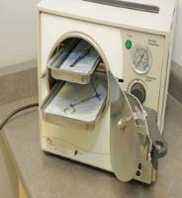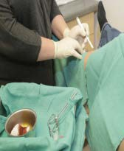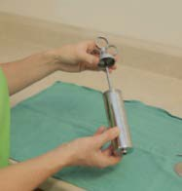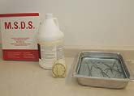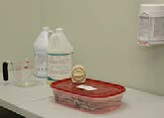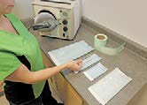
Patient
use
Sterilize
Package
Storage
and Transport
Clean
Inspect
and Dry
Pre-clean

Quality Assurance

Source: Ontario Agency for Health Protection and Promotion (Public Health Ontario). Infection Prevention and Control (IPAC) – online learning: reprocessing in community health care settings [Internet]. Toronto, ON: Queen’s Printer for Ontario; c2020 [cited 2020 Jun 17]. Available from: https://www.publichealthontario.ca/en/LearningAndDevelopment/OnlineLearning/InfectiousDiseases/Reprocessing/Pages/Course.aspx

The Same – Laundry

Wear gloves if contaminated with blood or body fluids; wear a gowns if likely to contaminate your clothing
- Handle laundry gently without shaking; no pre-rinsing

Specific requirements for laundering facilities in healthcare settings – including clinical offices
  - Separate space with negative pressure relative to surrounding areas
  - Hand hygiene facilities
  - Operate and maintain commercial laundry machines as per manufacturers instructions for use

Other option - third-party commercial laundering service
- Household laundry equipment and laundromats – do not meet the requirements for laundry in a healthcare setting e.g. prolonged high temperatures
Ontario Agency for Health Protection and Promotion (Public Health Ontario), Provincial Infectious Diseases Advisory Committee. Best practices for environmental cleaning for prevention and
control of infections in all health care settings. 3rd ed. Toronto, ON: Queen’s Printer for Ontario; 2018. Available from: https://www.publichealthontario.ca/-/media/documents/b/2018/bp- environmental-cleaning.pdf?la=en

  - Dirty tissues and PPE

Regular waste stream
    - Dispose of items into a hands free waste receptacle

Biomedical waste

Sharps container (acupuncture needles, needles)
    - Soiled materials that are so wet that blood can be squeezed out of them – biomedical waste container (i.e., yellow bag)

Ontario Agency for Health Protection and Promotion (Public Health Ontario), Provincial Infectious Diseases Advisory Committee. Best practices for environmental cleaning for prevention and control of infections in all health care settings. 3rd ed. Toronto, ON: Queen’s Printer for Ontario; 2018. Available from: https://www.publichealthontario.ca/-/media/documents/b/2018/bp-environmental- cleaning.pdf?la=en

practices of the clinic/office
  - IPAC CHECKLIST FOR CLINICAL OFFICE PRACTICE Core Elements

IPAC CHECKLIST FOR CLINICAL OFFICE PRACTICE Reprocessing of Medical Equipment/Devices

Use of PPE is determined by your PCRA:

Gloves:

Gloves are task-specific and single-use for the task
    - Do not use in hallways or non-patient care areas

Gowns:
    - Disposable or reusable

Surgical/procedure Mask:

No cloth masks for health care workers
    - Dispose of mask if it becomes wet or soiled
Ontario Agency for Health Protection and Promotion (Public Health Ontario), Provincial Infectious Diseases Advisory Committee. Routine practices and additional precautions in all health care settings. 3rd ed. Toronto, ON: Queen’s Printer for Ontario; 2012. Available from: https://www.publichealthontario.ca/-/media/documents/b/2012/bp-rpap-healthcare-settings.pdf?la=en

Eye protection:
    - Goggles, face shield or visor attached to mask

N95 Respirator:

Must be fit tested
    - Only for AGMP with COVID-19 patients or for patients with airborne disease such as active TB

Aerosol-Generating Medical Procedures (AGMP)

Example: breath stacking, CPAP, high flow O2
    - Not: chest physiotherapy, stress test, oral hygiene

Recommended Steps for Putting on/Taking Off PPE

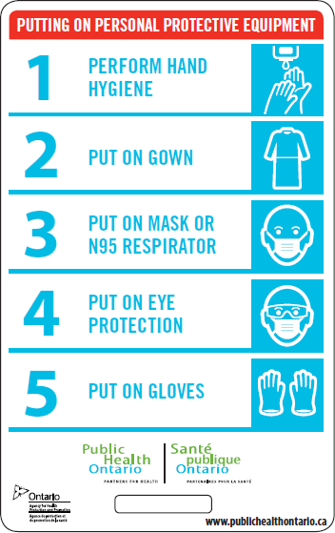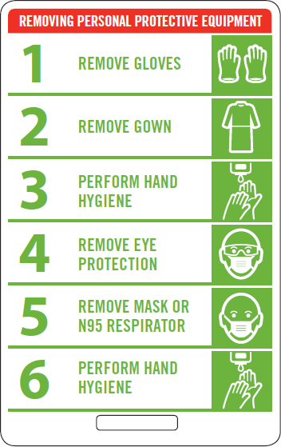

Source: Ontario Agency for Health Protection and Promotion (Public Health Ontario). Additional precautions signage and lanyard cards [Internet]. Toronto, ON: Queen's Printer for Ontario; 2020 [cited 2020 May 25]. Available from: https://www.publichealthontario.ca/-
/media/documents/l/2013/lanyard-removing-putting-on-ppe.pdf?la=en

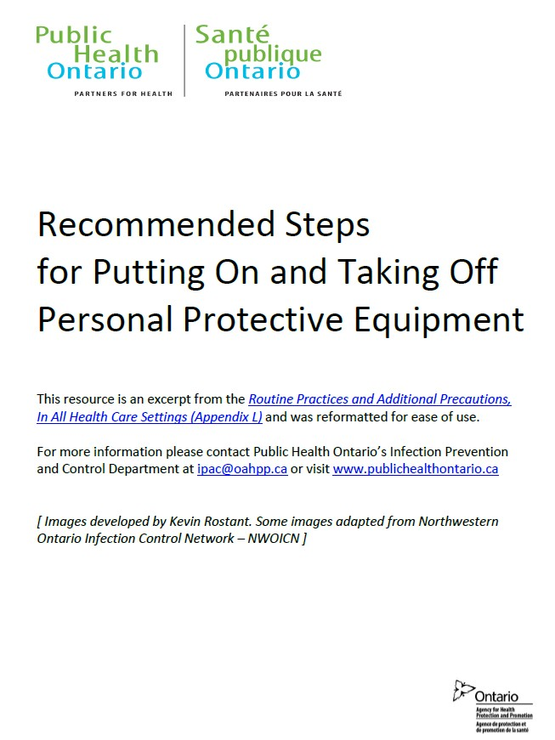

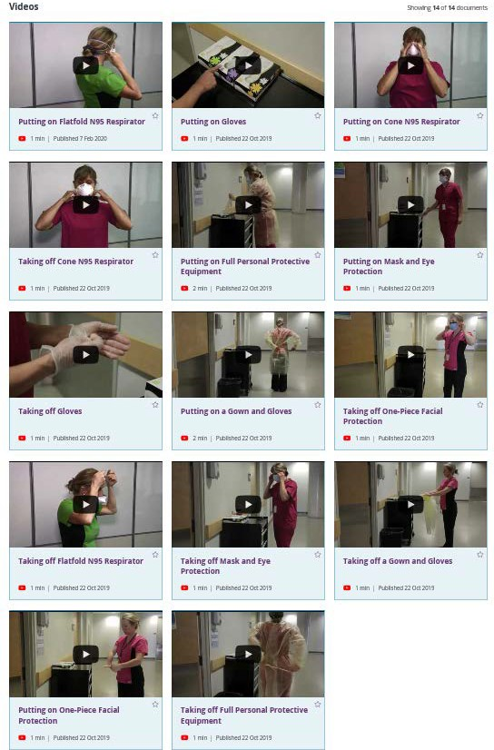
Source: Ontario Agency for Health Protection and Promotion (Public Health Ontario). Recommended steps for putting on and taking off personal protective equipment [Internet]. Toronto, ON: Queen's Printer for Ontario; 2020 [cited 2020 May 25]. Available from: https://www.publichealthontario.ca/-/media/documents/r/2012/rpap-recommeded-ppe-steps.pdf?la=en

Ontario Agency for Health Protection and Promotion (Public Health Ontario). Routine practices and additional precautions [Internet]. Toronto, ON: Queen’s Printer for Ontario; 2020 [cited 2020 Jun 17]. Available from: https://www.publichealthontario.ca/en/health-topics/infection-prevention-control/routine-practices-additional-precautions

Infection Prevention and Control Fundamentals
  - Best practice training resources

Meant to serve as an introduction to prepare newly introduced health care professionals with the fundamentals of infection prevention and control (IPAC)
  - Can also be used by health care professionals of all levels to build on existing IPAC knowledge

Ontario Agency for Health Protection and Promotion (Public Health Ontario). Infection prevention and control fundamentals [Internet]. Toronto, ON: Queen's Printer for Ontario; 2020 [cited 2020 May 19]. Available from: https://www.publichealthontario.ca/-
/media/documents/ncov/ipac/ipac-fundamentals.pdf?la=en

ACTIVITY | HCW PPE
Before every patient interaction | HCW must conduct a point-of-care risk assessment to determine the level of precautions required
All interactions with and within 2 metres of patients who screen positive | Droplet and Contact Precautions:  - Surgical/procedure mask (fit-tested N95 respirator for aerosol generating medical procedures)  - Isolation gown  - Gloves  - Eye protection (goggles or face shield)  - Perform hand hygiene before and after contact with the patient and the patient environment and after the removal of PPE
All interactions with and within 2 metres of patients who screen negative | - Surgical/procedure mask required  - Use of eye protection (goggles or a face shield) should be considered  - Perform hand hygiene before and after contact with the patient and the patient environment and after the removal of PPE
Ontario. Ministry of Health. COVID-19 operational requirements: health sector restart [Internet]. Toronto, ON: Queen’s Printer for Ontario; 2020 [cited 2020 May 19]. Available from: http://www.health.gov.on.ca/en/pro/programs/publichealth/coronavirus/docs/operational_requirements_health_sector.pdf

COVID-19 PPE Resources

IPAC Recommendations for Use of Personal Protective Equipment for Care of Individuals with Suspect or Confirmed COVID-19
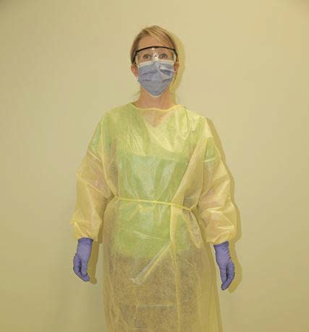
  - Droplet and Contact Precautions Non-Acute Care Facilities

Ontario Agency for Health Protection and Promotion (Public Health Ontario). IPAC recommendations for use of personal protective equipment for care of individuals with suspect or confirmed COVID-19 [Internet]. Toronto, ON: Queen’s Printer for Ontario; 2020 [cited 2020 May 19]. Available from: https://www.publichealthontario.ca/-/media/documents/ncov/updated-ipac-measures-covid-19.pdf?la=en
Source: Ontario Agency for Health Protection and Promotion (Public Health Ontario). PPE. Reprocessing photo shoot [IPAC Image Library].

One access point
  - Signage at access point
    - Form of passive screening COVID-19 Reference Document for Symptoms
    - Asking patients/clients to clean hands and don a mask

ABHR
  - Masks for patients/clients and essential visitors/support persons (for those who do not have their own)

Practice respiratory etiquette
  - Tissues

Hands free waste receptacle
Ontario. Ministry of Health. COVID-19 guidance: primary care providers in a community setting. Version 5 [Internet]. Toronto, ON: Queen’s
Printer for Ontario; 2020 [updated 2020 May 22; cited 2020 Jun 16]. Available from: http://www.health.gov.on.ca/en/pro/programs/publichealth/coronavirus/docs/2019_primary_care_guidance.pdf

Stagger appointments
  - Number of people in the waiting space – patients/clients and essential visitors/support person

Physical distancing

Chair spacing
    - Maintaining two metres (six feet) in the waiting area and between health care workers (HCWs)

Remove toys and magazines

    - Signage at the entry to your area/office/clinic

Active

Patients/clients are to be screened over the phone for symptoms of COVID-19 before scheduling appointments using the COVID-19 Patient Screening Guidance Document
    - Patients/clients and their essential visitor/support person are screened again on arrival to the clinic
      - Consider the use of a protective barrier for staff conducting the active screening
      - If no protective barrier the staff would use Droplet/Contact Precautions
Ontario. Ministry of Health. COVID-19 guidance: primary care providers in a community setting. Version 5 [Internet]. Toronto, ON: Queen’s Printer for Ontario; 2020 [updated 2020 May 22; cited 2020 Jun 16]. Available from: http://www.health.gov.on.ca/en/pro/programs/publichealth/coronavirus/docs/2019_primary_care_guidance.pdf

COVID-19 – Management of Patient Who
Screens Positive

If a patient screens positive over the phone, the appointment should be deferred if possible and the individual referred for testing
  - Only see patients, who screen positive, in person if you are able to follow Droplet and Contact Precautions and are knowledgeable on how to properly don and doff PPE

Patients who screen positive at the office should be:
    - given a surgical/procedure mask and be advised to perform hand hygiene
    - Immediately placed in a treatment area away from others

Ontario. Ministry of Health. COVID-19 operational requirements: health sector restart. Version 1 [Internet]. Toronto, ON: Queen’s Printer for Ontario; 2020 [updated 2020 May 26; cited 2020 Jun 16]. Available from: http://www.health.gov.on.ca/en/pro/programs/publichealth/coronavirus/docs/operational_requirements_health_sector.pdf

Masking of patients/clients and their essential visitor/support person
  - Cloth masks or procedure mask

Full-shift Masking
  - Surgical/procedure mask is also recommended for all staff working outside of direct patient care areas when interacting with other HCPs and staff and physical distancing cannot be maintained
  - Masks should be discarded once removed – limited supplies - re-used as long as they are not visibly soiled, wet or otherwise damaged.

Ontario. Ministry of Health. COVID-19 guidance: primary care providers in a community setting. Version 5 [Internet]. Toronto, ON: Queen’s Printer for Ontario; 2020 [updated 2020 May 22; cited 2020 Jun 16]. Available from: http://www.health.gov.on.ca/en/pro/programs/publichealth/coronavirus/docs/2019_primary_care_guidance.pdf

symptoms at home and at work
- Feeling unwell?
  - While at work – Immediately self-isolate (i.e., remove yourself from providing care) and limit interactions with other staff
  - While at home – Immediately self-isolate in your home. Do not go to work
  - In either case, notify your immediate manager/supervisor and/or Occupational Health and Safety Department; contact your health care provider, Telehealth, your local public health unit
- Healthy work place – do not come to work when you are ill

daily)
  - Cleaning and Disinfection for Public Settings
- Treatment areas
  - All horizontal surfaces, and equipment used on the patient (e.g., exam table, thermometer, BP cuff) should be cleaned and disinfected before another patient is brought into the treatment area or used on another patient

Plexiglass barriers are to be included in routine cleaning (e.g. daily)
  - Use a cleaning product that will not affect the integrity or function of the barrier

Ontario. Ministry of Health. COVID-19 operational requirements: health sector restart. Version 1 [Internet]. Toronto, ON: Queen’s Printer for Ontario; 2020 [updated 2020 May 26; cited 2020 Jun 16]. Available from: http://www.health.gov.on.ca/en/pro/programs/publichealth/coronavirus/docs/operational_requirements_health_sector.pdf

Clean before you disinfect - combination cleaner/disinfectants area available
- Disinfectants require a drug identification number (DIN)

Ready to use is preferred; no spray or trigger bottles
- If not using ready to use – follow the manufacturer’s directions for dilution exactly

Ensure you have the correct contact time
  - Item must wet with disinfectant
  - Allow to dry – do not wipe off

Ontario. Ministry of Health. COVID-19 operational requirements: health sector restart. Version 1 [Internet]. Toronto, ON: Queen’s Printer for Ontario; 2020 [updated 2020 May 26; cited 2020 Jun 16]. Available from: http://www.health.gov.on.ca/en/pro/programs/publichealth/coronavirus/docs/operational_requirements_health_sector.pdf

- Considerations:

Try to find a cleanable alternative
  - Dedicating to one patient/have patient bring in their own

Patient cleans hands before and after
  - If patient showing symptoms of communicable illness, defer use of this type of equipment

Laminate paper products for wiping
  - If equipment becomes damaged or soiled, replace

Barriers, covers

- CSA Group. CAN/CSA-Z314-18: Canadian medical device reprocessing. Toronto, ON: CSA Group; 2018.
- Ontario. Ministry of Health. COVID-19 guidance: occupational health and safety and infection prevention & control [Internet]. Toronto, ON: Queen’s Printer for Ontario; 2020 [updated 2020 Mar 20; cited 2020 Jun 16]. Available from: http://www.health.gov.on.ca/en/pro/programs/publichealth/coronavirus/docs/2019_occu pational_health_safety_guidance.pdf
- Ontario. Ministry of Health. COVID-19 guidance: primary care providers in a community setting. Version 5 [Internet]. Toronto, ON: Queen’s Printer for Ontario; 2020 [updated 2020 May 22; cited 2020 Jun 16]. Available from: http://www.health.gov.on.ca/en/pro/programs/publichealth/coronavirus/docs/2019_prim ary_care_guidance.pdf
- Ontario. Ministry of Health. COVID-19 operational requirements: health sector restart [Internet]. Toronto, ON: Queen’s Printer for Ontario; 2020 [cited 2020 May 19]. Available from: http://www.health.gov.on.ca/en/pro/programs/publichealth/coronavirus/docs/operationa l_requirements_health_sector.pdf

- Ontario Agency for Health Protection and Promotion (Public Health Ontario). Coronavirus Disease 2019 (COVID-19): universal mask use in health care [Internet]. Toronto, ON: Queen’s Printer for Ontario; 2020 [cited 2020 Jun 16]. Available from: https://www.publichealthontario.ca/-/media/documents/ncov/ipac/faq-covid-19- universal-mask-use-health-care.pdf?la=en
- Ontario Agency for Health Protection and Promotion (Public Health Ontario). COVID- 19– what we know so far about… routes of transmission [Internet]. Toronto, ON: Queen’s Printer for Ontario; 2020 [cited 2020 Jun 22]. Available from: https://www.publichealthontario.ca/-/media/documents/ncov/wwksf-routes- transmission-mar-06-2020.pdf?la=en
- Ontario Agency for Health Protection and Promotion (Public Health Ontario), Provincial Infectious Diseases Advisory Committee. Best practices for cleaning, disinfection and sterilization of medical equipment/devices in all health care settings. 3rd ed. Toronto, ON: Queen’s Printer for Ontario; 2013. Available from: https://www.publichealthontario.ca/-/media/documents/b/2013/bp-cleaning- disinfection-sterilization-hcs.pdf?la=en

References
- Ontario Agency for Health Protection and Promotion (Public Health Ontario), Provincial Infectious Diseases Advisory Committee. Best practices for environmental cleaning for prevention and control of infections in all health care settings. 3rd ed. Toronto, ON: Queen’s Printer for Ontario; 2018. Available from: https://www.publichealthontario.ca/-/media/documents/b/2018/bp-environmental- cleaning.pdf?la=en
- Ontario Agency for Health Protection and Promotion (Public Health Ontario), Provincial Infectious Diseases Advisory Committee. Best practices for hand hygiene in all health care settings. 4th ed. Toronto, ON: Queen’s Printer for Ontario; 2014. Available from: https://www.publichealthontario.ca/-/media/documents/B/2014/bp- hand-hygiene.pdf?la=en
- Ontario Agency for Health Protection and Promotion (Public Health Ontario), Provincial Infectious Diseases Advisory Committee. Routine practices and additional precautions in all health care settings. 3rd ed. Toronto, ON: Queen’s Printer for Ontario; 2012. Available from: https://www.publichealthontario.ca/-
/media/documents/b/2012/bp-rpap-healthcare-settings.pdf?la=en

Questions

For More Information About This Presentation, Contact:

ipaceast@oahpp.ca ipacwest@oahpp.ca ipacnorth@oahpp.ca ipaccentral@oahpp.ca ipaccentralwest@oahpp.ca
ipac@oahpp.ca

Public Health Ontario keeps Ontarians safe and healthy. Find out more at PublicHealthOntario.ca

