Testifying at a Discipline Hearing

A Guide for Witnesses

The College of Physiotherapists of Ontario is a not-for-profit organization created by the government to ensure that physiotherapists in the province are practicing safely and delivering quality care. The College is responsible for investigating complaints made regarding the practice of physiotherapists in order to protect the public.

The most serious cases may be referred to the Discipline Committee of the College for a hearing, making up approximately 2 to 4% of the complaints received each year. You can see the types of cases that are referred to the Discipline Committee by reviewing prior discipline decisions.

What is a Discipline Hearing?
A hearing is a formal process where a panel consisting of physiotherapists and members of the public considers concerns and hears evidence about a physiotherapist's practice. The panel will then make a decision about whether or not the physiotherapist can continue to practice and if so, whether there should be any conditions on their practice.

Why Have I Been Asked to Testify at the Hearing?
You have been asked to share your story at the hearing because you have information that may help the panel understand what happened in a specific case.

Before the Hearing

How Can I Prepare for the Hearing?
You will receive a copy of the information you shared with the College during the investigation phase (the interview) several weeks in advance of the hearing. A lawyer who works with the College will contact you to go over the information that you provided and talk about the questions that s/he will be asking you at the hearing. The lawyer can also answer any questions that you may have.

What Happens If, Due to an Emergency I Cannot Attend the Hearing?
If an emergency arises that makes it impossible for you to attend the hearing, please call the Hearings Office immediately. Telephone messages can be left 24 hours a day, at (416) 591 3828 or 1(800) 583-5885 extension 231.

Where are Discipline Hearings Held?
In most cases, discipline hearings are held at the College offices at 375 University Avenue suite 800 in Toronto. In certain circumstances, the hearing may be held at another location, which will be communicated to you.

How Do I Get to the College?
The College is located in downtown Toronto and is easily accessible by car, subway (St. Patrick station), bus and train. The College is a 20-minute walk north of Union Station and short distance away from the island airport (Porter airlines).

There are several public parking lots in the area, including underground parking in the College's office building.

Are My Expenses Covered?
Yes. For witnesses who testify on behalf of the College, there will be reimbursement for actual reasonable travel expenses, parking costs, mileage (.52cents / km) and for those travelling from outside the Greater Toronto Area, hotel accommodations. PLEASE SAVE ALL OF YOUR RECEIPTS.

Hotels near the College:

Sheraton Centre Toronto Hotel 123 Queen Street West 416-947-4800
Hilton Toronto 145 Richmond Street West 416-869-3456
800-445-8667
Metropolitan Hotel 108 Chestnut Street 416-977-5000
800-668-6600
Toronto Marriott Downtown 525 Bay Street 416-597-9200
800-905 0667

You will also be paid a per diem of $50.00 per day to cover your attendance at the hearing, which includes meals and incidental expenses. This fee is set by the court system and not the College.

Can I Bring a Support Person with Me?
Yes, you are welcome to bring a friend, relative or other support person with you to the
hearing. They can be with you in the room when you testify but they cannot participate in the process. Unfortunately, the College cannot cover the expenses for your support person.

What Should I Wear?
Discipline hearings are quite formal and all participants should dress appropriately. Business attire is highly recommended.

Can I Visit the College Before the Hearing?
Yes, you can arrange to visit the College prior to the hearing by contacting the Hearings Office. It may be possible to time your visit to coincide with another hearing that you can observe prior to testifying. Note that the College cannot cover any expenses associated with this visit as it is optional.

What If I Need Assistance or Accommodations?
If you have any particular needs, (i.e. the need for an interpreter, health-related concerns etc.) that may affect your ability to testify at the hearing or for which you require accommodation, please notify the Hearings Office as soon as possible.

Do I Have to Keep My Testimony Confidential?
The College asks that you not discuss your testimony with anyone until after the hearing. If you feel that it is important that you share this information with someone before or during the hearing, please discuss this with the College’s lawyer first.

I am Scared to Testify
Sharing your side of the story may be very difficult. Sometimes certain accommodations can be made to make the process less stressful. If you require such accommodations, please contact the Hearings Office.

The Day of the Hearing

What Happens When I Arrive at the College?
When you arrive at the College, someone will greet you and show you to the room that has been reserved for you. Snacks, meals and beverages will be provided for the duration of your time at the College.

You will find information in the room regarding how to access a phone, locate the washrooms, etc. If you need anything else please ask any staff member or dial extension 231 or 0 from your room.

You should plan to spend the entire day at the College. It is difficult to know in advance when you will be called to testify and how long your testimony will take. You might find it helpful to bring something to occupy your time while you are waiting.

What Will I See When I Walk into the Hearing Room?
A hearing is a formal process. People are referred to as Mr., Ms. etc and all participants have assigned seating.

Once you are seated and before you are asked any questions, a representative of the Discipline Committee will introduce everyone in the hearing room and affirm you prior to testifying. They will ask you to confirm that your testimony will be the truth.

You will see a court reporter who will record everything that is said during the hearing. S/he may use a keyboard or speak into a machine that looks like a cone shaped mask.

As a reminder please turn off your phone before you enter the hearing room.

Hearing Room Picture

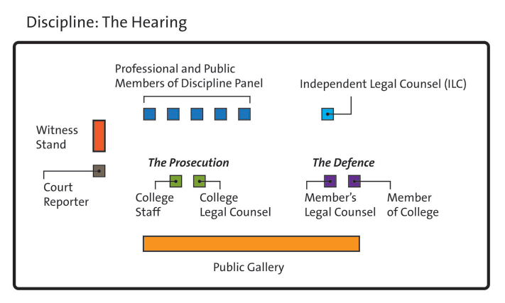

What Happens Next?
The College’s lawyer will ask you a series of questions, similar to the ones that you reviewed together before the hearing. Most witnesses provide information that is based on personal knowledge or observations of the events – this is an opportunity to share your story.

If the physiotherapist has a lawyer at the hearing they will likely have some questions for you. Additionally, the College’s lawyer may have some final questions.

Will There Be Breaks During the Hearing?
Yes. During the course of the hearing, there will be scheduled breaks in the morning, afternoon and at lunchtime. If you need a break during your testimony or have a health condition that may require regular breaks, let the Chair know, and s/he will arrange for a short break.

The College’s lawyer will often not be able to speak with you during the hearing as it is important that no one believes that you are being influenced in any way.

After You Testify

Can I Observe the Hearing After I Have Testified?
Yes, you can stay for the remainder of the hearing after you have testified, as discipline hearings are open to the public. In some cases, parts of a hearing may be closed to the public and all observers will be asked to leave the room during that time.

What Happens at the End of the Hearing?

The Discipline Committee will decide if, based on the information that they have heard, the physiotherapist is “guilty” or “not guilty” of professional misconduct or whether or not they are incompetent. If a physiotherapist is found guilty the panel may decide that one or more of the following outcomes are reasonable:
- That the physiotherapist is no longer allowed to practice as a physiotherapist
- That the physiotherapist should be reprimanded
- That the physiotherapist should be suspended
- That the physiotherapist can only continue to work under certain conditions (e.g. that the physiotherapist participate in a remediation program)
- That the physiotherapist pays a fine to the Government of Ontario

After the Hearing

Publication of Hearing Results
Once the hearing has been completed the panel will issue a written decision with reasons. A summary of this decision will be made available on the College’s website. A full version of the decision will be available on Canlii which is a legal database. In addition, any restrictions, terms, conditions or limitations on the physiotherapist’s ability to practice will be available on the public register.

If you would like to receive a copy of the decision after the hearing has finished, please let a staff member know.

Contact Information

What Is the College’s Address and Telephone Number?
The College of Physiotherapists of Ontario is located at 375 University Avenue, Suite 800 in Toronto, Ontario, M5G 2J5

Telephone: (416) 591-3828 or 1(800) 583 5885 extension 231
Email: hearingsoffice@collegept.org

Hearings Office
You can reach the Hearings Officer by calling the above numbers and dialing extension 231.

