Ontario Clinical Exam Candidate Technology Requirements
This document lists the basic technology requirements for candidates registered to participate in a virtual session of the Ontario Clinical Exam (OCE). Candidates are responsible for verifying their device and internet connection before their scheduled exam.
Additional details about room set up and technology will continue to be posted to the College website.
All testing should be done using the device you will be using on exam day. You must test from the exact location where you will be sitting on exam day.
If you are using a work device for the OCE be sure to check the firewall settings (see steps below) before the exam to be sure that your webcam, screen share, headset and microphone will function properly.
During the exam you will be able to see and hear your examiners and they will be able to see and hear you. You will also be asked to share your screen during the exam. You are required to share your screen for the entire exam.
Important: Candidates are responsible for ensuring they can meet the device and internet connection requirements in order to complete their exam. If you are considering completing the exam outside of Ontario, you must make sure you can test your device and internet connection from the exact location where you will be sitting on exam day.
It is crucial that your device and internet connection meet the requirements in this document. If you are unsure, please reconsider where you plan to complete the exam.
Please note: The OCE is recorded for quality assurance purposes.
General Questions? Contact the Exam Team
It is your responsibility to test your device and internet connection and resolve any issues that you encounter before your exam day. College staff will not help candidates to complete device checks or to complete and/or troubleshoot internet testing.
Staff are available to answer general questions about the virtual administrations of the Ontario Clinical Exam. Please contact the exam team at exam@collegept.org or 1-800-583-5885 ext. 215.

Technology Accommodation
Candidates are responsible for taking all reasonable steps to ensure that they meet the technology requirements for their scheduled exam day.

Technology accommodation is meant to reduce barriers for candidates living in areas where internet access or infrastructure is limited or underdeveloped, such as rural or Northern areas of Ontario.

The College of Physiotherapists of Ontario does not have a centralized testing site. Technology accommodation is only for candidates who have exhausted all other possible options for meeting the technology requirements. We cannot provide technology accommodation based on preference only.

Technology accommodation does not guarantee that the exam will be free from technological issues. Internet connectivity can fluctuate based on multiple factors and the exam consists of three internet connections: the candidate and two examiners. The technology accommodation provides opportunities for candidates who would otherwise be unable to attempt the OCE due to circumstances beyond their control.

Exam Device Requirements
- Candidates can only use a PC or Mac laptop or desktop computer to complete the OCE. Laptops and computers should always be plugged into a power outlet during the exam.
- Candidates CANNOT use an iPad to complete the OCE. Chromebook, iPads, tablets, mobile phones or smartphones do NOT meet the exam requirements and must NOT be used for the exam.
- A headset is strongly encouraged to improve sound quality for both candidates and examiners and reduce background noise during the exam.
- A portable webcam is required. Your camera must be turned on for the entire duration of the exam. You will be required to move around the room with your webcam to complete a mandatory room security check before starting the exam.
Important: You can use an external or built-in webcam as long as it is portable. You must be able to pick it up and move around the room to show the examiner your space.
For example, if you are using a laptop, you can use the built-in webcam by picking up your laptop and moving around the space. If you are using a desktop computer with a built-in webcam that can’t move, you will need to use an external webcam to move around the space.
- Candidates are NOT allowed to use additional screens or devices during the exam. You may use ONE desktop or laptop screen only. If an additional screen is detected it will be logged as a candidate conduct incident during the exam and could impact your ability to complete the exam.

Testing Your Device Set Up
To verify that your device meets the specifications to run the exam, please complete the Amazon Chime Readiness Check before your exam date.
Follow the instructions on how to complete the Amazon Chime Readiness check. After completing the check of your device, you should have 0 errors.
Note: You do NOT need to download Chime at the end of the test. Close the browser window when you have completed the test.

Using a Work Device or Completing the Ontario Clinical Exam at a Worksite
Physiotherapists work in a variety of settings. The following information may apply to you, and it is your responsibility to complete the required checks well before your exam day to avoid any issues.
If you decide to take your exam in the workplace, you must verify with your IT department or team that external web links are accessible and not blocked by the network firewall. The software used to run the OCE called Practique will need to be whitelisted (this allows the Practique website/URL to be accessed by the candidate while using workplace Internet connection and weblinks) by your IT support team.
If you are using a work laptop, ensure you review the firewall settings before the exam and confirm that all functions work, including the webcam, screen share, headset, and microphone. This may be a more common issue if you are completing the exam from a hospital-based worksite.
Internet Connection Requirements:
- For the best experience, candidates should be ‘hard wired’ or have their ethernet cable plugged directly into their device. Alternatively, candidates may choose to use an internet booster if their router is less accessible.
- If you are using a work device, ensure that you have checked the firewall settings ahead of time to confirm that you can access the exam site and that your microphone and webcam function properly.
- You should NOT use a 'Hotspot' connection with another mobile device.
Testing Internet Connectivity
- A stable internet connection with sufficient bandwidth is necessary. A minimum of 3.0 mbps upload and download speed is required. You can check your upload and download speed for free.
- Tests on internet speed should be done using the same device (PC or Mac laptop or desktop) and in the exact same location that will be used on the day of the exam.
- On exam day, please make sure nobody in your location is using the internet connection for streaming services or gaming. This may reduce the quality of your connection and impact your ability to complete the exam.
Browser Requirements
- Candidates must have the latest version of Chrome or Safari installed on their device.
- The OCE must be completed using Chrome, or Safari only. Microsoft Edge, Firefox, or other browsers are NOT recommended and can present compatibility issues.
Please note: When logged into the exam, staff can see which browser you are using. If you log in using the incorrect browser, you will be asked to log out of the exam and log back in using the correct browser. This will be logged as a tech incident on exam day.
Operating System and Storage
Candidates must ensure that their computers have an up-to-date operating system (OS) installed and sufficient disk space. OS requirements:
- Windows: minimum Windows 8 or 10
- MacOS 10.15: Catalina – 7 October 2019
- MacOS 11: Big Sur – 12 November 2020
Note: There is further information about how to check these below
- Hard drive storage space: Minimum 20 GB free space on the desktop/laptop
- RAM requirements: Desktop and laptop, 4 GB minimum and 8 GB recommended

Checking Hard Drive (HDD) Storage
Minimum 20GB free space on a device is required.
Mac
- Open the Apple menu, then select ‘About This Mac’.
- Click the Storage tab in the toolbar to see how much disk space you have available. On OS X Mountain Lion or Mavericks, click the ‘More info’ button, then click ‘Storage’.
Windows
- Open File Explorer. You can use the keyboard shortcut – Windows key + E – or click the folder icon in the task bar.
- Click ‘This PC’ from the left pane on your screen.
- You can see the amount of free space on your hard disk under the Windows (C:) drive, in the right pane.

Checking RAM
Mac
- Open the Apple menu.
- Click on the Apple logo in the top-left corner of your screen and select ‘About This Mac’. On the Overview tab, the Memory line lists the amount of RAM in GB. Ensure you have at least 4 GB; we recommend 8 GB.
Windows
- Right-click the Start menu or press the Windows key on your keyboard to open the start menu and type ‘About’ and press enter when ‘About your PC’ appears or select ‘About your PC’.
- A new window will open. On the right side of the window scroll down and, under device specifications, you will see ‘Installed RAM’. Ensure you have at least 4 GB of usable RAM; we recommend 8 GB.

Amazon Chime Readiness Check
- Open the Amazon Chime Readiness check.

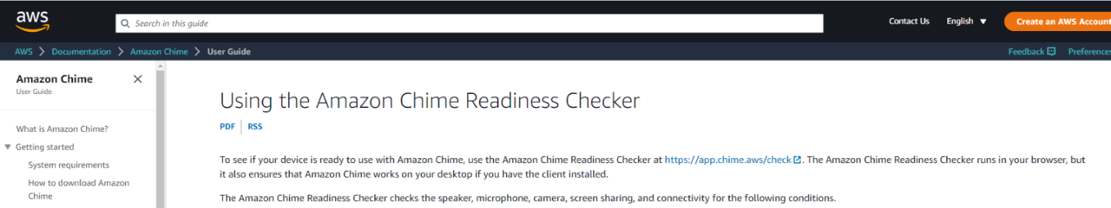

2. Select the Chime Check link to run the test.
Information outlined below on this website provides trouble shooting information should one piece of your set up not meet the device requirements.
The test will open once you click the link. If you have a headset, make sure it is connected before you run the test. Next Click the “Check my Device” button to run the test.
3. The test will run.
- The first check is of your sound. A tone will play. Listen for the tone. If you can hear the tone, click “yes”. This means your headset or speakers are working. If you do not hear a tone, click “no”. This means your headset or speakers are not working properly and further troubleshooting is required. Refer to the main Amazon Chime Readiness Check page for troubleshooting prompts.
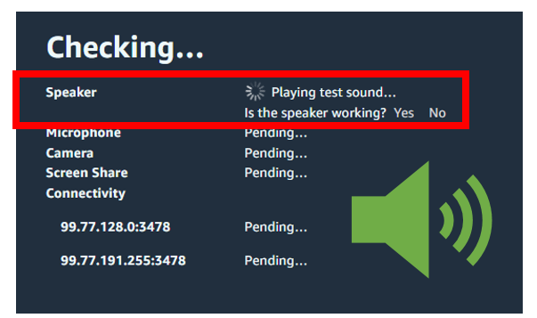
b) The test will continue to run and check the rest of your device functions.
c) When the test is complete. You should see all device areas have checkmarks beside them.
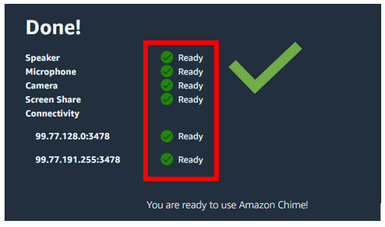
d) If one area does not have a check mark, you will need to follow the prompts to fix the issue.
