December 2017 | info@collegept.org

Welcome to the December Issue

'Tis the season! On behalf of the College I am wishing you the very best of the holiday season.

Between sips of eggnog, I hope that you will have a moment to check out my latest blog post, which is about potential changes to the College's Quality Assurance program. I'd love to hear what you think about our proposal.

Enjoy Perspectives, and I'll see you next year! Shenda

Registrar

Read Shenda's Blog

Wishing Everyone a Happy and Healthy Holiday Season and Best Wishes for the New Year
Holiday Hours:
The office will be closed from December 25 to January 1 (inclusive) and will re-open on Tuesday, January 2.

No L a u g h in g Ma t te r - Ca s e o f th e Mo n th

Just in time for the holidays, we meet a PT who violated her patient's privacy by secretly recording his physiotherapy session on her cell phone and sharing the footage with a colleague.

Patient's Privacy Violated

Pra c t ic e Ad v ic e Qu e s t io n

Practice Advice: What is a lock box?

Get the Answer

Co l le g e
Ev e n t : Bra mp to n , Kitc h e n e r, Pe te rb o ro u g h & Mo re

Brampton, Kitchener, Peterborough, Mississauga, and Hamilton - you are up! We're looking forward to seeing you at our Changes are Coming! Practice Assessment, Portfolio & PISA events in the new year.

Get involved and provide us with your input to help us develop the best program for Ontario PTs.

Registration is Easy

My th v s F a c t

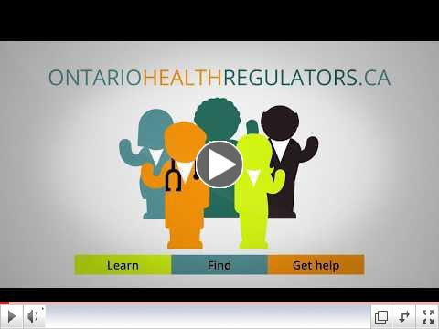
Myth vs Fact: Student names must be included on patient invoices.

Myth or Fact? Find Out

F re e Pre s c rip t io n Dru g Co v e ra g e F o r Ch i ld re n a n d Yo u th Sta rtin g J a n u a ry 1 , 2 0 1 8

As of January 1, 2018, prescription drugs in Ontario will be free for children and youth under the age of 24 years old. Click on the link below to get more details and find out what drugs will be covered.

Key Information Here

Ne w On ta rio He a l th Re g u la to rs Vid e o

Visit the OHR website

HIRE IEHPs

Hire IEHPs is offering a series of free online courses called Practice Readiness e- Learning Program (PReP): Communication Matters.

PReP is designed to help users understand various aspects of the Canadian workplace culture and communication to support successful workplace integration.

Learn more about the course.

Have a Look

Ge t CONF IDENT IAL Pra c t ic e Ad v ic e

The College provides a free and confidential advisory service available to physiotherapists, assistants, students, employers, patients and anyone else who has a question or needs to talk.

Speak with another PT live, Monday to Friday, 8:30 am to 5:00 pm. Make use of this great resource.

Contact the Advisor

PLEASE DO NOT UNSUBSCRIBE IF YOU ARE A MEMBER OF THE COLLEGE.
If members unsubscribe, they will be contacted to re-subscribe. The College communicates
to members by email, sending information such as tax receipts, Standards updates and mandatory registration requirements such as PISA, Jurisprudence and registration renewal.
We strive to keep communications relevant and to a minimum.

Questions, comments or suggestions related to e-Perspectives?
Get in touch at communications@collegept.org 416-591-3828 ext. 234 or 1-800-583-5885 ext. 234
www.collegept.org
Read the NEW Standard
Watch the Video
Collaborative Care (effective December 1, 2017)
Practice Assessment, Portfolio &
PISA Webinar

