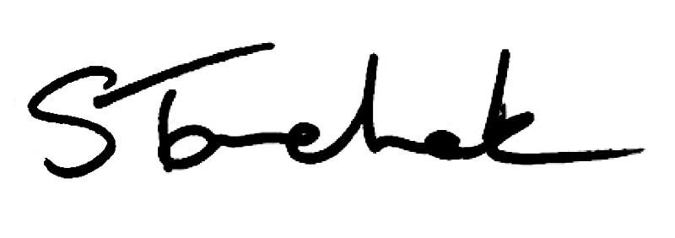

August 2017 | info@collegept.org

Welcome to the end of summer issue of Perspectives!

The brand new Supervision Standard officially comes into effect September 1, 2017.

Do you supervise students, volunteers or physiotherapist assistants? Take a few minutes to read the updated Standard as many of the changes directly impact the responsibilities you have as their supervisor.

I hope you've had a great summer and I'll see you in September. Shenda

Read Shenda's Blog

Ch a n g e s In Effe c t : T h e Pro te c t in g Pa t ie n ts Ac t

The Ontario government passed Bill 87, the Protecting Patients Act, on May 30, 2017.

This legislation brought in several changes to how Colleges deal with matters of sexual abuse. Read about the changes.

Changes Here

NEW Sta n d a rd In Effe c t Sta rtin g Ne x t Mo n th

The new Supervision Standard goes into effect September 1, 2017.

Make it a priority to become familiar with what's new. Here's a sample of some of the changes.
A supervised person cannot perform controlled acts the supervisor cannot perform.
Co-signing of student charting is now required.
The name and title of a supervised person must appear on patient invoices.
Find out what else is different at the link below.

Unsure about the new expectations? Contact the Practice Advisors for help at practiceadvice@collegept.org or call 647-484-8800/1-800-583-5885.

Review NEW Standard

L o o k in g F o r A Wa y T o Pro v id e Be t te r Pa t ie n t Ca re ?
I t ' s No w Po s s ib le

Physiotherapists now have the ability to continue to provide care to patients who started their treatment in Ontario, but live in or relocate to another province.

This category - called Independent Practice - Extended Access with Restrictions - is available across the country. It covers both in-person and tele-rehabilitation situations.

Find out more about how to apply, what is required, costs, and times.

Learn More

Writte n Pro to c o ls

As PTs you are aware that you need a written communication protocol when working with PTAs, but this begs the question: are there any other written protocols PTs should be aware of? The answer is YES.
Do you perform controlled acts? You'll need to have an adverse events protocol or written instructions on how to manage any adverse outcomes that can be reasonably foreseen.
You must have a way to inform each patient what the fees are for your physiotherapy services. You must always have a written process for routinely reviewing fees and billings done using your physiotherapist registration number.
You must keep records or a log that demonstrate your equipment is being inspected and maintained regularly.
If you are the Heath Information Custodian, you will need to have written privacy policies.

Any Questions?

T h e Co l le g e Is Co min g T o A City Ne a r Yo u !

The College is overhauling the practice assessment process, PISA and the portfolio to create a system that meets everyone's needs. We need to hear from you.

Join us in-person for: Changes are Coming to the Practice Assessment, Portfolio & PISA: Should They Stay or Should They Go?, an interactive session aimed at gathering ideas and discussing next steps.

Food and refreshments will be served!

When will the College be in your city?

Pra c t ic e Ad v ic e

I want to leave my practice. What should I do?

Register Here

My th v s F a c t

Myth vs Fact: The College regulate clinics.

Get the Answer

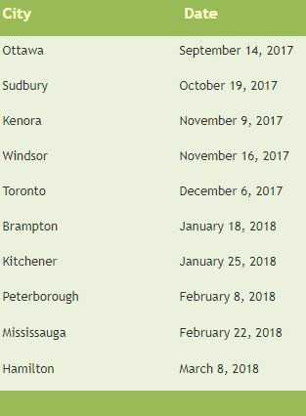
Myth vs Fact? Find Out

He lp fu l Re s o u rc e s fo r He a l th c a re Pro fe s s io n a ls

Here is a list of resources and links we think you'll find useful.

Is there a resource we've missed that you want to share? Tweet us your favourite go-to by clicking the link below. We love hearing from you!

Resource List:
The Role of Physiotherapy in Canada: Contributing to a Stronger Healthcare System Report
The Market Profile of Physiotherapists in Canada Briefing Physio Ignite - Become a better physiotherapist in community Hand Hygiene E-Learning - share with everyone in your office
Canadian Physiotherapy Association - questions about liability insurance and private practice issues
Canada Revenue Agency - If you are planning to start a business Join the Quality Improvement Community - Share, Learn and Innovate

Add to the List Here

Interviewing A Potential Employer?

Watch the Video
NEW Boundaries and Sexual Abuse

Read the Standard

Questions, comments or suggestions related to e-Perspectives?
Get in touch at communications@collegept.org 416-591-3828 ext. 234 or 1-800-583-5885 ext. 234
www.collegept.org

PLEASE DO NOT UNSUBSCRIBE IF YOU ARE A MEMBER OF THE COLLEGE.
If members unsubscribe, they will be contacted to re-subscribe. The College communicates
to members by email, sending information such as tax receipts, Standards updates and mandatory registration requirements such as PISA, Jurisprudence and registration renewal.
We strive to keep communications relevant and to a minimum.

