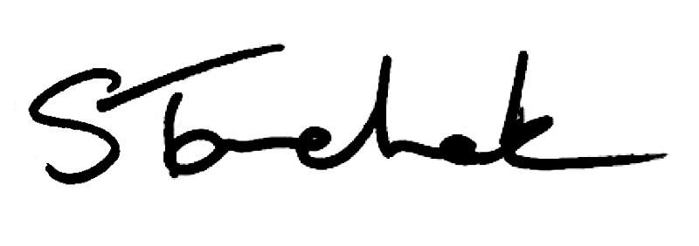

October 2017 | info@collegept.org

Welcome to the October Issue of Perspectives

Council had quite a meeting last month. They approved 3 new Standards.

I don't need to tell you that the Standards describe the expectations of your profession with respect to specific areas of practice. They form a significant part of the foundation against which physiotherapists are evaluated by their peers and patients, as well as in the Quality Assurance program or through the Investigations or Discipline Committees.

We have tried to make them easy to read and easy to find on our new website. Be sure to check them out.

Infection Control and Equipment Maintenance and the Record Keeping Standards both go into effect November 1, 2017, with the Collaborative Care Standard going into effect December 1, 2017.

And don't forget to read my new blog post. What do Harvey Weinstein and health regulation have in common? You'll have to read my blog to find out.

Enjoy Perspectives and I'll see you again next month.

Shenda

Read Shenda's Blog

Sig n Up fo r We b in a r - No v e mb e r 2 3

Changes are Coming to the Practice Assessment, Portfolio & PISA: Should They Stay or Should They Go? Webinar

Can't make it to our in-person event? Not to worry. We are holding a webinar on November 23 for anyone who is interested. Invite your employer or colleagues. Register for the webinar by clicking below.

Sign Up

NEW
In fe c t io n Co n tro l a n d Eq u ip me n t Ma in te n a n c e Sta n d a rd In Effe c t No v e mb e r 1 , 2 0 1 7

As of November 1, 2017, the new Infection Control and Equipment Maintenance Standard replaces the current Infection Control Standard. Click on the link below to read the new Standard and find out what's different.

Highlights include:
Updated terminology and resources on infection control
New equipment maintenance expectations: 1) use equipment that is maintained and safe, 2) document routine reviews of the maintenance and safety of equipment used

Read the Standard

NEW Re c o rd Ke e p in g Sta n d a rd In Effe c t No v e mb e r 1 , 2 0 1 7

November 1 might be a few days away, but you can access the new Record Keeping Standard before it goes into effect. Click on the link below to find out what's stayed the same and what is different.

Highlights include:
Information in clinical records must support physiotherapists' rationale for the care that they provide
PTs must ensure entries made by PTAs or other people they supervise meet the Standard

Read the Standard

PT As CANNOT Re mo v e Ac u p u n c tu re Ne e d le s

Under no circumstances can or should physiotherapists delegate any part
of acupuncture to physiotherapist assistants. This includes the removal of needles.

Why Can't PTs Delegate?

Ou tre a c h : Ke n o ra , Win d s o r, T o ro n to & Mo re

We're looking forward to seeing you at our next outreach event: Changes are Coming to the Practice Assessment, Portfolio & PISA: Should They Stay or Should They Go?.

Locations include: Kenora, Windsor, Toronto, Brampton, Kitchener, Peterborough, Mississauga and Hamilton.

Register Now

Ca s e o f th e Mo n th - Pila te s Is Not Ph y s io th e ra p y

In October's Case, we meet a physiotherapist and clinic owner who sent her patients for Pilates treatment and billed it as physiotherapy.

How do you think this story ends?

Read the Story

PT s mu s t Re p o rt Priv a c y Bre a c h e s to th e Co mmis s io n e r

Physiotherapists must notify the Information and Privacy Commissioner of Ontario about certain privacy breaches effective October 1, 2017.

More Details Here

Pra c t ic e Ad v ic e Qu e s t io n An s we re d

Question: A PT student on a placement with me has been regularly having coffee with one of the patients. What should I do?

Helpful Advice

2 0 1 6 - 2 0 1 7 An n u a l Re p o rt

Read our latest Annual Report, highlighting our major accomplishments over the past year and review the College's financials.

Read the Report

Co u n c i l Hig h l ig h ts

What happened at September's Council meeting? Read the Council highlights below to find out. Remember, everyone is invited to attend Council meetings. If you can't be here in person, you can follow us on Twitter as we live tweet the meetings at @CollegeofPTs.

Read the Highlights

Qu e s t io n Ab o u t T i t le : An ima l Re h a b i l i ta t io n

Question: When performing animal rehabilitation, can I use the title physiotherapist and can I bill the treatment as physiotherapy?

Yes or No?

My th v s F a c t

Myth vs Fact: Physiotherapists are allowed to offer discounts to patients.

Myth or Fact? Find Out

The Public Register

PLEASE DO NOT UNSUBSCRIBE IF YOU ARE A MEMBER OF THE COLLEGE.
If members unsubscribe, they will be contacted to re-subscribe. The College communicates
to members by email, sending information such as tax receipts, Standards updates and mandatory registration requirements such as PISA, Jurisprudence and registration renewal.
We strive to keep communications relevant and to a minimum.

Questions, comments or suggestions related to e-Perspectives?
Get in touch at communications@collegept.org 416-591-3828 ext. 234 or 1-800-583-5885 ext. 234
www.collegept.org

Watch the Video
Controlled Acts and Other Restricted Activities Standard

Read the Standard

