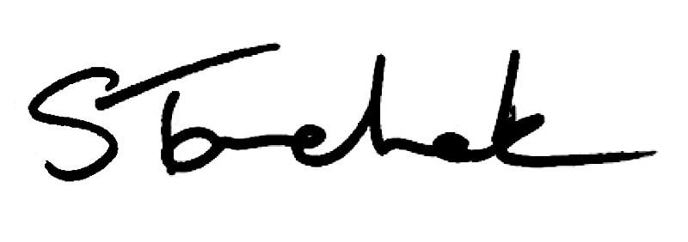

January 2017 | info@collegept.org

Welcome to the January Issue of Perspectives

Happy 2017! We're starting off the new year with a MUST READ edition of Perspectives. Please take time to find out what's new, what's changing and what's coming soon!

Below is important information on the new Advertising Standard (now in effect), a soon-to-be Fees, Billing and Accounts Standard, a PISA update, annual renewal details, a PTs Working with PTAs Webinar you should sign up for, Council Election nominations, an open By-Law Consultation, outreach events in Barrie and Ottawa, my Blog and more!

Happy reading, and I'll see you next month.

Shenda

NEW F e e s , Billin g & Ac c o u n ts Sta n d a rd o n th e Wa y

Starting March 1, 2017, a new Fees, Billing and Accounts Standard becomes effective. All physiotherapists are obliged to be aware of the changes.

Learn more about a new requirement to routinely review your fees, billings and accounts, the need to have a written process in place, being able to demonstrate the review was done, and if errors are discovered, taking reasonable steps to correct the error and document actions taken.

Click to See Standard

Do n ' t Mis s th e J a n u a ry 2 7 We b in a r o n Wo rk in g with
PT As

Join Shenda Tanchak, Darryn Mandel ,PT and Fiona Campbell, PT as they walk you through the changes to the revised Physiotherapists Working with Physiotherapist Assistants Standard, explain what these new expectations mean and answer questions. Everyone is welcome - employers, PTAs and students.

Date: Friday, January 27, 2017
Time: 12:15 pm to 1:15 pm EST

Sign up today to be a part of this hour-long, information session. Don't miss out!
Send questions you want answered during the live event to communications@collegept.org.

Register For The Webinar

Imp o rta n t Ne ws Ab o u t Pra c t ic e Mo n i to rs & PT
Re s id e n ts

Monitoring changes are being made for anyone holding a Provisional Practice certificate of registration as of April 1, 2017. It will apply to all PT Residents granted from April 1, 2017 onward.

If you act as a Practice Monitor or Supervisor or are a PT Resident please read the complete article to be sure you understand how these changes will affect you or your workplace.

Latest Changes Here

Co mp le te An n u a l PISA Be twe e n F e b ru a ry 1 to Ma rc h 3 1

Complete your annual Professional Issues Self-Assessment - PISA - this year between February 1 to March 31. The mandatory 7-question online exercise covers top practice advice questions the College receives.

Unlike the recent Jurisprudence Module, PISA has no passing mark. You are only required to have answered the 7-question online exercise and give some thought to these issues and resources.

Watch for an email from the College on February 1, 2017, with additional information and links or check the website. Send questions to communications@collegept.org.

I t ' s So o n T ime to Co mp le te An n u a l Re n e wa l - Sta rt Pre p a rin g

It's almost time to renew your registration. Beginning February 1 and running until March 31, all physios with an independent practice certificate must renew their registration.

But why not get started now? You can get a jump on it by updating activities you roster for or changing your employment or contact details now. Dig out your

insurance policy number and company name. Have you updated your professional portfolio recently? Don't forget you will need to declare it is updated when you renew.

Access The PT Member Portal

No w In Effe c t : REVISED Ad v e rtis in g Sta n d a rd

Please take a moment and review the revised Advertising Standard that came into effect January 1, 2017.

Find out how "advertisement" is defined, if ads can contain testimonials (no!) and what a physio's accountabilities are if their employer places an ad on their behalf.

Read the Standard, check out the FAQs and watch the video.

Advertising Standard Resources Here

Me mb e rs - Yo u r F e e d b a c k Is Ne e d e d - Op e n Co n s u l ta t io n

The College by-laws have undergone an overhaul to make them easier to understand and read. Along with that some changes are being proposed to requirements for those people on Council and Committees, as well as changes to fees other than registration.

Comment on By-Laws

Ca l l in g All PT s - Co mp le te Ph y s io th e ra p y Pra c t ic e Su rv e y

Complete an important survey that will review and renew the Essential Competency Profile for Physiotherapists in Canada and develop Entry-to- Practice Milestones. Your help is needed!

The National Physiotherapy Advisory Group has a collaborative initiative called the Physiotherapy Practice Profile (Triple P) project. They are asking for your input by responding to the Physiotherapy Practice Survey.

Complete the Survey Now

Amazing Opportunity to Nominate a PT Peer - Council Election

Do you live in District 4-Eastern, District 5-Northern or District 8-Central?

Check your district here.

If so, you can nominate a peer to run for College Council or better yet, run yourself! It is an amazing opportunity for anyone looking for a challenge, wanting to give back and a chance to learn and grow as a professional.

Those physios living in a district up for election should watch their inboxes on January 19 for an email allowing them to nominate a peer.

See What It's All About

Su p e rv is io n Su rv e y - We Ne e d to He a r F ro m Yo u !

The College is conducting research for a NEW Supervision Standard and we need to know what you think about supervision.

If you are interested in participating on our short survey, please sign up below.

Sign Up Here

Ba rrie & Otta wa Ou tre a c h Ev e n ts : Sig n Up

An Evening with the College outreach events are coming to Barrie and Ottawa. Join the conversation about the new Physiotherapists Working with Physiotherapist Assistants Standard.

Everyone is welcome. Invite PT students, physiotherapist assistants, colleagues and employers. Ask questions and be a part of the conversation. Send questions ahead of time to communications@collegept.org.

Register Here

Co l le g e will ONL Y b e c o mmu n ic a t in g b y e ma i l

Starting April 1, 2017, all communications from the College will be electronic/email only.

This includes reminders about your regulatory obligations, notification of new or changed Standards, practice assessment alerts and your tax receipts.

This makes it incredibly important that you have a unique, working email address on file with the College, otherwise you will miss crucial information. If your email address changes, please update it immediately with the College.

Update Your Information

My th v s . F a c t

True or False: My voice is not being heard. PTs don't have a role with regards to assessors and assessments. Only the Assessor's opinion matters.

Myth or Fact? Find Out

Are You A New PT? Concurrent Treatment of a Patient by a Physiotherapist and Another
Health Care Professional

PLEASE DO NOT UNSUBSCRIBE IF YOU ARE A MEMBER OF THE COLLEGE.
If members unsubscribe, they will be contacted to re-subscribe. The College communicates
to members by email, sending information such as tax receipts, Standards updates and mandatory registration requirements such as PISA, Jurisprudence and registration renewal.
We strive to keep communications relevant and to a minimum.
Questions, comments or suggestions related to e-Perspectives?
Get in touch at communications@collegept.org 416-591-3828 ext. 234 or 1-800-583-5885 ext. 234
www.collegept.org
Read the Standard
Watch the Video

