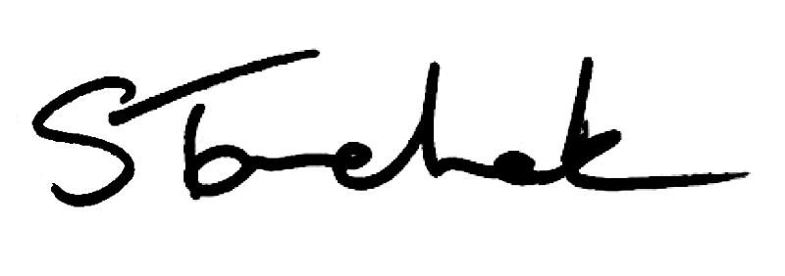

February 2017 | info@collegept.org

Welcome to the February Issue

Doing The Right Thing - Nobody Said It Was Going To Be Easy. It's the title of my latest blog post, and an expression I'm sure we've all heard before. It also happens to be true.

Doing what is right and what is best will make you feel uncomfortable at times and can sometimes be messy. However, the consequences of not doing what's right and in the best interests of patients FAR outweigh your momentary feelings of discomfort.

Read more of my thoughts on this subject here and don't be afraid to leave a comment. I want to hear from you. Enjoy your read and we'll talk again in March.

Shenda

Read Shenda's Blog

Bill 8 7 - Pro te c t in g Pa t ie n ts Ac t - Up d a te

The Ontario government has put forward proposed legislation to greatly increase the College's ability to protect patients who experience sexual abuse.

Read Proposed Changes

Did Yo u Mis s th e Wo rk in g with PT As We b in a r? No p ro b le m. Wa tc h th e Arc h iv e d Ve rs io n

If you work with assistants, take an hour and watch the recent Physiotherapists

Working with Physiotherapist Assistants Standard webinar.

Get answers to the most common questions and watch the Registrar, Shenda Tanchak, Council member, Darryn Mandel and the Senior Physiotherapist Advisor, Fiona Campbell run through real life scenarios and discuss how to apply the Standard to practice.

Access the Webinar Here

Ca s e o f th e Mo n th - No Se c o n d Ch a n c e

What happens when the Ministry of Health and Long-Term Care has concerns about a physiotherapist's record keeping and treatment practices? Find out more in February's Case of the Month.

Read the Story

Co l le g e By - la w Ch a n g e s - Ple a s e Co mme n t

The College recently reviewed its By-Laws to make them easier to read and understand. While there are numerous changes from the current version, the majority do not have an effect on the intent. However, there are some changes considered more significant and the College would appreciate your input. Answer our 9-question survey.

Review the By-laws

NEW F e e s , Billin g & Ac c o u n ts Sta n d a rd - Ma rc h 3 1 L a u n c h

Starting March 1, 2017, a new Fees, Billing and Accounts Standard will come in effect. All physiotherapists are obligated to be aware of changes to the rules.
Please read and make any necessary changes now.

Got questions about how the changes will effect your practice? Contact the Practice Advisor - she is happy to help.

Click to See Standard

Keep Your Registration Number Safe

Watch the Video

Code of Ethics

Read the Code Of Ethics

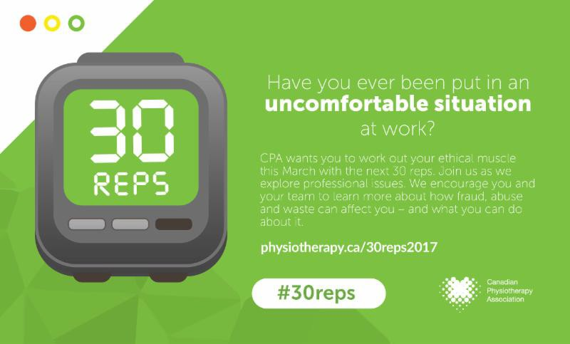

Questions, comments or suggestions related to e-Perspectives?

Get in touch at communications@collegept.org 416-591-3828 ext. 234 or 1-800-583-5885 ext. 234
www.collegept.org

PLEASE DO NOT UNSUBSCRIBE IF YOU ARE A MEMBER OF THE COLLEGE.
If members unsubscribe, they will be contacted to re-subscribe. The College communicates
to members by email, sending information such as tax receipts, Standards updates and mandatory registration requirements such as PISA, Jurisprudence and registration renewal.
We strive to keep communications relevant and to a minimum.

