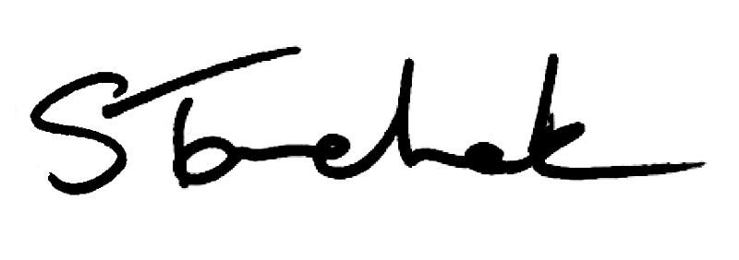

March 2017 | info@collegept.org

Welcome to the March Issue

Did you know that March is National Fraud Prevention Month? Have you ever been a victim of fraud or do you have fraud prevention tips you'd like to share? Tweet
us @collegeofpts using the #Fraud2017. Enjoy Perspectives and I'll see you in April! Shenda

Shenda' sBlog
Practice Advice Question

Question:

Can O2 titration be delegated to a physiotherapist assistant (PTA)?

Get The Answer Here

What the College Learned From YOU
If you weren't able to join her in person, read all about Fiona Campbell, PT and College Practice Adviser's experiences as she travelled across Ontario meeting with more than 800 PTs, PTAs and employers.

G et answers to the big 5 questions physiotherapists asked.

Read All About It
Case of the Month: Restraints - Helpful or Harmful?
Are restraints helpful or harmful when used with high risk patients? This month's Case comes directly from a Coroner's Report and a Ministry of Health request to share these events as a lesson learned and opportunity to improve.

Find out What Happened

Consent E- Learning Module

Here's a little consent refresher. Get reacquainted with the key principles of consent and test your knowledge. A great education opportunity for students, new PTs in your workplace or physiotherapist assistants as well.

Consent is always a conversation with your patient, never just ticking a box.

What is Consent?

PLEASE DO NOT UNSUBSCRIBE IF YOU ARE A MEMBER OF THE COLLEGE.
If m em bers unsubscribe, they will be contacted to re-subscribe. The College com m unicates to m em bers by em ai l , sending inform ation such as tax receipts, Standards updates and
m andatory registration requirem ents such as PISA, Jurisprudence and registration renewal.
We str ive to keep com m unications relevant and to a m inim um .

Questions, comments or suggestions related to e-Perspectives?
G et in touch at communications@collegept.org 416-591-3828 ext. 234 or 1-800-583-5885 ext. 234
www.collegept.org
Read the Code Of Ethics
Watch our Video on
Advertising

