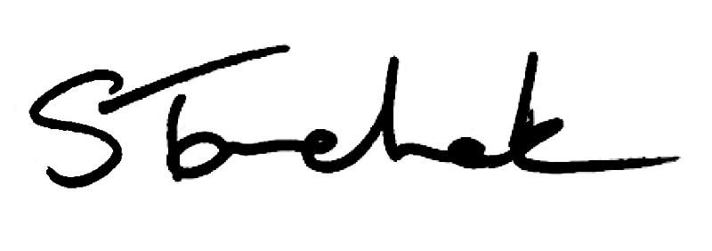

April 2017 | info@collegept.org

Welcome to the April Issue

Elections are over and I want to extend huge congratulations to Nicole Graham who was elected in the Northern District and to Gary Rehan and Catherine Hecimovich for their re-elections in the Eastern District and Central District respectively. We're looking forward to continuing to work with Gary and Cathy and to welcome Nicole to Council.

There is something else that I wanted to make sure that you know about - beginning in May the College will review all PT websites for compliance with the recently updated Advertising Standard. We'll let you know if we find out that your website is breaking the rules so that you can make the changes.

Keeping scrolling to get more details on what this means and what you can do if you're unsure if your website is compliant.

See you next month,

Shenda
Read Shenda's Blog

Imp o rta n t : Co l le g e to Re v ie w All PT We b s i te s

Starting in May, the College will review all websites (with the exception of hospitals) to make sure everyone is following the Advertising Standard that came into effect in January 2017.

If you or the clinic you work for have a website, please review the Advertising Standard now.

Not sure if your site is okay? The College's Practice Advisor is happy to help: practiceadvice@collegept.org or 1-800-583-5885 ext. 241.

Read the Standard

Pra c t ic e Qu e s t io n

Question:

The new Controlled Acts and Other Restricted Activities Standard says I need a written plan for managing adverse events. What would that look like?

Have a Look

A Big T h a n k s to 8 , 9 3 3 PT s Wh o Co mp le te d PISA!
T h e Qu e s t io n s & An s we rs a re He re

Hip Hip Hooray! PISA is complete for another year (watch for it again in February 2018). And, can you believe there are now almost 9,000 registered physios in Ontario?

A number of people reached out asking to see the questions, answers and related links again. Happy to provide.

Remember, you can always contact the Practice Advisor if you are unsure of what to do in any situation at practiceadvice@collegept.org.

PISA Questions & Answers Here

Ca s e o f th e Mo n th

It's one, two, three strikes and you're out! Professional accountability and supervision are up to bat for April's Case of the Month.
Read this Fascinating Case

Wh a t to Do i f Ex p o s e d to Blo o d a n d Bo d y F lu id

You've been exposed to blood and/or body fluid - what do you do first?

The Physiotherapy Alberta College + Association partnered with 12 health regulatory Colleges in Alberta to create resources for health care professionals who have been exposed or are at risk of exposure to blood and body fluids.

Free Resources Here

My th v s . F a c t

Myth vs. Fact: The College can make or change rules on a whim.

Myth or Fact? Find Out

Po n d e rin g Ch a n g e s to Co l le g e Pra c t ic e
As s e s s me n ts

At a recent OPA InterACTION conference, College President Stephen Mangoff and Registrar Shenda Tanchak spoke to a group of 300 physiotherapy students and registered PTs about proposed practice assessment changes.

The current program has been in place for 13 years and research shows it's time to re-evaluate and update based on shifting practices, demographics and the risk research.
Read the Article Here

Co o rd in a t in g Ca re with Ch a n g in g Sc o p e s is T o u g h In te r- p ro fe s s io n a l Co l la b o ra t io n E- T o o l He lp s

Make collaborating with other health care professionals that much easier with
the Inter-professional Collaboration e-Tool. Create workflow plans and mark patient progress all in one place. Get information on scope of practice for each of the health care professions in one place.
Learn More Here

We ' re Mo v in g

If you are coming to the College or mailing us something, please be aware that as of May 1, we are relocating to another office within the same building.

Our new address is 375 University Avenue, Suite 800, Toronto ON M5G 2J5. Phone numbers will remain the same.

And remember, Council meetings are open to the public, so feel free to come by the new office and join us for Council meetings.
Join Us for Council

Watch the RECORD KEEPING Video

ADVERTISING Standard

PLEASE DO NOT UNSUBSCRIBE IF YOU ARE A MEMBER OF THE COLLEGE.
If members unsubscribe, they will be contacted to re-subscribe. The College communicates
to members by email, sending information such as tax receipts, Standards updates and mandatory registration requirements such as PISA, Jurisprudence and registration renewal.
We strive to keep communications relevant and to a minimum.

Questions, comments or suggestions related to e-Perspectives?
Get in touch at communications@collegept.org 416-591-3828 ext. 234 or 1-800-583-5885 ext. 234
www.collegept.org

