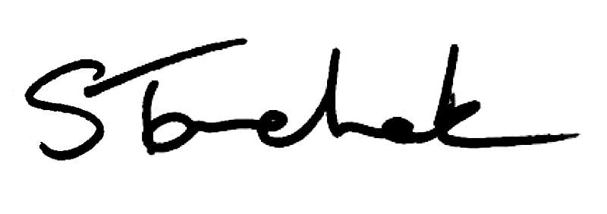

August 2017 | info@collegept.org

Wel come t o t he August i ssue of Per spect i ves
We all get busy and put things off - I am guilty of doing it. However, with four new Standards coming into effect over the coming months, this is something you can't put off - take 20 minutes and read through the new rules - see what the changes mean for you and your practice.

Start with the Boundaries and Sexual Abuse Standard that is in effect now.

Enjoy Perspectives! Shenda

NEW: Bo u n d a rie s a n d Se x u a l Ab u s e Sta n d a rd Effe c t iv e Au g u s t 1 , 2 0 1 7

The Bounda r i es a nd Sexua l Abuse St a nda r d impacts everyone. It covers all interactions you have with patients.

Within it you'll find a definition of sexual abuse (and it may be
broader than you think), an expanded definition of a patient, and

details on the one-year "cooling off" period between the end of the PT-patient relationship and a dating relationship and much more.

Be aware that the rule includes restrictions on treating relatives and friends and outlines your mandatory reporting requirements related to sexual abuse.

Rea d t he St a nda r d Now

COMING SOON: Se p te mb e r 1 , 2 0 1 7 Re v is e d Su p e rv is io n Sta n d a rd

There's a new Supervision Standard that applies to anyone
involved in patient care - this includes PT students, bridging program students, volunteers, PT Residents, other
physiotherapists, and PTAs.

Give it a read and you'll see that physios cannot supervise relatives or friends. A supervised person cannot perform controlled acts the Supervisor cannot perform. Co-signing of student charting is now required. And the name and title of a supervised person must
appear on patient invoices. Find out what else is new and different.

Rea d t he Super vi si on St a nda r d

Are PTs Required To Co-Sign PTA Notes?

Watch the Video
NEW Restricted Titles, Credentials and Specialty Designations

Read the Standard

2 - Min u te Su rv e y - T e l l Us Ho w to Be t te r Se rv e Yo u

We would really appreciate you taking a few minutes to tell us how we can make the practice advice service more useful to you, your

colleagues and patients.

Thanks so much for your ideas!

Compl et e t he Shor t Sur vey

Ca s e o f th e Mo n th

After a six-year absence, this PT failed to demonstrate the
requirements needed to be reissued an Independent Practice Certificate.

Rea d t he Ca se

Ba d Bu s in e s s Co s ts Us All

Taking personal liberties with your career might be an individual choice, but the consequences of such actions are far reaching.

How Ba d Busi ness Cost Us Al l

Wh y Ca n ' t PT As Re mo v e Ac u p u n c tu re Ne e d le s ?

We know it's a confusing exception, but there's history and reasoning behind it.

Fi nd Out Why Her e

My th v s . F a c t

Applying for registration in person does not make the process go faster.

Myt h or Fa ct ? Fi nd Out

Ca l l F o r Ab s tra c ts - OPA An n u a l Co n fe re n c e

The Ontario Physiotherapy Association (OPA) invites submissions of abstracts for educational sessions and the submission of abstracts related to original academic research, clinical research,
systematic reviews, and innovative special interest projects at their Inter ACTION 2018 conference.

Int er ACTION Conf er ence

F o l lo w Us o n F a c e b o o k

Why not follow us on Facebook and find out what's new, important or changing. Visit Our Facebook Page.

Let 's Be Fr i ends

Questions, comments or suggestions related to e-Perspectives?
Get in touch at communications@collegept.org 416-591-3828 ext. 234 or 1-800-583-5885 ext. 234
www.collegept.org

PLEASE DO NOT UNSUBSCRIBE IF YOU ARE A MEMBER OF THE COLLEGE.
If members unsubscribe, they will be contacted to re-subscribe. The College communicates
to members by email, sending information such as tax receipts, Standards updates and mandatory registration requirements such as PISA, Jurisprudence and registration renewal.
We strive to keep communications relevant and to a minimum.

