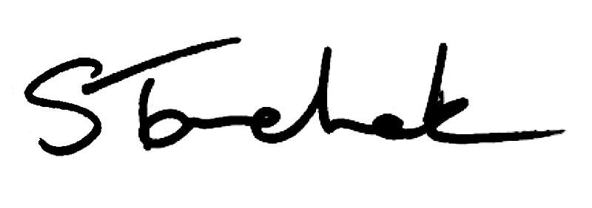

September 2017 | info@collegept.org

Welcome to the September Issue

The Ministry of Health and Long-Term Care has indicated it is taking steps to expand the scope of practice for physiotherapists. This is exciting news.

We'll continue to keep you up to date on all the progress through Perspectives.

Learn more about this development and read Ontario Health Minister Dr. Eric Hoskins' letter here.

Shenda

Read Shenda's Blog

PT s Be in g Ap p ro a c h e d T o Bre a k Ru le s - Do n ' t Do I t !

It's come to our attention that a law firm in the Ottawa area is approaching physiotherapists and offering them money in exchange for referrals to their practice.

Get the Details

Ne e d to Kn o w: Ch a n g e s to Pe rs o n a l He a l th In fo rma t io n Pro te c t io n Ac t

There have been a number of changes introduced to Ontario's Personal Health Information Protection Act. Learn more about what they mean for you as a regulated health care professional. They come into effect October 1, 2017.

Learn More Here

Is I t Ph y s io th e ra p y ? Ca s e o f th e Mo n th

Is what you're doing REALLY physiotherapy? Or is it something else?

In September's Case of the Month, we meet a physiotherapist whose use of "alternative therapies" doesn't quite fall under the scope of traditional physiotherapy.

And, have a look at a handy decision tool created to walk you through the decision- making process.

Is it Physiotherapy Case

Wh a t ' s In A Na me ?

Reminder: The name you use in practice must be the same name that is displayed on the Public Register. Physiotherapists should not be practicing under any name other than the one that appears on Find a Physiotherapist.

Do you go a by shortened version of your first name name and would you like it displayed on the Public Register? Simply submit a request to the College in writing to make it happen.

Contact Registration

Ho w to Co rre c t ly Us e Yo u r PT T i t le

Question: What is the correct way to use title when signing my name?

Answer :

Right Way

Robert Lille PT MSc (PT)

Ameer Brown PT MSc (PT), FCAMP

Wrong Way

Josine Grey B.Sc , MSc. PT

Jack Spratt FCAMP, MSc PT

Belinda Bowie M.Sc.PT, B.A., B.Sc.(Hons)

Dr. Francine Ramise RMT (PhD)

Have a look at the recently updated Restricted Titles, Credentials and Speciality Designations Standard for more information on use of title. If your questions are still unanswered, reach out to the Practice Advisor for answers.

Visit the Standard

T h e Co l le g e is Co min g to a City Ne a r Yo u ! Re g is te r No w

We hope to see you at our next outreach event: Changes are Coming to the Practice Assessment, Portfolio & PISA: Should They Stay or Should They Go?.

Locations include: Sudbury, Kenora, Windsor, Toronto, Brampton, Kitchener, Peterborough, Mississauga and Hamilton. See dates and locations and register by clicking below. Sandwiches and cookies will be served!

Can't make it to our in-person event? No problem. We are holding a webinar on November 23 for anyone who is interested. Invite your employer or colleagues.
Register for the webinar by clicking below.

Register for the Ci ty Nearest You

We b in a r No v e mb e r 2 3 : Ch a n g e s a re Co min g

Register for the webinar Changes are Coming to the Practice Assessment,

Portfolio & PISA: Should They Stay or Should They Go? taking place on Thursday, November 23.

Don't miss the chance to share you ideas about what changes are needed.

Register for Webinar

Is a F a c e b o o k Pa g e Co n s id e re d Ad v e rtis in g ?

Question: I heard that my clinic's Facebook page is considered "advertising." Is this true?

Answer: Yes it is. A Facebook page can be used for many reasons, but one of the primary reasons businesses have a Facebook page is to attract new patients.

As the clinic controls the Facebook page content, it is considered advertising, and the Advertising Standard applies. This means that there can be no patient reviews on the Facebook page. While LIKES are okay, ratings or stars are not permitted.

Advertising Standard

Pra c t ic e Ad v ic e Qu e s t io n An s we re d

I have a long-standing PT therapeutic relationship with an elderly patient who directs all her care. She confided in me that the support worker assigned to her is rude and difficult to have around. I am concerned. What do I do?

Get the Answer

My th v s . F a c t

Myth vs. Fact: If a patient does not show up for treatment or cancels with less than 24 hours notice I can charge a fee.

Find Out

How To Provide Exceptional Patient Care

Watch the Video
Supervision

Read the Standard

Questions, comments or suggestions related to e-Perspectives?

Get in touch at communications@collegept.org 416-591-3828 ext. 234 or 1-800-583-5885 ext. 234
www.collegept.org

PLEASE DO NOT UNSUBSCRIBE IF YOU ARE A MEMBER OF THE COLLEGE.
If members unsubscribe, they will be contacted to re-subscribe. The College communicates
to members by email, sending information such as tax receipts, Standards updates and mandatory registration requirements such as PISA, Jurisprudence and registration renewal.
We strive to keep communications relevant and to a minimum.

