April 201 9 | www.collegept.org | info@collegept.org

Happy spring!

I would like to thank everyone for your help in achieving a successful annual renewal this year. The vast majority of you renewed well before the deadline and based on what I have heard, most members indicate that the renewal experience this year was a huge improvement.

On another note, we are really excited to roll out our new practice assessment process. We believe that the more streamlined approach to practice assessments will help us to ensure that PTs are meeting the standards and most importantly, delivering safe and effective patient care.

The program will begin with a large pilot test of 250 members. If you are selected for the pilot, your participation will provide useful feedback about the program. In this version of the program, the selection is based on how long since you were last assessed. So, if you have not been assessed before, you should be prepared. Learn more about the new program.

Rod Hamilton Registrar
College of Physiotherapists of Ontario

Webinar on April 25: Patients and Mental Health

How can you best support patients who disclose mental health challenges?

Join us for a webinar on Thursday, April 25 from noon until 1 pm and hear from a panel of experts who will provide practical strategies, share helpful support and answer your questions.
Register Now

New Career Opportunities! Become a College Committee

Member

The College is currently recruiting for six Committee positions - this is a great chance to get more involved, gain additional knowledge about regulation and contribute to the public interest. These are part-time, paid positions.

The deadline to apply is Friday, May 3.
Apply Now

Getting Up Close and Personal: How to Help Make it a Positive Patient Experience

The definition of sexual abuse includes touching a patient in a sexual nature and can result in revocation of the PT's license.

Touches that can be perceived as sexual by a patient may be inadvertent by the physiotherapist, especially when working in close proximity for clinically appropriate reasons. These situations are often very uncomfortable for the patient, and it's important that a PT takes every reasonable step to help them understand the treatment.

Always remember:

Communication is key. If the treatment requires you to be in close proximity with the patient make sure that you clearly explain what parts of the body you will be touching and why. Allow the patient to ask questions and make sure you get consent.

Ask the patient if there's anything you can do to make them feel more comfortable. Consider using draping or even a barrier like a pillow between you and the patient.

Regularly check in with the patient during treatment to make sure they're still comfortable. Let them know that they can ask that you stop at any time if they feel unsure.
More About Sex ual Abuse

New Blog Post: Patient Privacy, Dignity and the Importance of Draping

Fiona Campbell, Senior Physiotherapist Advisor, outlines the importance of good draping and the vital role it plays in patient dignity. Plus, she shares a helpful video produced by students at the University of Toronto and more tips for creating a safe and comfortable space for patients.

Be sure to give the blog a read.

Funding for Professional Development

The Allied Health Professional Development Fund provides grants for professional development activities for physiotherapists which enhance skill, knowledge, practice, and service delivery.

Continuing professional development activities completed between April 1, 2019 and March 31, 2020 are eligible for grant funding so apply today!

Do You Have a Written Communications Plan for Working with Assistants?

Did you know the Working with Physiotherapist Assistants Standard requires PTs to have a written communications protocol that includes:

How and when they will discuss patient care with the physiotherapist assistant
How to contact the physiotherapist
How to contact the alternate supervisor if the physiotherapist cannot be reached

If you don't already have a plan take some time this week to create one. We even have sample plans to get you started.

Learn More
View the Samples

Video—What is a Physiotherapy Information Advisor?

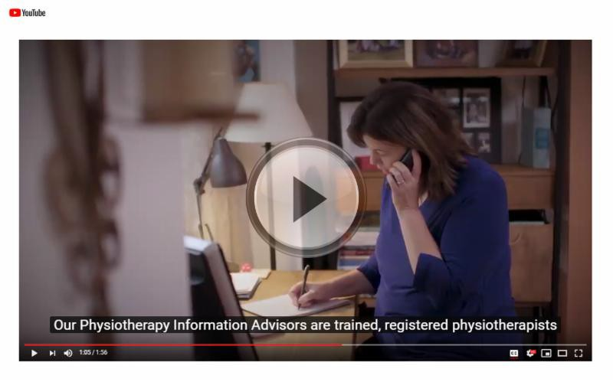
If you're waiting to complete the clinical component of the Physiotherapy Competency Exam working as a PTA can help you gain valuable real-life experience...but what happens when your duties cross the line?
New: Case of the Month

Did you know our Practice Advisors—also called Physiotherapy Information Advisors
— are available to answer questions from anyone including patients, caregivers and employers?

This brief video is a great resource to share with current and potential patients! Feel free to share on your social media channels or use the embed link from YouTube to include this video on your clinic website.

Of course our Practice Advice team is always there to answer questions from PTs. Email advice@collegept.org or call 1-800-583-5885 ext. 241.

Practice Advice Question

Help! I lost a patient record...what should I do?

What are my professional obligations?
Get the Answer
Myth vs Fact

Physiotherapists need to roster separately for acupuncture and dry needling.

Is this a myth or a fact?
Get the Answer

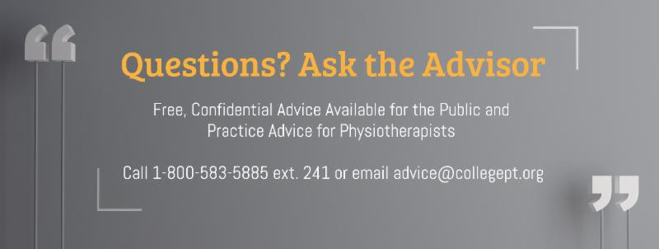Find out in a new Case of the Month, The Clinic Owner Doesn't Always Know Best.
Read the Case

Council Election - Voting Closes April 17!

Attention PTs who live in District 1 (South Western) and District 2 (Central Western): there's less than a week left to vote in the Council election!

Voting closes on April 17 at 2 p.m.

Check your email for the voting link.

Questions or comments related to Perspectives?
Get in touch at communications@collegept.org or 1-800-583-5885 ext. 234

www.collegept.org

