March 2019 | www.collegept.org | info@collegept.org

Spring is just around the corner – and so is the Annual Renewal deadline. I want to remind you that all physiotherapists must renew their registration before March 31 at 11:59 pm.

Please don’t leave it until the last minute because the system will close at midnight on the dot and you risk being kicked out mid-renewal.

For an optimal experience it’s highly recommended that you complete renewal on a laptop or desktop computer.

Also, we do have a dedicated renewal team available to assist you – but that is only during business hours Monday to Friday. Note that March 31 falls on a Sunday this year, so staff will be unavailable. For assistance, contact renewal@collegept.org or call 1-800-583-5885 ext. 235.

Thank you all for your cooperation.

Rod Hamilton Registrar
College of Physiotherapists of Ontario

New Webinar!
In Harm’s Way – Strategies to Support Patients Dealing with Mental Health Issues
What should you do when a patient discloses that they have been abused, they tell you they are experiencing suicidal thoughts, or that they are struggling with their mental health? It's a situation more and more physiotherapists find themselves in.

Join us for a webinar on Thursday, April 25 from noon until 1 p.m. and

hear from a panel of experts including psychiatrist Dr. Mary Preisman, social worker Jennifer Burt-Yanoff and College Senior Physiotherapist Advisor, Fiona Campbell, who will provide practical strategies, share helpful supports and answer your questions.
Register Now

ONLY 11 DAYS LEFT TO COMPLETE ANNUAL RENEWAL
Remember that you MUST renew your certificate of registration prior to March 31 – no exceptions! Do not leave this until the last minute as the system automatically shuts down and you will not be able to complete renewal.

March 29 is the final business day that our dedicated renewal team is in the office to assist you and answer questions. It's best to complete renewal before the final weekend so that we can be available to help if needed.

If you do not complete renewal prior to the March 31 deadline you will be charged a $225 late fee in addition to your $595 registration fee for a total of $820.

So renew now!

Questions?
Contact the Renewal Team renewal@collegept.org 1-800-583-5885 ext. 235
Renew Now

Remember to Update Your Personal and Employment Information
Although Annual Renewal is a great time to double check that all your personal and employment information is up to date, all PTs need to remember to make any changes to their information in a timely manner throughout the year.

In fact, by law, physiotherapists must report any changes to their personal or employment details to the College within 30 days of the change. In serving

the public interest it's imperative that information that appears on the Public Register is up to date.

New Practice Assessment Process Launching April 1!

Starting April 1, 2019, we'll be rolling out the new practice assessment program, beginning with a pilot test of the remote assessment. The pilot test will allow us to:
Test the new assessment tools
Collect feedback from members and assessors
Better determine the scoring system for on-site assessments

We'll select 250 PTs from a pool of physiotherapists who have never had a practice assessment. To make sure this selection is an appropriate representation of all PTs we will select members from different practice settings, members who are rostered for specific activities and members who work with specific patient populations. This way, when we study the data following the pilot project, it will apply to all physiotherapists.

If selected, your participation is mandatory, and you must complete the practice assessment. After completing the pilot test, you will be removed from rotation for practice assessments for approximately 10 years.
Learn More

New IPC Guidelines for Avoiding Abandoned Records

The Information and Privacy Commissioner has released new guidelines: Avoiding Abandoned Health Records: Guidance for Health

New Blog Post! Life As a PT in Rural, Remote and Northern Communities

Restricted access to service, the opportunity to wear many hats, tight- knit relationships with colleagues and the community...

Information Custodians Changing Practice.

The guidelines describe who acts as custodian when there’s a change of practice, what to do if you find abandoned records, and more.

View the guidelines here.

Our very own Practice Advisor based in the north, Kirsten Pavelich, breaks down the challenges and benefits of working as a physiotherapist in rural, remote or northern communities.
Read the Latest Blog Post

More on Privacy

Myth vs. Fact

A physiotherapist must file a self-report to the College if they have a charge of driving while texting.

Is this a myth or a fact?
Get the Answer

New Case of the Month

Multiple patient charts, hundreds of treatments, only a handful of recorded notes from the physiotherapist, and one skeptical insurance company.

Find out what happens next in a new case of the month...
Read the Case
Practice Advice Question

Q: Is there any harm in providing treatment sessions to a fully capable patient who appears to not want to attend/participate, but comes because their son brings them?
Get the Answer

Check Out Our Revamped YouTube Channel!

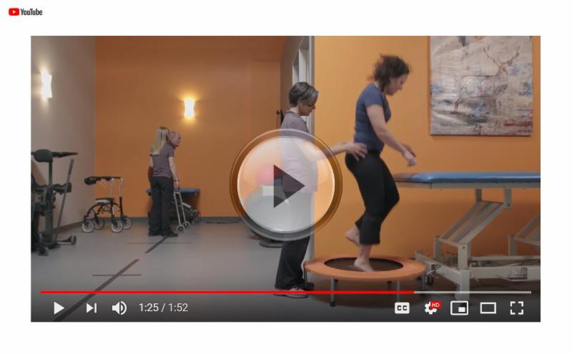

Have you visited our YouTube channel recently? If not, be sure to check it out. We've created a number of new videos including a five-part series that details the role of the College and key initiatives like the Public Register and our Physiotherapy Information Advisors (Practice Advisors).

Some videos are geared toward PTs while others are patient or employer focused.

Share these videos with your networks and feature them on your own website or social media channels using the share or embed option on YouTube.

Click play on the image above to start browsing!

Questions or comments related to Perspectiv es?
Get in touch at communications@collegept.org or 1 -800-583 -5885 ext. 234

www.collegept.org

