July 2019 | www.collegept.org | info@collegept.org

Welcome to the July issue of Perspectives. There is a lot of great content in this newsletter so be sure to scroll through. The Case of the Month explores the always relevant topic of valid, informed consent and is a must read for all physiotherapists and students.
Have a safe and enjoyable summer. Rod Hamilton
Registrar
College of Physiotherapists of Ontario

New Blog: Five Steps to Minimizing the Risk of Infection

Physiotherapists are expected to identify and minimize any risks caused by infections or the use of equipment in their practice, as outlined in the Infection Control and Equipment Maintenance Standard .

But do you know what steps to take if you have a patient with an open wound? What if the wound is weeping or has a strange odour? Not following appropriate protocols could have serious consequences, including negatively impacting patients.

Our Practice Advice team compiled a list of five key steps that every physiotherapist should take to identify and minimize the risk of infection. Be sure to check it out!
Read the Blog

IPC Fact Sheet: Protect Against Phishing

Everyone receives some unsolicited emails known as spam. Some of these emails may actually be phishing attempts where the attended goal is to get the recipient to do something that compromises the security of their personal information.

Phishing messages can be quite sophisticated and employees can easily be tricked into opening an infected attachment, clicking on a suspicious link or disclosing sensitive information.

The Information and Privacy Commissioner of Ontario (IPC) has developed a new fact sheet 'Protect Against Phishing' to help guide public institutions and health care organizations.
Learn More

New Case of the Month: Ticking a Box Isn't Enough

Consent. It's a recurring trend in concerns that the College receives from patients and something physiotherapists must always keep top of mind.

Even if you obtain valid, informed consent nine times out of 10, there is a good chance that one time you didn't may create problems... like in our new Case of the Month.

Be sure to give it a read and remember, a signed form does not equal consent.
Read the Case

Six Keys to Effective Communication

Communication can go a long way and can be a very effective tool in preventing complaints from patients. The College has seen many complaints where communication seems to be the root issue. Often these issues can be avoided if risks and benefits are clearly explained, simple language is used or empathy is shown.

Be sure to review our six tips for effective communication and incorporate them in your practice.
Read the Tips

New Clinical Learning Series from the Regional Geriatric Program of Toronto

Looking for continuing education or ongoing professional development opportunities?

The Regional Geriatric Program (RGB) is a new clinical learning series, available at no charge.

The series consists of introductory educational modules for clinicians, along with supporting posters and patient handouts on seven key clinical topics: delirium, mobility, polypharmacy, pain, loneliness, nutrition, and urinary incontinence.

This is a great learning opportunity for PTs so be sure to check it out.

Learn More

Digital Practice White Paper and Survey – Please Complete!

The World Confederation for Physical Therapy (WCPT) and the International Network of Physiotherapy Regulatory Authorities (INPTRA) recently established a Digital Physical Therapy Practice Task Force and developed a white paper addressing physical therapy practice and regulation in the digital age.

The task force is looking for feedback on the white paper and has created a survey. Please read the white paper and respond to the survey with as much detail as possible. It only takes a few minutes to complete.
Complete the Survey

Practice Advice Question

When treating children/youths, what is the age of consent for physiotherapy treatment?
Get the Answer
Myth vs Fact

Physiotherapists can charge patients a fee to provide them with a copy of their health record.

Is this a myth or a fact?
Get the Answer

In Memoriam: Former College President Patricia Hartnett

The College wishes to recognize the significant contributions of former President and board member Patricia Ann Hartnett who passed away on July 2, 2019 after a brief but valiant battle with cancer.

Patty was valedictorian of the physiotherapy program at the University of Toronto during her graduating year and had a very successful career in physiotherapy and health administration. For the last 18 years Patty worked as a hands-on therapist at West Park Health Care Centre. Our sincere condolences to Patty's family, friends and colleagues – she will be missed.

The College would like to welcome our newly registered physiotherapists.

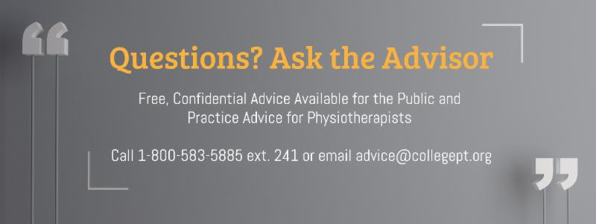View the List

Comments or questions related to Perspectives?
Get in touch at communications@collegept.org or 1-800-583-5885 ext. 234.

www.collegept.org

