MUST COMPLETE

How to Complete the Record Keeping Review
Using the College’s Checklist

Physiotherapists selected to complete a screening interview must audit one of their patient records using the Record Keeping Checklist that can be downloaded.
The purpose of performing a self-audit of one patient record is to raise your awareness and self-reflect about the requirements of the Record Keeping Standard. By reviewing one of your patient records, we are asking you to answer the checklist as honestly as possible. If you find any gaps in your record keeping, consider ways you can change or improve your record keeping to address the gaps.
Once you review your record and complete the checklist, you need to upload the checklist in the PT Portal one week before your screening interview. The assessor assigned to do your screening interview will review the checklist and answer three questions with yes or no responses along with any additional comments. This review will become part of your screening interview report, but it is not discussed or scored during your interview. The assessor reviews your completed checklist before or after the interview.
The three questions the assessors will answer are:
- Did the PT submit a completed record-keeping checklist for one patient record? (Yes/ No)
- Did the PT score any areas of the checklist as No? (Yes/ No)
- Did the PT describe steps they took or plan to take to address the items scored No? (Yes/ No)

Comments:
It’s okay to answer ‘No’ to items on the checklist. If you respond ‘No’, the assessor will be looking for a description of how you plan to address the concern.

Let’s Get Started:

Step 1: Pick one of your records to review.

Here is some guidance on selecting one of your records:
- Pick a record of a patient who has been discharged from physiotherapy within the last year.
- If you work with physiotherapist assistants (PTAs), pick a file that includes care that you assigned to the PTA
- Ensure you review the complete physiotherapy record. A complete physiotherapy record can include:
    - financial record (if applicable),
    - clinical notes (e.g., assessments, progress notes, reassessments, etc.)
    - attendance tracking sheets
    - copies of exercise sheets (if any)
    - forms signed by the patient
    - reports sent to or received from others
    - notes completed by the physiotherapist assistant, including exercise tracking sheets

Step 2: Review the record you selected.
- Download the Record Keeping Checklist.
- Insert your name & date of screening interview
- Identify the record you reviewed. Do not use the person’s real name or personal information like telephone numbers that can be linked to the patient. Use something such as a file ID number, physiotherapy assessment date, or some other combination of unique identifiers.
- Find a quiet room and plan to spend about 15 – 30 minutes reviewing the record.
- Follow the instructions for filling out the checklist.
- When finished, sign and date when you completed the review.
  - It is okay to type in your name or use an electronic signature

Step 3: Upload the completed checklist to the PT Portal.
DO NOT UPLOAD THE PATIENT CHART TO THE PT PORTAL

- If you completed the checklist on paper, scan or take a photo of your completed checklist. You are uploading an electronic file.
- Login to the PT Portal
- Go to the Practice Assessments area.
- Click on your Screening Interview link.
- Right below your task list, you will see an area where you need to upload the checklist and then click submit.
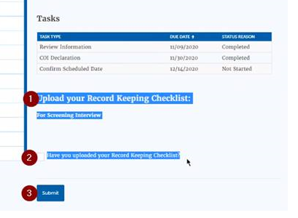

Step 4 – You are Done!
There is nothing more to do. The assessor answers the three questions provided above and these responses become part of your report. The checklist you submitted will also be saved to your screening interview file.
As a reminder, the record you reviewed and the completed checklist are not discussed during your screening interview.

Don’t be shy—Get help with your record keeping!
Now that you finished this part of the process, start implementing your plans to address those gaps in your record keeping.
If you need any help, the College has a confidential practice advisory service to answer any of your questions. Contact a practice advisor at advice@collegept.org or call 1-800-583-5885 ext. 241.

Additional Record Keeping Resources
Check-out the great resources on record keeping that are available to all physiotherapists:
- Record Keeping Standard
- Record Keeping eLearning Module
- Record Keeping Frequently Asked Questions
- Case of the Month – No Second Chances When It Comes to Patient Care and Record Keeping

